Animal Tracking System
  - (Facility Manager)

Table of Contents
Introduction 2
Functionality Overview 3
View History of Animals 4
View history details 5
Make Correction 6
Declare Acquisition 6
Request Transfer Out 7
Acknowledge Completed Transfers 8-9
Purchase Request 9-10
Process Purchase Requests 11-11
View Details 12
Process 13
Request Import 13
Request Export……………………………………………………………………………………15
Reporting Issues………………………………………………………………………………….16

Table of Screen Shots
Screen Shot 1 (Kerberos Login Screen) 2
Screen Shot 2 (Protocol Animal Numbers Summary) 3
Screen Shot 3 (Animal Numbers Summary- with PI Selected) 4
Screen Shot 4 (Animal Tracking History) 4
Screen Shot 5 (Purchase Request Details) 5
Screen Shot 6 (Animal Numbers Correction Request Form) 6
Screen Shot 7 (Animal Tracking History - Updated) 6
Screen Shot 8 (Animal Acquisition Declaration Form) 7
Screen Shot 9 (Animal Transfer Request Form) 8
Screen Shot 10 (Animal Transfer Acknowledgement) 9
Screen Shot 11 (Animal Purchase Request Form) 10
Screen Shot 12 (Pending Animal Purchase Requests) 11
Screen Shot 13 (Purchase Request Details) 12
Screen Shot 14 (Animal Purchase Request – Approval Form) 13
Screen Shot 15 (Animal Import Request Form)…………………………………………………………………14
Screen Shot 16(Animal Export Request Form)…………………………………………………………………15

Introduction
Safety Services/IT has created a new application called Animal Tracking System. The system is designed to track the number of animals used on UC Davis research and teaching protocols. This will allow us to provide real time animal numbers to our regulatory agencies and help us ensure that projects do not exceed the number of animals for which they were approved.

Accessing the site for facility managers
To access the site, please follow instructions below:
- Go to the Facility Management page:
http://iacuc.ucdavis.edu/iacuc/Vivaria/manager.cfm. From the facility manager’s page, click on the Animal Tracking System link: http://iacuc.ucdavis.edu/iacuc/ATS_FM/index.cfm

- Enter your Kerberos Login

Screen Shot 1 (Kerberos Login Screen)
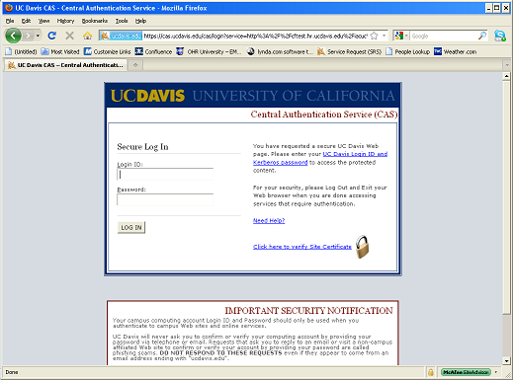

After logging in, the ‘Animal Numbers Summary’ page is displayed.

Screen Shot 2 (Protocol Animal Numbers Summary)
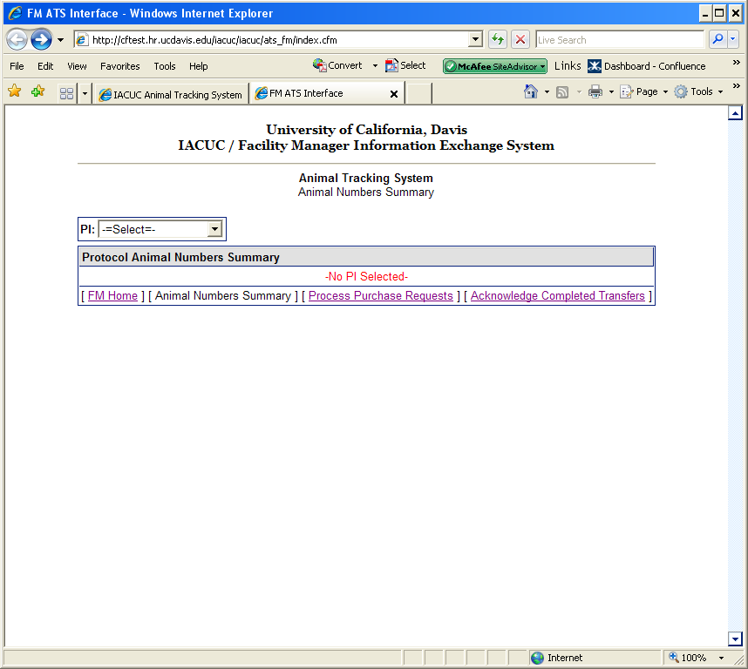

Functionality Overview
Facility Managers (FMs) will have access to the follow functions:
- View History of Animals Acquired on a protocol
- Declare newly acquired animals
- Submit a purchase request
- Transfer animals from one protocol to another or from one location to another
- Acknowledge Completed Transfers
- Approve Purchase Requests
  - This function is for staff designated as the purchase agent

View History of Animals
This feature provides a brief summary as well as detailed view of the history of selected species on a specific protocol. From the ‘Animal Numbers Summary’ page, select a PI. Then click “View History” link for a specific species.

Screen Shot 3(Animal Numbers Summary- with PI Selected)

Screen Shot 3 (Animal Numbers Summary- with PI Selected) 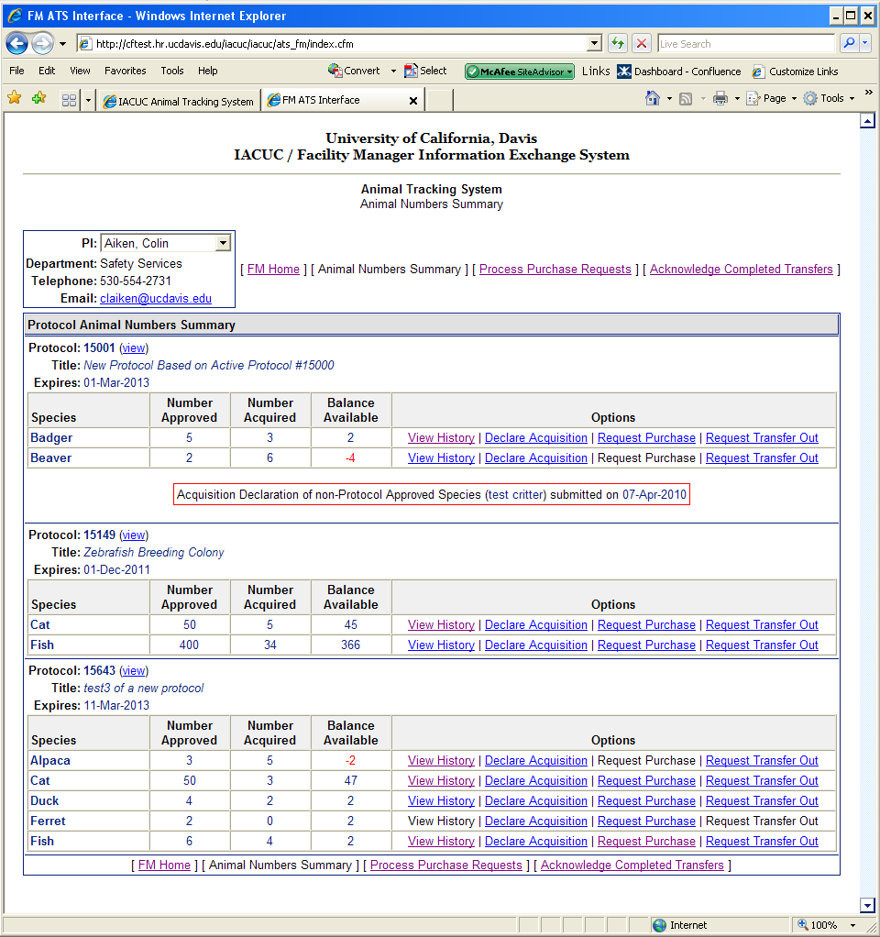

Screen Shot 4 (Animal Tracking History)
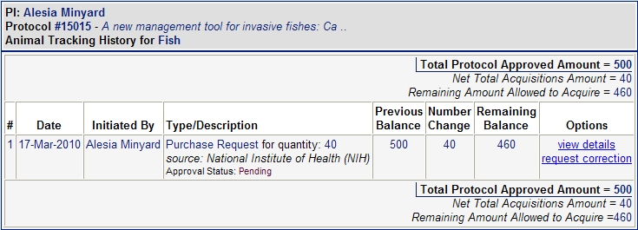
The Animal Numbers Summary history page will appear. The FM will be able to view the number of animals approved on the protocol in the upper right hand corner of the page, the previous balance of animals, the number of animals acquired or purchased (number change) and the remaining balance of animals available.

View history details
By clicking the “view details” link the FM will be able to view the details of a specific purchase for the protocol selected.

Screen Shot 5 (Purchase Request Details)
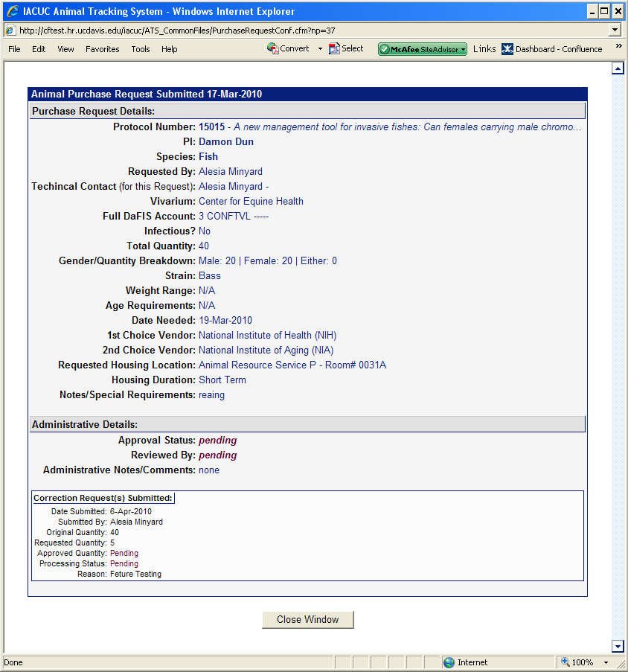
Close Window

Make Corrections
This feature allows the FM to make a correction to a specific purchase for the selected protocol.
A correction may be needed in cases when the original number entered was a typographical error, an animal(s) arrives dead, an animal(s) arrives sick and cannot be used by the PI or in cases where the number of animals delivered is either less than or more than the number ordered.
From the ‘Animal Numbers Summary Detail History’ page (screen shot 4), click the “make corrections” link in the options column. Enter actual quantity received and the reason for the correction. Click “Submit Request”.

Screen Shot 6 (Animal Numbers Correction Request Form)
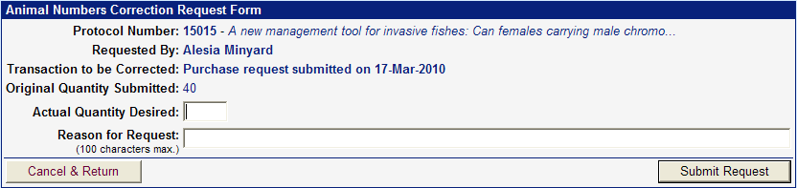

Screen Shot 7 (Animal Tracking History - Updated)
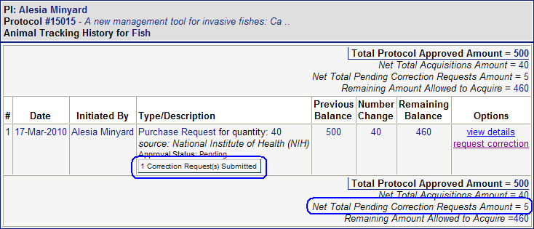
The requested change will now be highlighted in red on the page. After the request is submitted an email notification will be sent to the requester, PI and alternate contact for verification.

Declare Acquisition
This feature allows FMs to enter animals acquired thru means other than the standard purchasing channel. Examples include:
Auction
Breeding
Captured
Client-Owned
Purchase – (Animals purchased outside the standard purchasing process; this is not commonly done)
Other-Not Listed

*Please note animals coming from non-approved vendors through purchase, donation, import etc. may not be acquired until after the Attending Veterinarian’s office has approved the source. From the ‘Protocol Animal Number Summary’ (Screen Shot 3) click the “Declare Acquisition” link from the protocol the animals are being declared under. Enter the required information:

- Species acquired: (a separate declaration must be submitted for each species being declared)
- Quantity of animals acquired:
- Strain (if known)

- Reporting start date: Time frame animals are being reported
- Reporting end date: Time frame animals are being reported
- Current location of animals: (for field studies indicate if animals were captured and released or brought on campus)
- Any additional notes:

Once all of the information has been entered click the “Submit Declaration” button.

Screen Shot 8 (Animal Acquisition Declaration Form)
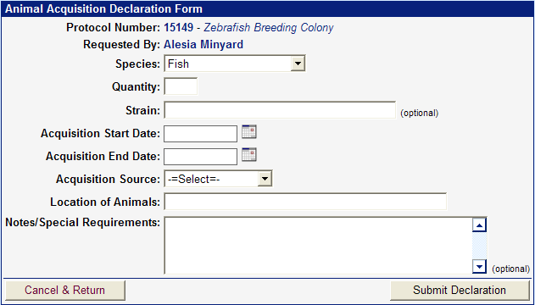

The quantity acquired or used will now appear on the ‘Animal Numbers Summary’ page under view history for the species selected.
An email notification will be sent to the requester, PI and alternate contact verifying the declaration was submitted.

Request Transfer Out
This feature allows a FM to transfer animals between protocols (from one PI’s protocol to another PI’s protocol or from one protocol to another with the same PI) and/or between locations. For animals that are considered “with use” the final disposition of the originating protocol must include transferring animals to other PI’s protocols and the receiving protocol must include other PI’s protocols as a source of animals. An exception to this protocol requirement is if animals are purchased and never used or if animals are generated from breeding and not used for any other purpose, they can be transferred between protocols per policy without the specific designation in the disposition or source sections of the protocol. From the ‘Animal Numbers Summary’ (Screen Shot 3) page, click “Request Transfer” for a specific protocol and species desired. Select a PI from the ‘PI’ list.
Complete the required information on the ‘Animal Transfer Request Form’:
- Select the PI the animals will be transferred to:
- Select the protocol number the animals will be transferred to:
- Number of animals being transferred: (the number of animals being transferred may not exceed the remaining balance)

- Strain of animal:
- Status of animal:
- With use = animals have been used under the current protocol as their use is described in the protocol e.g. animals were bred or generated under a PIs protocol approved for breeding or animals purchased under the current research protocol were used for a procedure such as blood collection approved in the protocol.
- Without use= animals were purchased under the current protocol but have never been used.
- Date animals need to be transferred:
- Current location of the animals:
- Location animals are being transferred to: (if the animals are not changing location select the current location)
- If the location selected is a TRACS area enter the current and new recharge numbers:
- Will there be special husbandry or strain related conditions: If yes, describe
- Are the animals infected or have they been treated with any potential hazardous agents: If yes, describe
- Will animals return to the original protocol:
- Will animals return to the original location:
- Reason/purpose for the transfer: It is essential to support the principles of the 3 R’s for reducing, refining and replacing animals used in teaching and research.

After all of the information has been entered click the “Submit Request” button.

Screen Shot 9 (Animal Transfer Request Form)
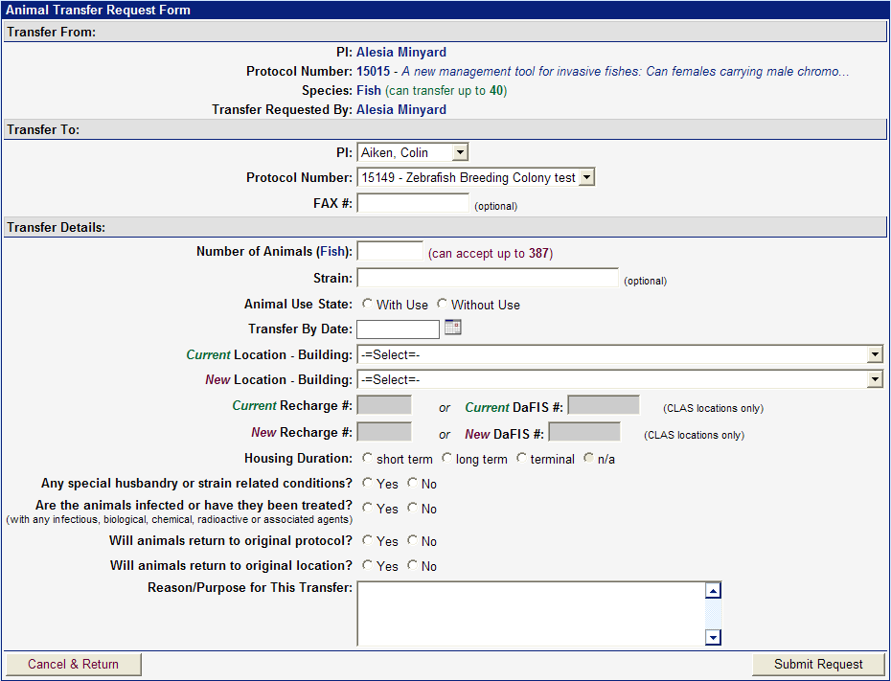

The data from the Transfer Request form will appear on the ‘Animal Tracking History’ for both PI’s in the transaction. An email notification will be sent to the requester, PI and alternate contact verifying the request was submitted. Either the Health Monitoring Coordinator or IACUC staff will approve or deny the transfer. If the request is denied the requestor will be contacted and the reason for the denial will be provided.

Acknowledge Completed Transfers
This feature allows the FM to acknowledge a transfer has taken place after it has been approved by IACUC or the Health Monitoring Coordinator.
If the FM does not want the transfer to go through please email the IACUC office: iacuc-staff@ucdavis.edu
From the ‘Animal Numbers Summary’ page, click the “Acknowledge Completed Transfers” link. Click the “Declare This Transfer Complete” button on the desired transfer to acknowledge the transfer. The transfer will now appear on the ‘Recently Acknowledged Animal Transfers’ section of this page.

Screen Shot 10 (Animal Transfer Acknowledgement)
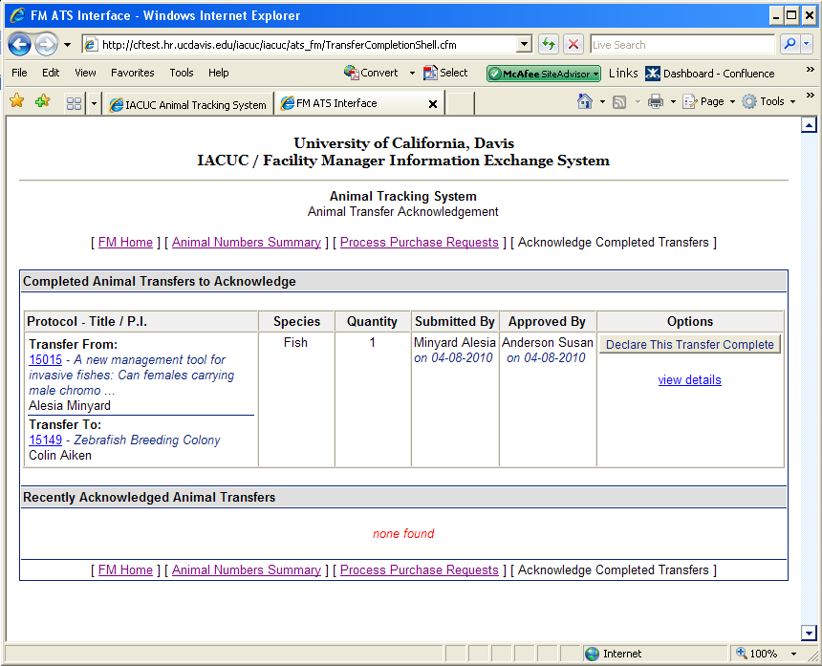

Purchase Request
This feature allows FMs to enter a request to purchase a specific species for a selected protocol. Please note: purchase requests are processed through TRACS (http://safetyservices.ucdavis.edu/article/animal-orders) and must be received by noon on Thursday for animals to be received the following week (see above website for exceptions).
Click the “Request Purchase” link on the ‘Protocol Animal Number Summary’ (Screen Shot 3) page. Fill out the required information:
- Technical Contact Name: (the name of the person to be contacted for questions about this specific request)
- Technical Contact Telephone:
- Fax # (optional)
- Vivarium where animals will be housed:
- Recharge number (please contact your department’s business office for account number assistance)
- Will the animals be infectious? If yes, with what?
- Quantity and gender specifications: (the number of animals requested may not exceed the remaining balance on the protocol)
- Strain:
- Weight range preference:
- Age preference:
- Dated Needed:
- Vendor choices: (purchase request for the Jackson laboratory must include the stock number)
- Requested housing location/building:
- Housing duration: (will the animal(s) be in this location for less than 2 months, longer than 2 months or will they be used acutely upon arrival)
- Notes/special requirements: (e.g. animals require barrier housing)

After all the information has been entered click the “Submit Request” button.
Screen Shot 11 (Animal Purchase Request Form)
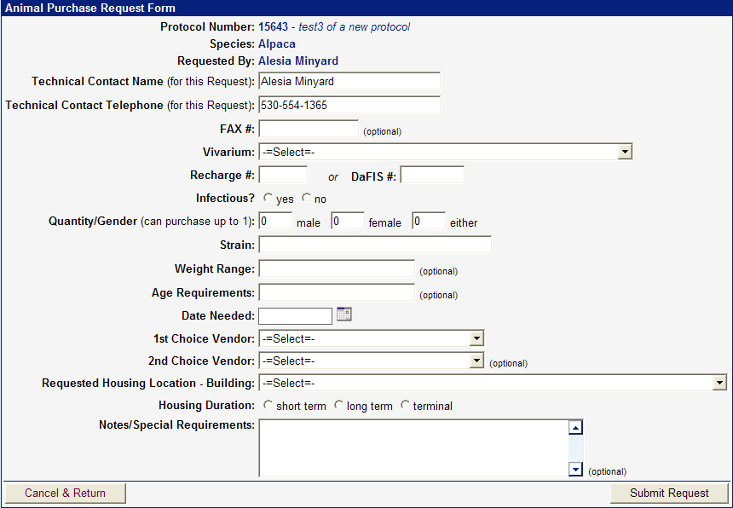

An email notification will be sent to the requester, PI and alternate contact to verify the ordered submitted. The Health monitoring coordinator will review all requests for non-approved vendors. The facility manager will approve or deny the requests. If the request is denied the requester wil be notified with the reason.

Process Purchase Requests
This feature gives Purchasing Agents (PA) the ability to review purchase requests. It also allows PAs to approve or deny submitted requests. Note: this feature is only available to staff who are designated as a purchasing agent. Most purchase requests will be processed through the TRACS main office and they will work directly with the vendor to process the order. For departments who have approval to purchase their own animals, you will still need to contact the vendor directly to complete the purchase request after approving the order in the ATS.
From the ‘Animals Summary Page’ (Screen Shot 2) click the “Process Purchase Request” link. You will be directed to the ‘Pending Animal Purchase Requests’

Screen Shot 12 (Pending Animal Purchase Requests)
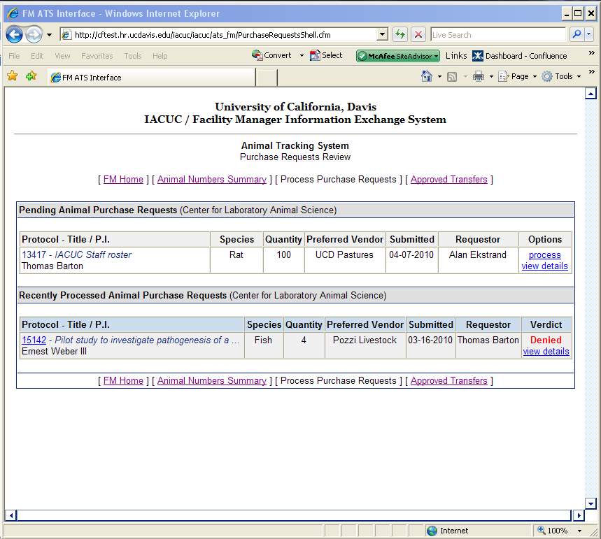

View Details
This feature allows the PA to view the details of a pending purchase request.
From the ‘Pending Animal Purchase Requests’ page, click “view details”

Screen Shot 13 (Purchase Request Details)
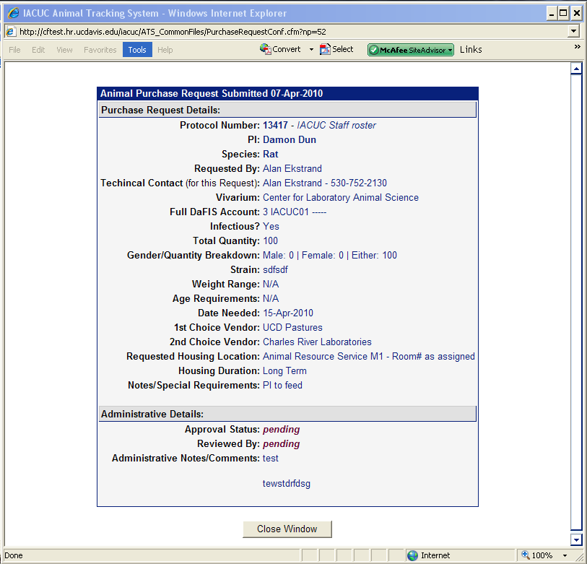

Process
This feature allows the PA to process pending purchase request
Enter the ‘Pending Animal Purchase Requests’ (Screen Shot 12) page and click “process”.
Fill out necessary information:
Approve purchase:
Notes/Responses: (if request is denied enter reason here)
When all of the information has been entered click the “Process Request” button. Once the request is processed, the ‘Pending Animal Purchase Requests’ page is displayed again; and the newly processed request will appear in the ‘Recently Processed Animal Purchase Requests’ of this page.

Screen Shot 14 (Animal Purchase Request – Approval Form)
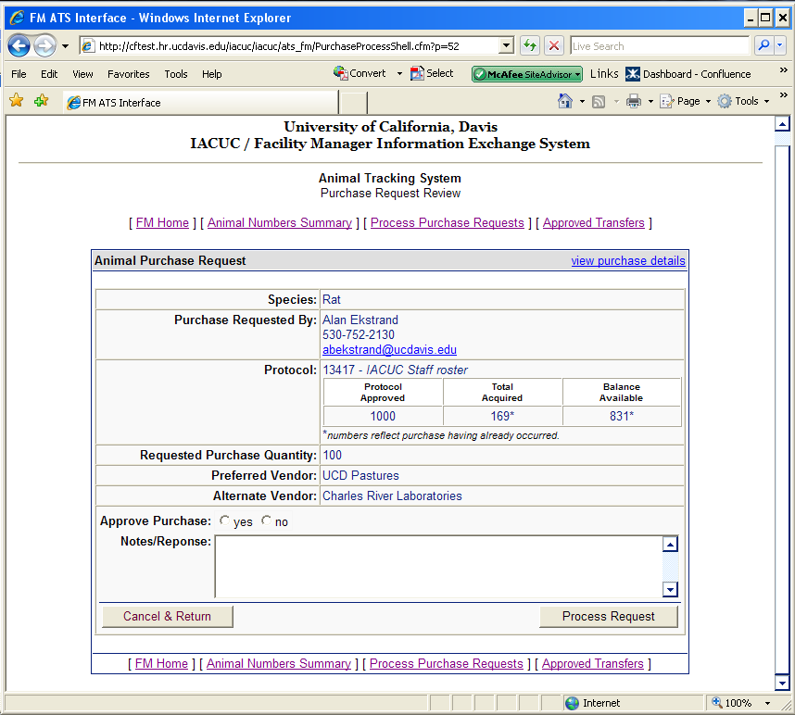

Request Import
This feature allows a FM to submit a request to the Health Monitoring Coordinator when a PI wants an animal(s) to be shipped to UC Davis from a non-approved vendor or from another institution. The PI must have approval in the animal care and use protocol for this source of animals. If the protocol is not approved for this source, an amendment must be submitted and approved by the IACUC prior to the request being approved.
Enter the required information on the Animal Import Request form:

- Enter the quantity of animals being shipped.
- Enter the source; where the animals are being shipped from. Select whether or not this source has been used before
- Provide the contact information for the source of the animals. Enter the PI’s information for the source if different than the contact information.
- Choose the vivarium where the animals will be housed once they arrive at UC Davis. Select the desired building for housing. Provide the recharge number.
- Provide any special instructions for the care of these animals in the notes section.
- Attach Supplemental Import Form and other health record documentation from colony source.

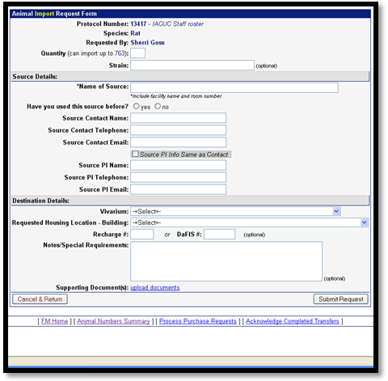
Screen Shot 15 (Animal Import Request Form)

Submit the request after all fields have been entered.
The request will be reviewed by the Health Monitoring Coordinator. Questions should be addressed to animaltransfer@ucdavis.edu
Please note: once the import request has been approved by the Health Monitoring Coordinator the PI may make the necessary arrangements to have the animals shipped. It is the PI’s responsibility to arrange the shipping of the animals.

Request Export
This feature allows a FM to submit a request to the Health Monitoring Coordinator when a PI wants an animal(s) to be shipped from the UC Davis animal care program to another institution. The PI must have approval in the animal care and use protocol for this source as a final disposition of the animals. If the protocol is not approved for this destination, an amendment must be submitted and approved by the IACUC prior to the request being approved.
Enter the required information on the Animal Export Request form:
Screen Shot 16 (Animal Export Request Form)
- Enter the quantity of animals being shipped.
- For animals requiring an individual ID number, please enter all numbers included in this shipment in the Notes section. For animals not requiring a Unique ID Number, no entry is required.
- Enter the destination; where the animals are being shipped to.
- Provide the contact information for the destination of the animals. Enter the PI’s information for the destination if different than the contact information.
- Select whether or not animals have been shipped to this destination before.
- Select whether or not you are required to have a copy of the animal/colonies health report.
- Select whether or not the shipper requires a health certificate.
- Fill in the date of shipping.
- Attach any supporting documents related to the export.
- Provide any special instructions for the care of these animals in the notes section. Also, provide any notes for CVS in this section when requesting physical exams, vaccinations, etc.

Submit the request after all fields have been entered.
The request will be reviewed by the Health Monitoring Coordinator. Questions should be addressed to animaltransfer@ucdavis.edu

Please note: once the export request has been approved by the Health Monitoring Coordinator the PI may make the necessary arrangements to have the animals shipped. It is the PI’s responsibility to arrange the shipping of the animals.

Reporting Issues
If you encounter any issues and/or have any feedback, please send an email to: iacuc-staff@ucdavis.edu

