Animal Tracking System
  - (Principal Investigator)

Table of Contents
Introduction 2
Accessing the site 2
Functionality Overview 3
View History of Animals 3
View history details 4
Request Correction 5
Declare Acquisition 5
Purchase Request 6
Request Transfer Out 8
Request Import…………………………………………………………………………………….9
Request Export……………………………………………………………………………………11
Reporting Issues………………………………………………………………………………….12

Table of Screen Shots
Screen Shot 1 (Kerberos Login Screen) 2
Screen Shot 2 (Protocol Animal Numbers Summary) 3
Screen Shot 3 (Animal Tracking History) 4
Screen Shot 4 (Purchase Request Details) 4
Screen Shot 5 (Animal Numbers Correction Request Form) 5
Screen Shot 6 (Animal Tracking History - Updated) 5
Screen Shot 7 (Animal Acquisition Declaration Form) 6
Screen Shot 8 (Animal Purchase Request Form ) 6
Screen Shot 9 (Animal Transfer Request Form) 9
Screen Shot 10 (Request Import)…………………………………………………………….……………………9 Screen Shot 11 (Request Export)………………………………………………………………………………..10

Introduction
The Animal Tracking System is designed to track the number of animals acquired or used on UC Davis research and teaching protocols. It also helps oversee the movement of animals to ensure the biosecurity of our animal facilities. This will allow us to provide real time animal numbers to our regulatory agencies and help us ensure that projects do not exceed the number of animals for which they were approved.

Accessing the site
To access the site, follow instructions below:
- Enter the online IACUC website: https://iacuc.ucdavis.edu/protocol/. From the website, click on the Animal Tracking System link under the Animal Tracking and Renewals heading on the far right hand side of the page
- Enter your Kerberos Login

Screen Shot 1 (Kerberos Login Screen)
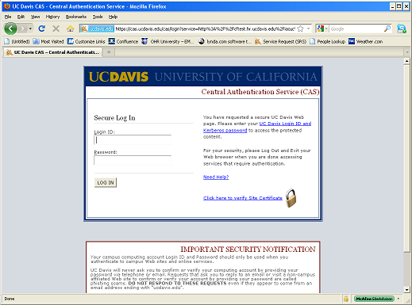

After logging in, the ‘Protocol Animal Numbers Summary’ page will appear. This page lists all protocols associated with the PI currently logged in.

Screen Shot 2 (Protocol Animal Numbers Summary)
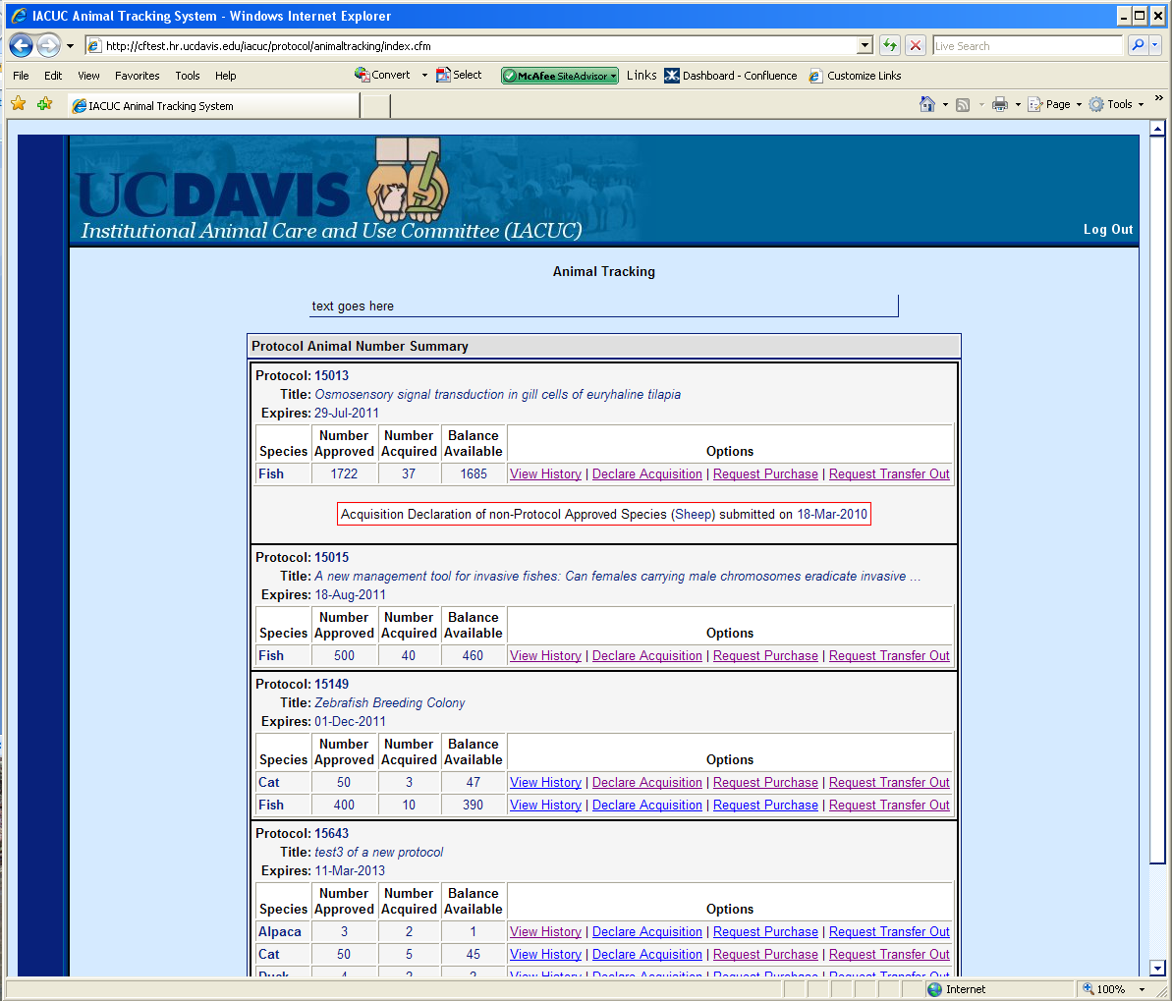

Functionality Overview
Principal Investigators (PIs) have access to the following functions:
- “View History” of animals acquired on a protocol
- “Declare Animals” that have been newly acquired or used
- “Request Purchase” of animals
- “Request Transfer” of animals from one protocol to another or from one location to another
- “Request Import” and “Request Export” of animals

View History of Animals
This feature provides a brief summary as well as detailed view of the history of selected species on a specific protocol.
From the ‘Protocol Animal Number Summary’ (Screen shot 2) page, click “View History.”
The protocol Animal Numbers Summary history page will appear. The PI will be able to view the number of animals approved on the protocol in the upper right hand corner, view the previous balance of animals, the number of animals acquired or purchased (number change) and the remaining balance of animals available.

Screen Shot 3 (Animal Tracking History)
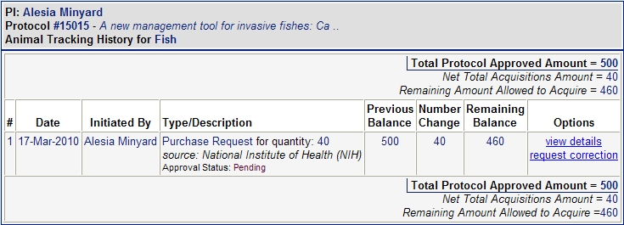

View history details
The feature allows the PI to view the details of specific purchases for the protocol selected.
Using the protocol selected from Screen Shot 3, click the “view details” link in the options column of the history page to view the purchase request details.
Screen Shot 4 (Purchase Request Details)
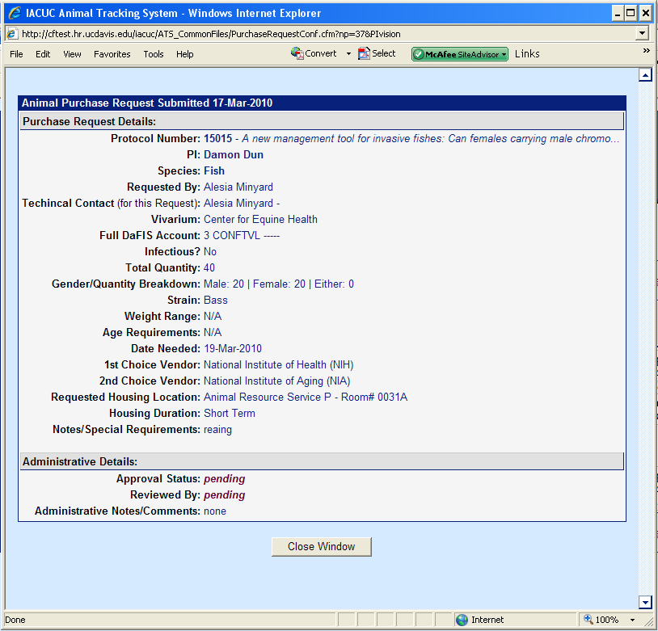
Close Window

Request Correction
This feature allows the PI to request a correction to a specific purchase for the selected protocol.
A correction may need to be requested in cases when the original number entered was a typographical error, an animal(s) arrives dead, an animal(s) arrives sick and cannot be used by the PI or in cases where the number of animals delivered is either less than or more than the number ordered.
From the ‘Animal Numbers Detail History’ page (screen shot 3), click the “request corrections” link in the options column. Enter actual quantity received and the reason for the request (correction). Click “Submit Request”.
Screen Shot 5 (Animal Numbers Correction Request Form)
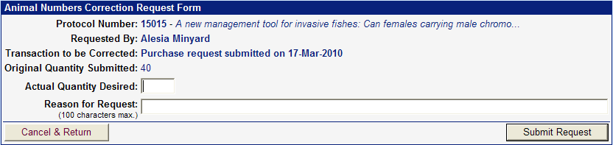

Screen Shot 6 (Animal Tracking History - Updated)
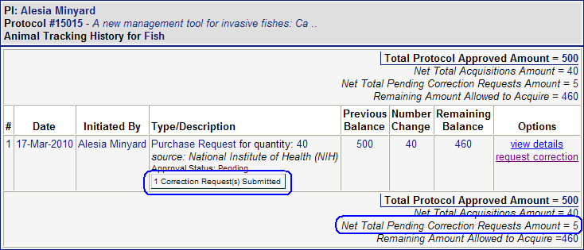
The requested change will now be highlighted in red on the page (Screen Shot 6). After the request is submitted an email notification will be sent to the requester, PI and alternate contact for verification.
The IACUC staff will review the request and either approve or deny the request. If a request is denied, the IACUC staff will contact the requester with an explanation.

Declare Acquisition
This feature allows PIs to enter animals acquired thru means other than the standard purchasing channel. Examples included: (Please note animals coming from non-approved vendors through purchase, donation, import etc. may not be acquired until after the Attending Veterinarian’s office has approved the source.)
Auction
Breeding
Captured
Client-Owned

Purchase – (Animals purchased outside the standard purchasing process; this is not commonly done)
Other-Not Listed

From the ‘Protocol Animal Number Summary’ (Screen Shot 2) click the ‘Declare Acquisition’ link from the protocol the animals are being declared under. Enter the required information:

- Species acquired: (a separate declaration must be submitted for each species being declared)
- Quantity of animals acquired:
- Strain (if known)
- Reporting start date: Time frame animals are being reported
- Reporting end date:
- Current location of animals: (for field studies indicate if animals were captured and released or brought on campus)
- Any additional notes:

Once all of the information has been entered click the ‘Submit Declaration’ button.

Screen Shot 7 (Animal Acquisition Declaration Form)
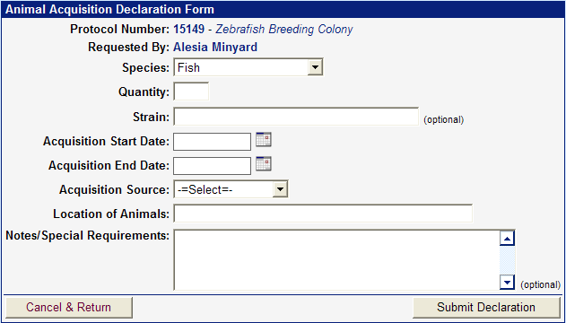

The quantity acquired or used will now appear on the ‘Animal Numbers Summary’ (Screen Shot 2) page under view history for the species selected.
An email notification will be sent to the requester, PI and alternate contact verifying the declaration was submitted.

Purchase Request
This feature allows PIs to enter a request for purchase for a specific species for a selected protocol. Please note: purchase requests are processed through TRACS (http://safetyservices.ucdavis.edu/article/animal-orders) and must be received by noon on Thursday for animals to be received the following week (see above website for exceptions).

- Click the “Request Purchase” link on the ‘Protocol Animal Number Summary’ (Screen Shot 2) page. Fill out the required information:
- Technical Contact Name: The name of the person to be contacted for questions about this specific request
- Technical Contact Telephone:
- Fax # (optional)
- Vivarium where animals will be housed:
- Recharge number (please contact your department’s business office for account number assistance)
- Will the animals be infectious? If so, with what?
- Quantity and gender specifications: (the number of animals requested may not exceed the remaining balance on the protocol)
- Strain:
- Weight range preference:
- Age preference:
- Dated Needed:
- Vendor choices: (purchase request for the Jackson laboratory must include the stock number)
- Requested housing location/building:
- Housing duration: (will the animal(s) be in this location for less than 2 months, longer than 2 months or will they be used acutely upon arrival)
- Notes/special requirements: (e.g. animals require barrier housing)

After all the information has been entered click the “Submit Request” button.

Screen Shot 8 (Animal Purchase Request Form)
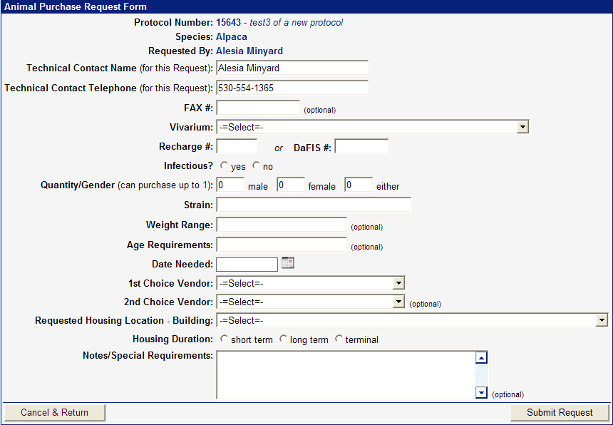

An email notification will be sent to the requester, PI and alternate contact to verify the ordered submitted. The Health monitoring coordinator and/or facility manager will approve or deny the request. If the request is denied the requester wil be notified with the reason.

Request Transfer Out
From the ‘Animal Numbers Summary’ (Screen Shot 2) page, click “Request Transfer” for a specific protocol and species desired. Complete the required information on the ‘Animal Transfer Request Form’:
- Select the PI the animals will be transferred to:
- Select the protocol number the animals will be transferred to:
- Number of animals being transferred: (the number of animals being transferred may not exceed the remaining balance)
- Strain of animal:
- Status of animal:
- With use = animals have been used under the current protocol as their use is described in the protocol e.g. animals were bred or generated under a PIs protocol approved for breeding or animals purchased under the current research protocol were used for a procedure such as blood collection
- Without use= animals are purchased under the current protocol but have never been used.
- Date animals need to be transferred:
- Current location of the animals:
- Location animals are being transferred to: (if the animals are not changing location select the current location)
- If the location selected is a TRACS area enter the current and new recharge numbers:
- Will there be special husbandry or strain related conditions: If yes, describe
- Are the animals infected or have they been treated with any potential hazardous agents: If yes, describe
- Will animals return to the original protocol:
- Will animals return to the original location:
- Reason/purpose for the transfer: (it is essential to support the principles of the 3 R’s for reducing, refining and replacing animals used in teaching and research.

After all of the information has been entered click the ‘Submit Request’ button.

Screen Shot 9 (Animal Transfer Request Form) 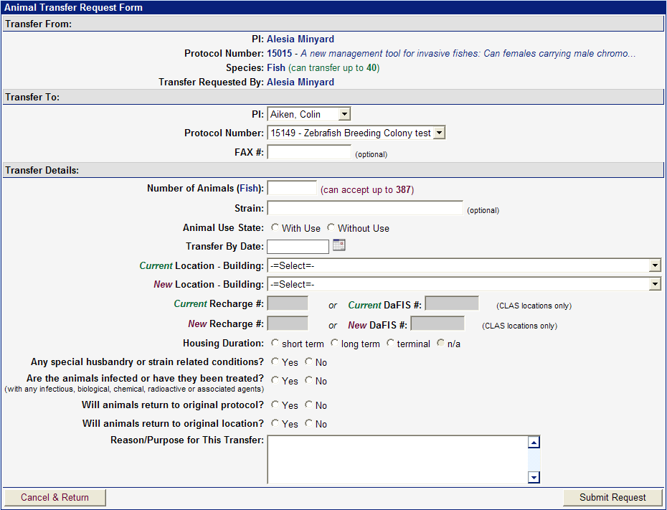

The data from the Transfer Request form will now appear in the ‘Animal Tracking History’ under each protocol in the transaction. An email notification will be sent to the requester, PI and alternate contact verifying the request was submitted. Either the Health Monitoring Coordinator or IACUC office will approve or deny the transfer. If the request is denied, the requester will receive notification stating the reason for denial.

Request Import
This feature allows a PI to submit a request to the Health Monitoring Coordinator when the PI wants an animal(s) to be shipped to UC Davis from a non-approved vendor or from another institution. The PI must have approval in the animal care and use protocol for this source of animals. If the protocol is not approved for this source, an amendment must be submitted and approved by the IACUC prior to the request being approved.
Enter the required information on the Animal Import Request form:

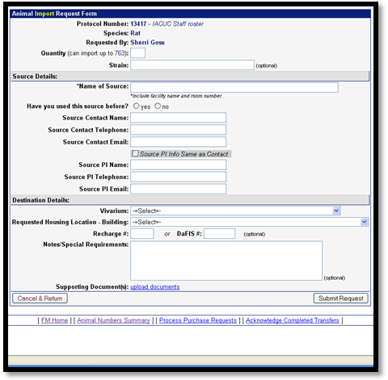
Screen Shot 10 (Animal Import Request Form)

- Enter the quantity of animals being shipped.
- Enter the source; where the animals are being shipped from. Select whether or not this source has been used before.
- Provide the contact information for the source of the animals. Enter the PI’s information for the source if different than the contact information.
- Choose the vivarium where the animals will be housed once they arrive at UC Davis. Select the desired building for housing. Provide the recharge number.
- Provide any special instructions for the care of these animals in the notes section.
- Attach Supplemental Import Form and other health record documentation from colony source.
Submit the request after all fields have been entered.
The request will be reviewed by the Health Monitoring Coordinator. Questions should be addressed to animaltransfer@ucdavis.edu
Please note: once the import request has been approved by the Health Monitoring Coordinator the PI may make the necessary arrangements to have the animals shipped. It is the PI’s responsibility to arrange the shipping of the animals.

Request Export
This feature allows a PI to submit a request to the Health Monitoring Coordinator when the PI wants an animal(s) to be shipped from the UC Davis animal care program to another institution. The PI must have approval in the animal care and use protocol for this source as a final disposition of the animals. If the protocol is not approved for this destination, an amendment must be submitted and approved by the IACUC prior to the request being approved.
Enter the required information on the Animal Export Request form:
Screen Shot 11 (Animal Export Request Form)

- Enter the quantity of animals being shipped.
- For animals requiring an individual ID number, please enter all numbers included in this shipment in the Notes section. For animals not requiring a Unique ID Number, no entry is required.
- Enter the destination; where the animals are being shipped to.
- Provide the contact information for the destination of the animals. Enter the PI’s information for the destination if different than the contact information.
- Select whether or not animals have been shipped to this destination before.

- Select whether or not you are required to have a copy of the animal/colonies health report.
- Select whether or not the shipper requires a health certificate.
- Fill in the date of shipping.
- Attach any supporting documents related to the export.
- Provide any special instructions for the care of these animals in the notes section. Also, provide any notes for CVS in this section when requesting physical exams, vaccinations, etc.
Submit the request after all fields have been entered.
The request will be reviewed by the Health Monitoring Coordinator. Questions should be addressed to animaltransfer@ucdavis.edu
Please note: once the export request has been approved by the Health Monitoring Coordinator the PI may make the necessary arrangements to have the animals shipped. It is the PI’s responsibility to arrange the shipping of the animals.

Reporting Issues
If you encounter any issues and/or have any feedback, please send an email to: iacuc-staff@ucdavis.edu

