Name of Agent(s) _____________________________________________
Date(s) Administered____/___/___; ___/___/___/___; ___/____/____
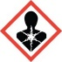
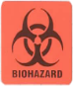
Route Administered______________________
Amount/Dose Administered________________
Date Cleared From Animal_________________ ^{(If Agent Clears)} Check Here if Agent Does Not Clear From Animal
PI________________ ACU Protocol______________
Note: The hazard information on this card must match Section 8 of your ACU protocol

