Cayuse 424
Presented by the UC Davis Sponsored Programs Office

Learning Objectives

By the end of this training, you will hopefully…
- Know the general proposal submission process
  - For some, this will be a refresher
- Know how to prepare and submit a proposal in Cayuse 424
- Know how to create and update a Professional Profile (in Cayuse 424)

Helpful resource: SPO Key Terms (abbreviations and definitions)

Use CTRL + Click on row below to jump to that section
Contents
Proposal Submission Process 3
Proposal Submission Process 3
Proposal Routing and Submission Timeline 4
Cayuse 424 4
Cayuse 424 hosts Professional Profiles 5
Cayuse 424 5
Cayuse 424 Proposals 6
Cayuse 424 Front Page 6
Opportunities Tab 6
Start a Proposal 8
Completing a Proposal 10
Completing a Proposal (1st page) 10
Completing a Proposal (bottom half of 1st page) 12
Completing a Proposal (2nd page) 14
Completing a Proposal (RR Performance Sites page) 19
Completing a Proposal (RR Other Project Information) 20
Completing a Proposal (RR Key Persons) 21
Completing a Proposal (RR Budget page 1) 25
Completing a Proposal (RR Budget page 3) 29
Completing a Proposal (Proposal Summary) 31
Completing a Proposal (Proposal Management) 32
Exiting a Proposal 34
Activity: Prepare a Proposal in Cayuse 424 35
Preparing a Subaward Proposal 47
Cayuse Professional Profiles 50
Professional Profiles Overview 50
How to Check a Professional Profile 50
Activity 2: Your Professional Profile 52
Permissions 53
Name Field 55
Degrees Field 55
Demographics Field 56
Biosketches & Institutional Association 56
Contact Info 57
eRA Role 57
Dept / Division / Title 58
Salary and Fringe Worksheet 58
Performance Site 59
Routing Profile 59
Resources 60
Contact Us 60
424 Resources 60
Common Acronyms 60
SPO Contacts & Links 61
SPO Office Hours & Training Opportunities 61
Research Administration Forum 61
Office of Research Listservs 61
UC Learning Center classes 62
Thank you! 62
Addendum 63
How to Pull Content from Cayuse SP to Paste into 424 63

Proposal Submission Process

Proposal Submission Process
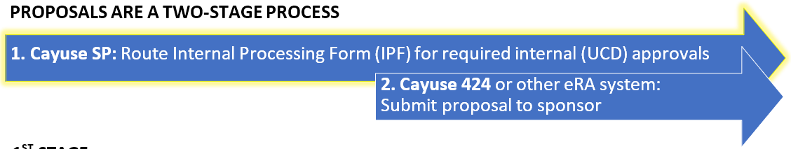
1ST STAGE:
All outgoing proposals must first be routed in Cayuse SP. Exceptions:
- Pre-proposals that do not require a budget, institutional signature or adherence to terms and conditions at the proposal stage
- Applications to internal programs (Academic Senate, Campus Research Initiatives, Limited Submissions)

PI (w/ dept assist) prepares and routes IPF with required attachments
- PIs and Co-PIs certify proposal
- Dept Head (Chair or Director) authorizes it
  - Dean’s Office too in Schools of Medicine and Veterinary Medicine
- Sponsored Programs Office (SPO) performs institutional review for regulatory compliance and adherence to UC policy
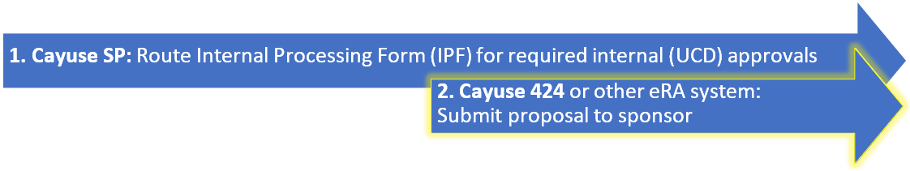
2ND STAGE:
The sponsor’s Funding Opportunity Announcement will indicate what eRA submission
system(s) may be used.
- Read the guidelines carefully and thoroughly
  - Follow links in document to agency-specific guidelines to ensure you are compliant with all requirements
- Some sponsors require submission by email or mail

PI (w/ dept assist) prepares proposal for submission to sponsor
- SPO reviews for campus & sponsor compliance
- In most cases, SPO submits proposal to sponsor

Proposal Routing and Submission Timeline

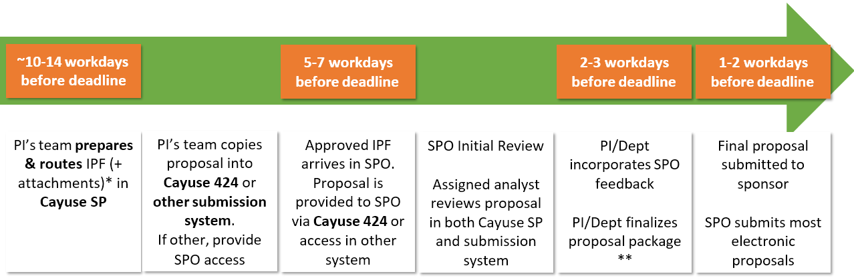

* Minimum attachments: Scope of work, budget, and budget justification. Other attachments may also be required.
- The scope of work can be a draft with the final version provided later.
- The PI’s team may work on other documents for submission, such as the project narrative or biosketches, until closer to the deadline.
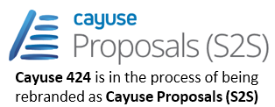
** This is when PI and their team should provide final attachments.

Cayuse 424

- If a sponsor’s guidelines allow submission through either Grants.gov or system-to-system (S2S), you must use Cayuse 424.
  - Cayuse 424 is linked system-to-system to Grants.gov, the submission system for most Federal agencies.


- Excluded from Cayuse 424:
  - NSF uses Research.gov
  - NASA uses NSPIRES

- Using Cayuse 424 speeds the review process.
  - It allows your assigned SPO analyst to access your proposal without you having to manually provide access in Grants.gov.
  - Professional and institutional profile information can auto-populate.
  - Allows multiple users to view the proposal simultaneously (while one person at a time edits).
  - Can copy proposals for resubmission, reducing data entry.
  - 424 stores documents relevant to the proposal, facilitating file search and communication.
  - 424 automatically integrates subaward budgets and personnel information with a prime proposal.

Cayuse 424 hosts Professional Profiles

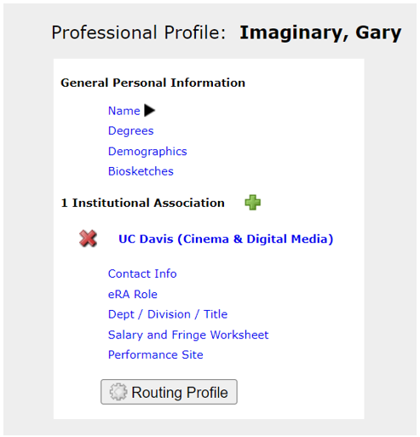
Professional Profiles contain salary, appointment, and unit affiliation for everyone in the Cayuse Research Suite.
- These details import into both Cayuse SP IPFs and Cayuse 424 proposals.

Professional Profiles will be covered in more detail later
in this training.

Cayuse 424



Information entered into a Cayuse SP IPF doesn’t automatically populate in a Cayuse 424 proposal.

While Cayuse SP appears to have an option to pair the two systems, this feature creates technical issues downstream. Do not pair proposals.
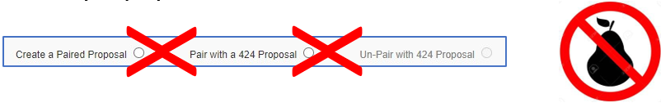
Instead, you will need to duplicate into 424 the content you put into SP.

Cayuse 424 Proposals

Cayuse 424 Front Page
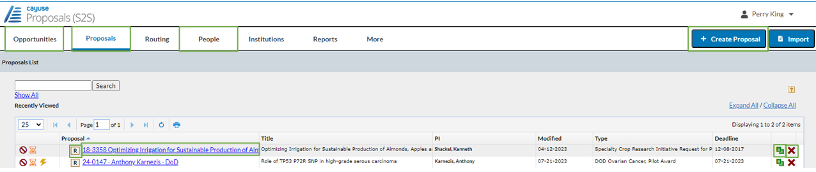

- Opportunities: Find a sponsor’s funding opportunity to begin your application
- + Create Proposal: Click here to prepare a proposal in which UC Davis is a subrecipient and the other institution uses Cayuse.
- Proposals: Find a proposal you or a PI have already created
- Select the Proposal name to edit
  - Select R to view as read-only. This will allow others to edit the proposal while you review it.
  - Select the green papers to copy the proposal or to transform it to a different funding opportunity.
  - Select the red X to delete the proposal
- People: Allows you to manage Professional Profiles

Opportunities Tab
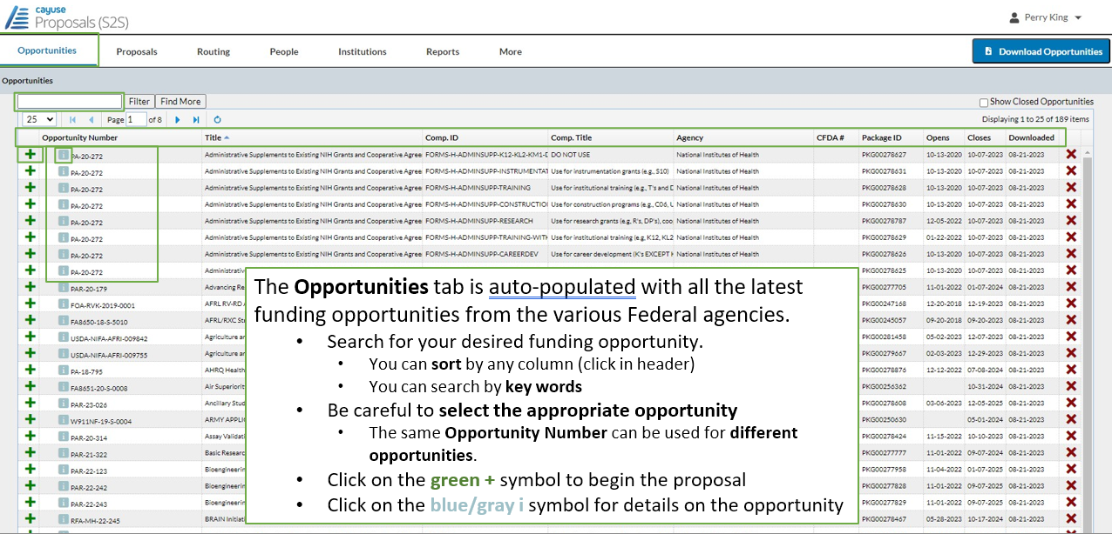
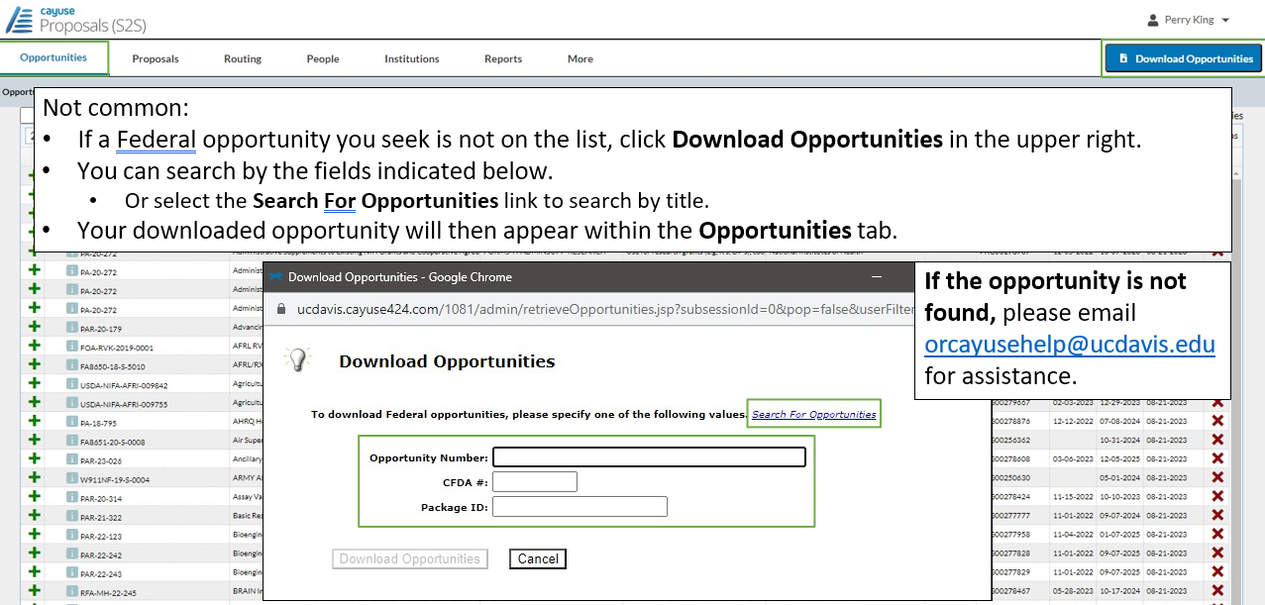
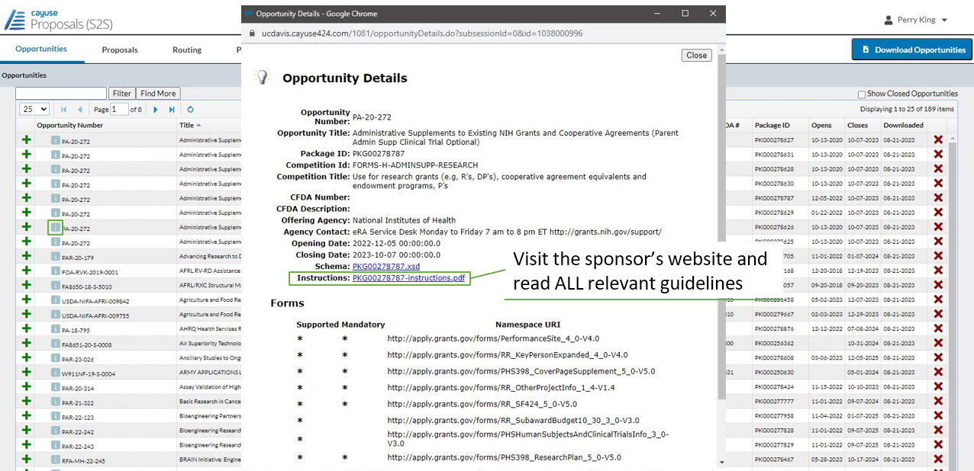

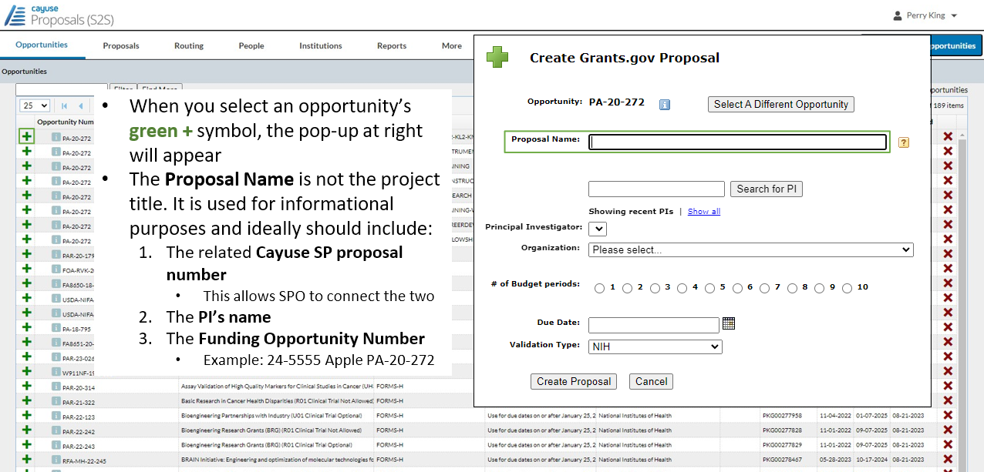
Start a Proposal

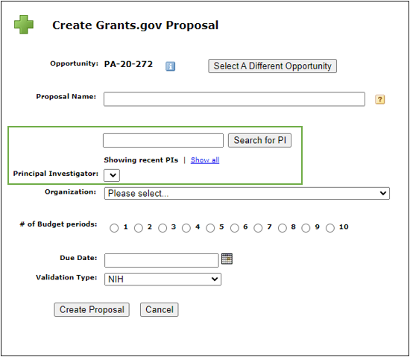
- Any investigators you recently added to a proposal will appear in a list at the Principal Investigator field.
  - If the PI’s name is listed, simply click on it.
- If the PI’s name is not listed:
  - Enter the PI’s last name in the empty search field.
  - Click Search for PI.
    - If the PI is not in Cayuse, email ORCayuseHelp@ucdavis.edu with the individual’s info:
      - Name
      - Kerberos username (if known; for many this differs from their UCD email address)
      - UCD email address
      - Dept
      - PI status - yes, they will be submitting as PI.

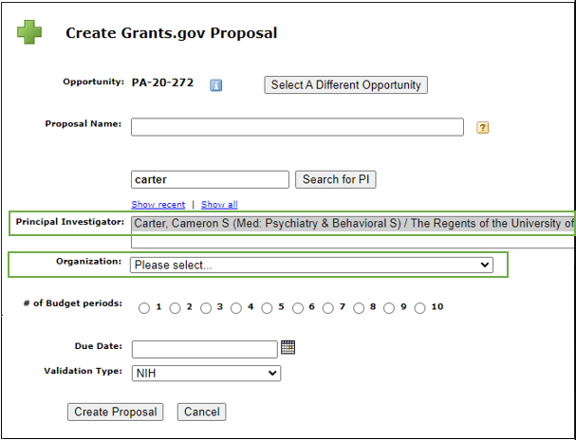
- Once the PI’s name appears in the Principal Investigator field, click it to select it.

- For Organization, search for and select The Regents of the University of California (Davis)
  - For some sponsors, this field will auto-populate when you select the PI.

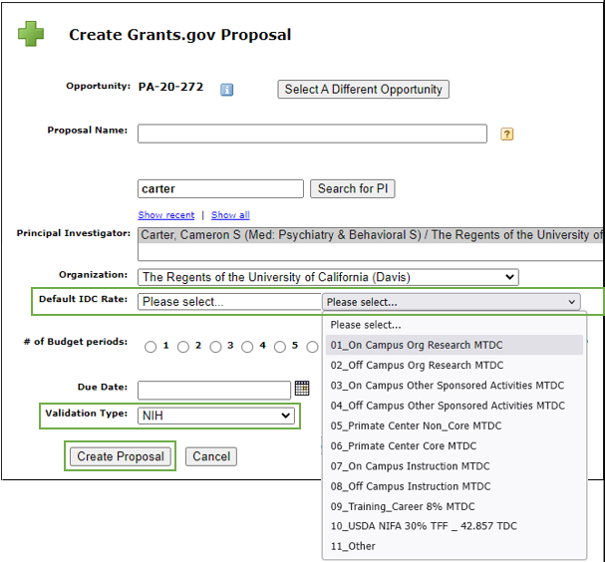
- For some sponsors, the Default IDC (Indirect Cost) Rate field will appear.
  - If unsure which rate to pick, a common one for research projects is On Campus Org Research MTDC
  - MTDC = Modified Total Direct Costs

- # of Budget periods: Select appropriate number for project.

- Due Date: Date due to sponsor.

- The Validation Type will usually autopopulate based on the opportunity you select.

- When ready, click Create Proposal to continue.
CGA page: On-Campus vs. Off-Campus F&A (Indirect Cost) Rates

Completing a Proposal
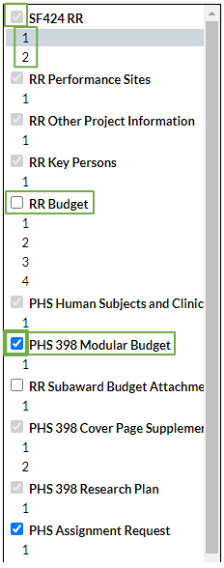
- As with Cayuse SP, you navigate through the various pages of the proposal in the left column.

- Each greyed out checkbox indicates an application form required by the sponsor.
        - Note that several forms are more than one page in length.
        - You can add optional forms to your proposal by adding a checkmark in the form’s empty box.

- For certain types of NIH funding opportunities, when the total direct costs being requested are $250,000 per year or less, NIH requires the applicant submit a simplified modular budget.
        - In these cases, as shown, add a check next to the (PHS 398) Modular Budget form and remove the check from RR Budget.
          - Complete the Modular Budget rather than the more detailed RR Budget

      - Note: the forms in the left column vary by sponsor/funding opportunity. This presentation will cover common forms.
        - For details on how to complete other forms, see the Cayuse 424 Handbook.

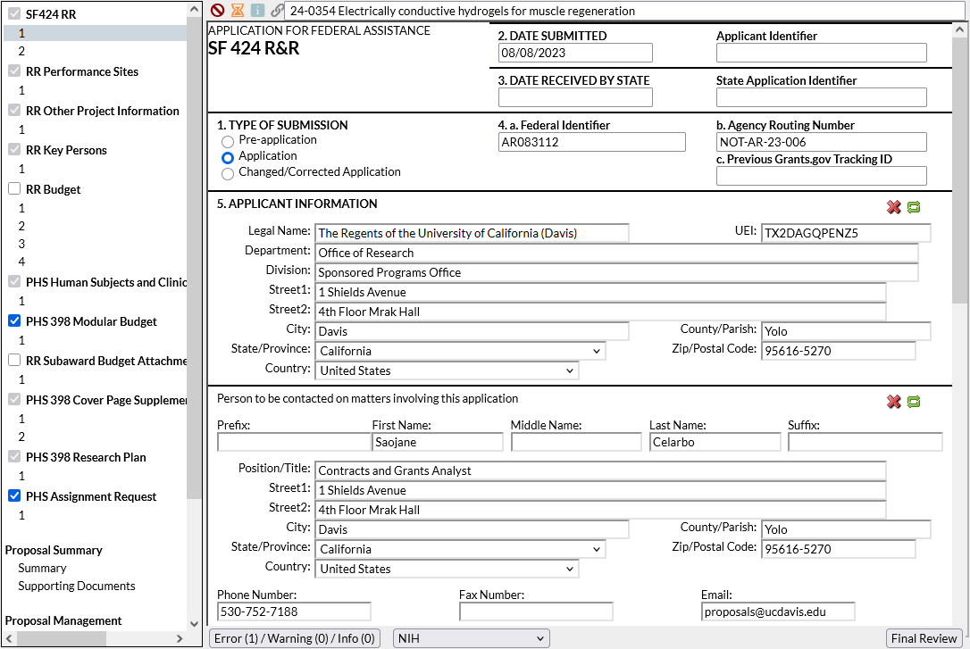
Completing a Proposal (1st page)
1. Type of Submission: Select appropriate entry

2., 3. and 4. Though it’s not obvious, for a new application there is nothing to add here.
- If #1. Type of Submission is Changed/Corrected Application because an original proposal submission had to be changed or corrected, in section 4.c. of the corrected proposal enter the previous Grants.gov Tracking ID # for the original (uncorrected) proposal.

5. Applicant Information: The university is the applicant - The Regents of the University of California (Davis)
- Address: 1 Shields Avenue, Davis, CA 95616-5270

The Unique Entity Identifier (UEI) is found on the UC Davis Institutional Information page.
- This is a good page to bookmark

Person to be contacted on matters involving this application: Enter your assigned SPO Proposals Analyst.
- If the IPF is still routing in Cayuse SP and an analyst isn’t yet assigned, enter what you can and add the name later.
- If fields are all greyed out, click the pencil icon in the top right of this section to autofill from a Cayuse Professional Profile
- Best email to use here: proposals@ucdavis.edu

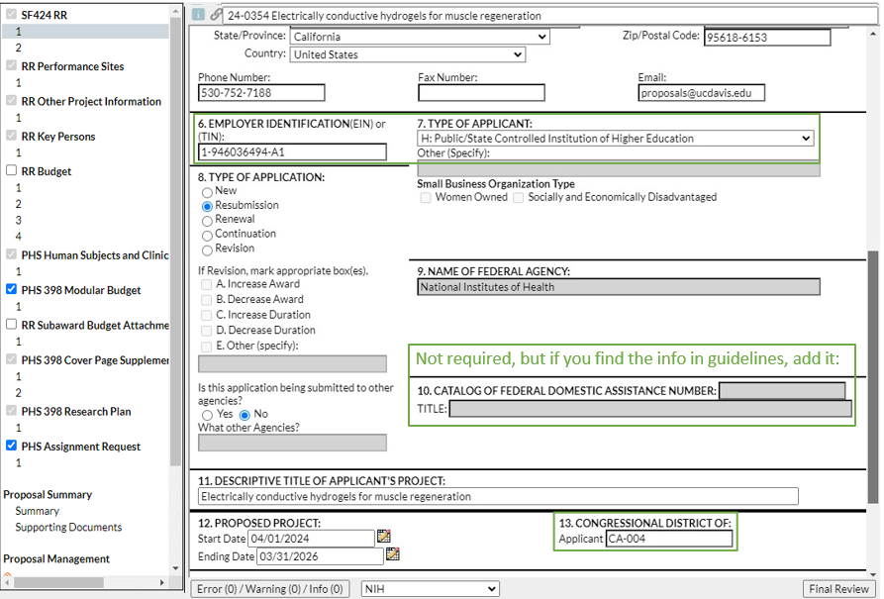
Completing a Proposal (bottom half of 1st page)

Again, use the Institutional Information page to populate:
6. EIN/TIN
13. Congressional District

7. Type of Applicant: UC Davis is a “Public/State Controlled Institution of Higher Education.”

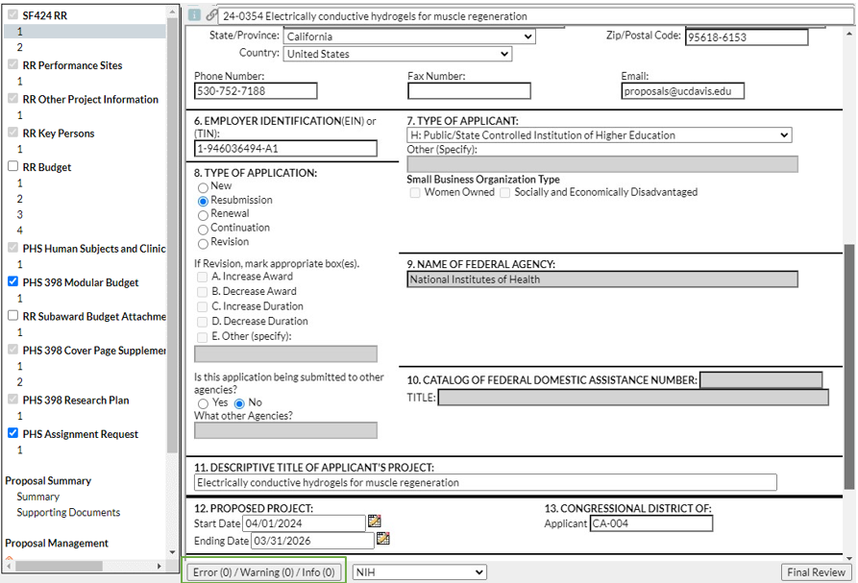
At the bottom of the form is a box that shows errors and warnings.
- Click on it to see errors and warnings that may prevent a successful proposal submission.
  - Links take you to the indicated error/warning for correction.

- Some errors or warnings may be “false” errors based on a standard sponsor application and not your specific funding opportunity.
  - Please check with your SPO analyst if you have any questions as to whether a particular error or warning can be ignored.

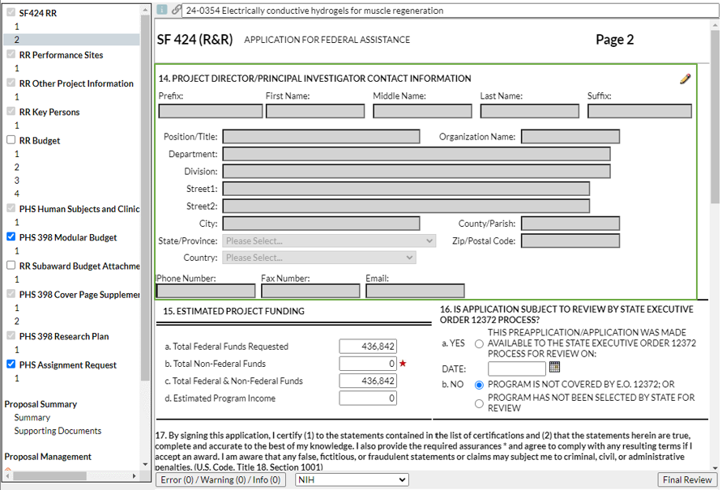
Completing a Proposal (2nd page)

14. Project Director/PI

Select the pencil icon to auto-populate this section from the PD’s/PI’s Professional Profile (in Cayuse 424).

Note: You can either add the PD/PI here or to the RR Key Persons form. Populating either will populate both.

You can manually update auto-populated fields as needed.

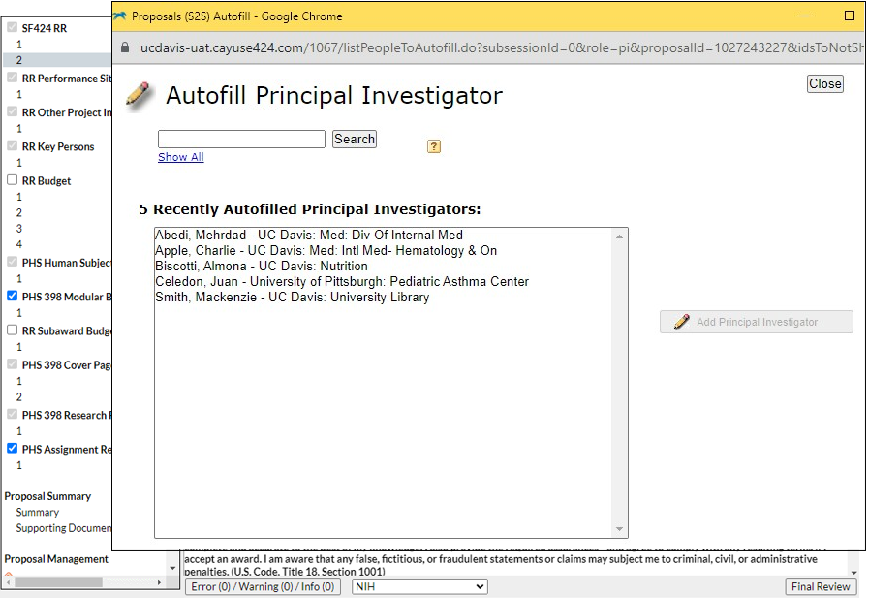
14. Project Director/PI

After you select the pencil icon, either search for the PI (by last name) or select from a list of recently autofilled PIs.

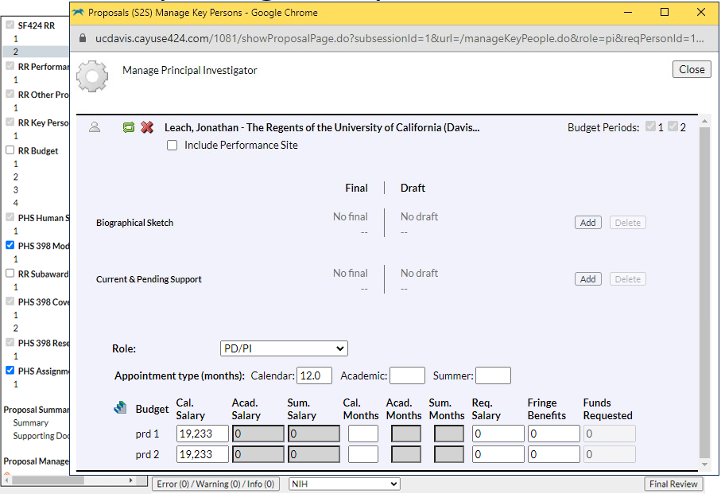
14. Project Director/PI

You then have the following options:
- Include Performance Site (autopopulated from Professional Profile)
- Change Role, though you rarely do this for the PD/PI. Other options:
  - Co-PD/PI
  - Other Senior Personnel
- Revise their (autopopulated) appointment type, salary, and effort.
  - Effort: enter portion of calendar, academic or summer months they will dedicate to the project.

Important:
The automatic salary and fringe totals in Cayuse 424 always need to be overridden manually.
- They don’t use any split rate fringe and rarely match the internal budget.

Update these figures as needed to match the internal budget.

If you overwrite an auto-calculated value, a red star will appear. 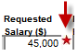

Use caution when overwriting calculated fields.
- Overwritten values will not update when you update related fields.
  - This can cause final values to be wrong.
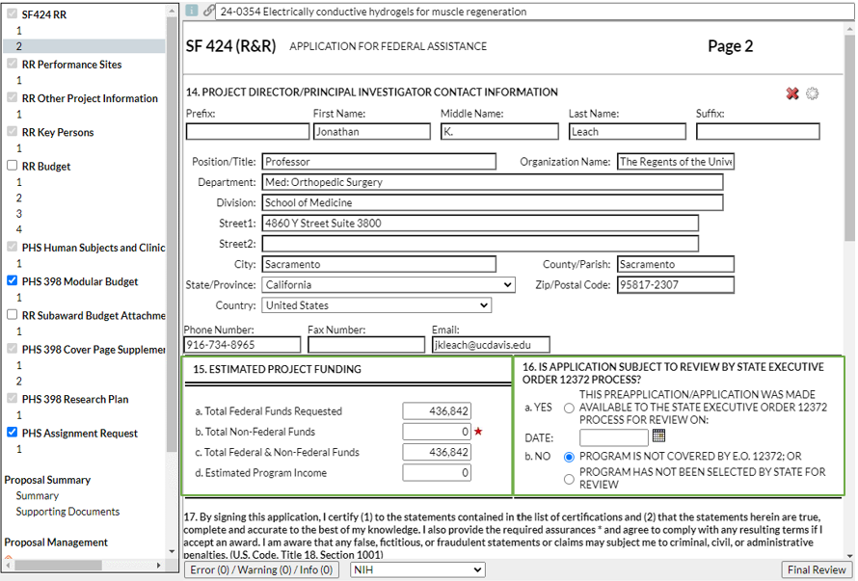
- To return a red star field to its auto-calculated value, delete your manual entry.

15. Estimated Project Funding: There is no need to populate the budget figures here, as these fields are auto-
populated when you complete the RR Budget pages.

16. State Exec Order 12372: Check sponsor guidelines for answer.
- Example: the NIH SF424 (R&R) Application Guide reads “Applicants should check ‘No, Program is not covered by E.O. 12372.’”

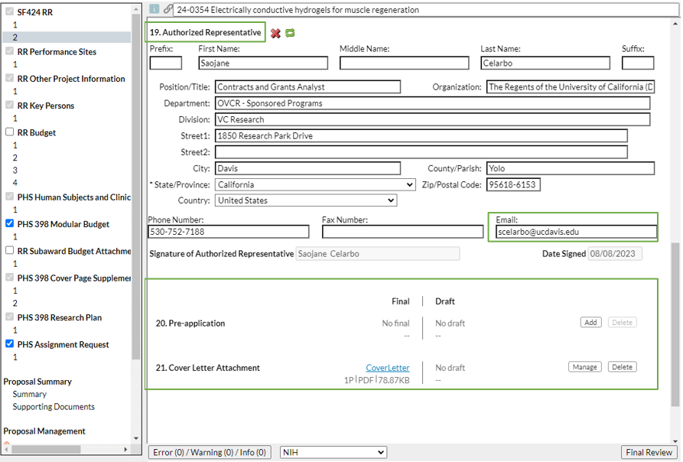
19. Authorized Representative: Again, enter your assigned SPO analyst.
- Good email to use here: your SPO analyst’s direct email.

Attachments in Cayuse 424:
- PDFs are generally preferred.
  - Check sponsor guidelines to make sure non-PDFs are allowed and/or requested.
    - NIH, for instance, only allows PDFs, but some sponsors may request a Powerpoint or Excel.

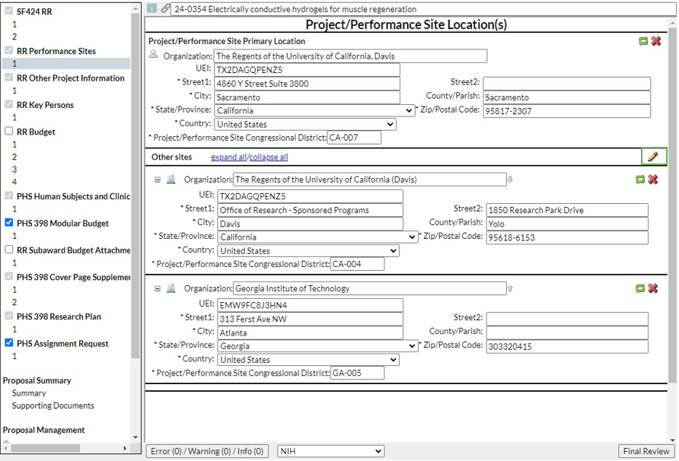
Completing a Proposal (RR Performance Sites page)

Enter the location(s) where project work will be performed.

Click the pencil icon to add or remove Performance Sites.

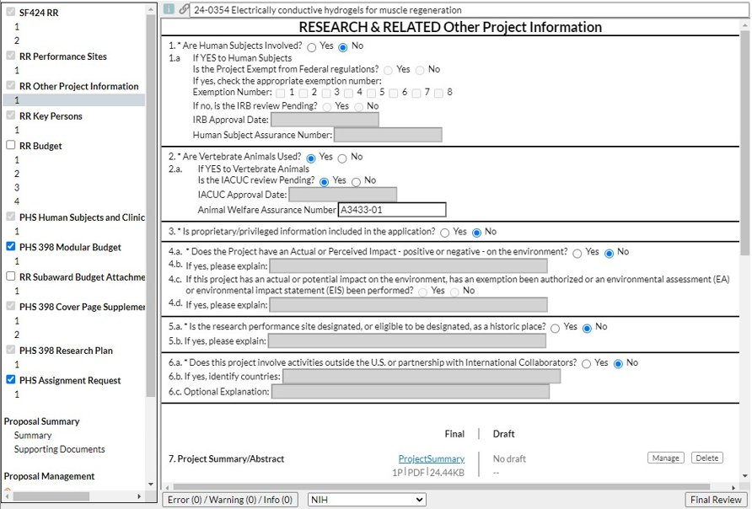
Completing a Proposal (RR Other Project Information)

The PI should have the answers to these questions.

If human or animal subjects are involved and no IRB/IACUC review is pending, the protocols should be submitted for review to ensure they are in place should the proposal be awarded.

There are fields at the bottom of this page to attach a range of documents.

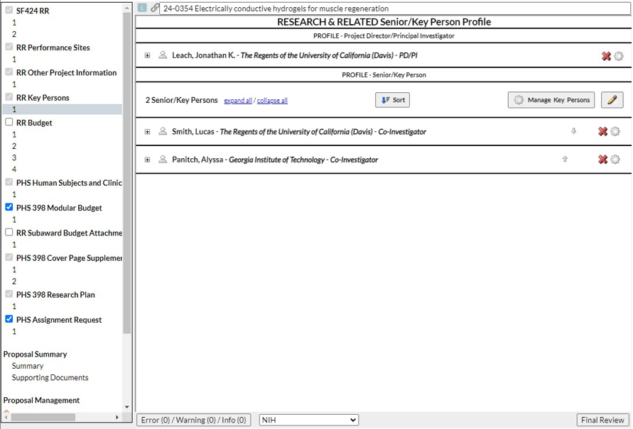
Completing a Proposal (RR Key Persons)

As mentioned before, a PI added earlier will show up here.

Click the pencil icon to add additional Co-PIs or Senior Personnel.

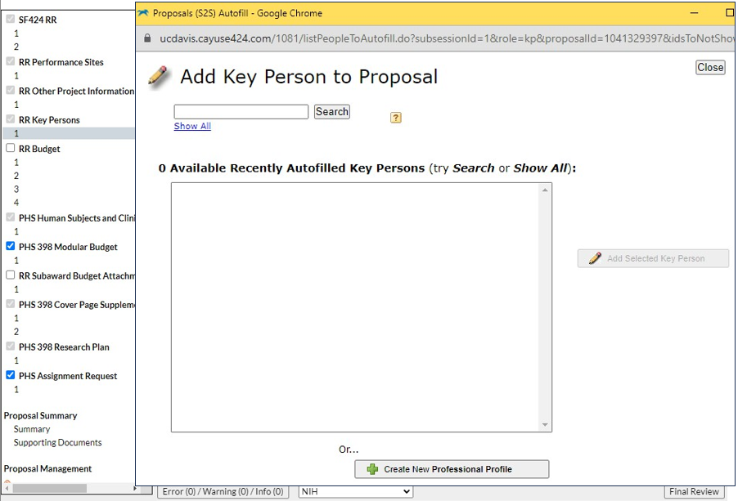
This stage is similar to adding a PD/PI.

At bottom is an option to Create New Professional Profile. Only do this for personnel who are NOT at UC Davis.

To request a Professional Profile for someone at UC Davis, write ORCayuseHelp@ucdavis.edu.
- We’ll cover in later slides what info you should provide.

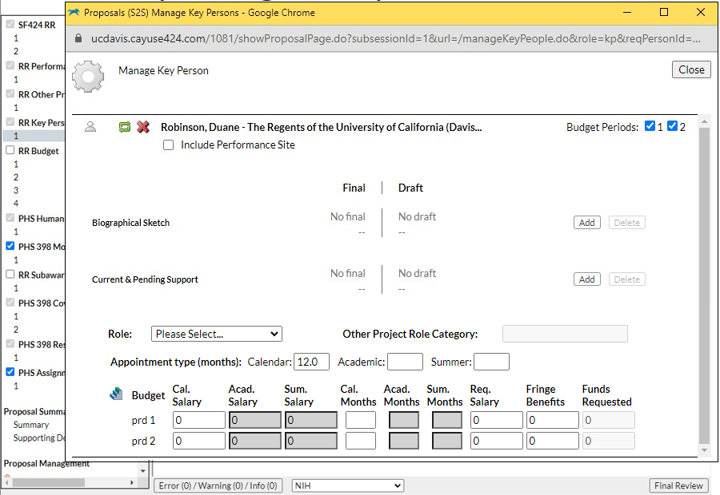
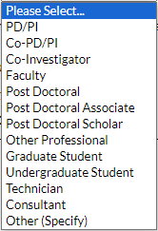
You can make the same edits as for a PD/PI, and additionally select which Budget Periods this key person will participate in.

Role: There are far more options here than for the PD/PI:

- For NIH: Do not select Other Professional

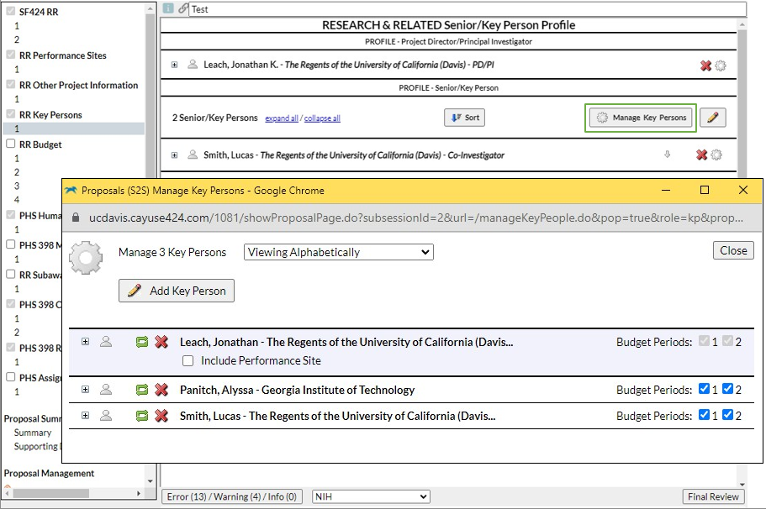
To edit effort for personnel already added to the proposal, select Manage Key Persons.

These are available options:




(Re)visit effort screen

Visit Professional Profile

Re-autofill from Profile

Remove from proposal

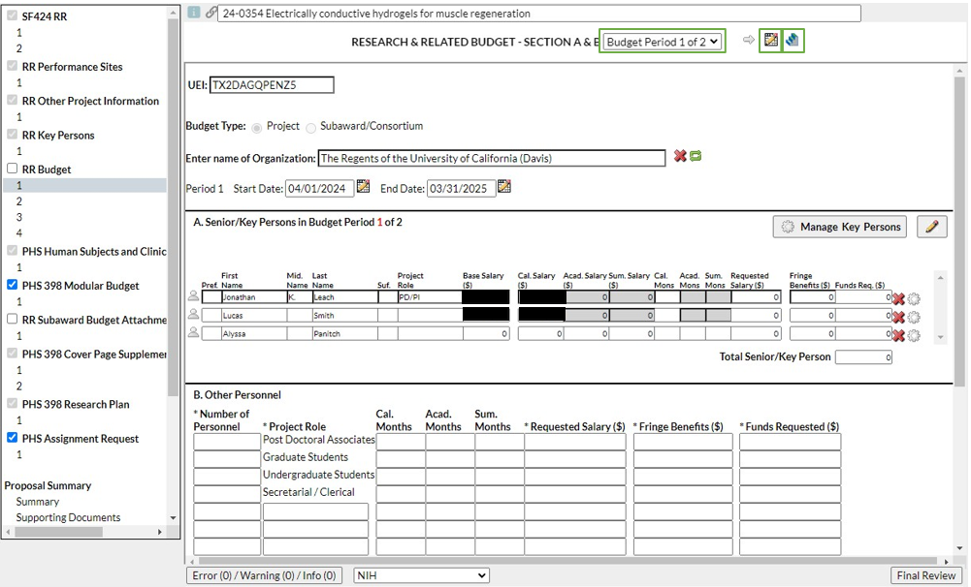
Completing a Proposal (RR Budget page 1)

RR Budget:
- Note that the budget page is for the first budget period only.
  - You have to select Budget Period 2 of 2 or the grey arrow icon to make entries for the 2nd budget period.

Budget Period Editor: Add/delete/change budget periods

Stair icon: Once you populate Budget Period 1, use this to replicate your entries into future budget
periods or to add escalations.

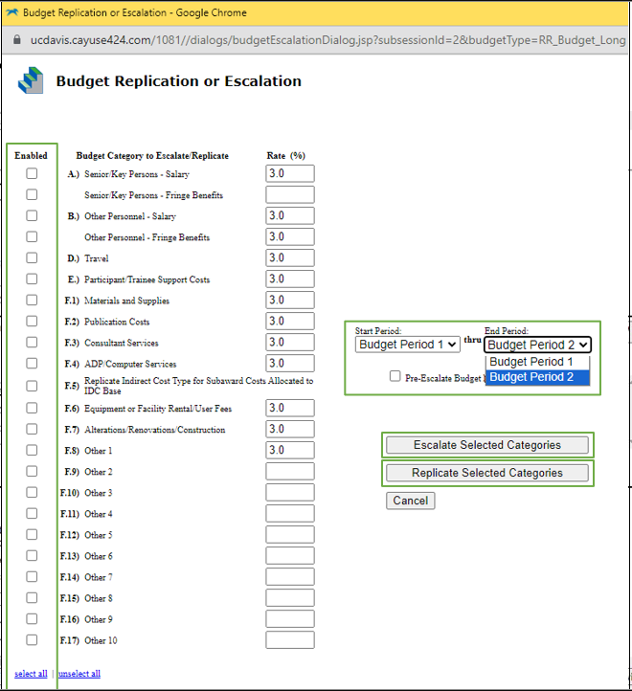
To replicate one budget period to others:
- Select categories to be replicated
- Can select all
- Select End Period
- Can replicate to the next period or all project periods
- Click Replicate Selected Categories.

To escalate budget periods is similar:
- Select categories to be escalated
- Select End Period
- Click Escalate Selected Categories.

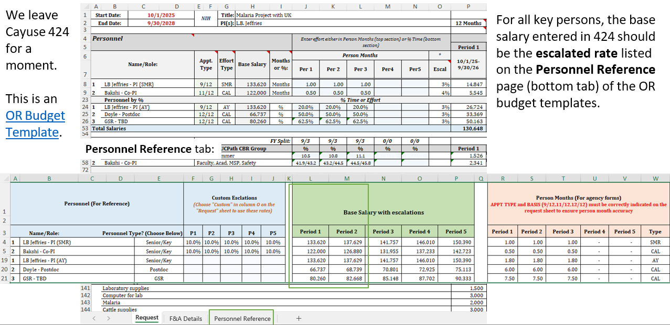
Important: For 9/12 or 11/12 faculty, the base salary should not include the summer. The federal government does not include summer in its base salary. Workaround:
- In Cayuse 424, the base salary should be copied to either the Acad Salary or Sum Salary field to avoid warnings. Example:

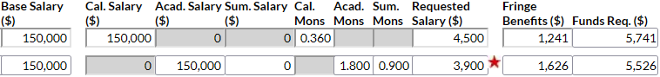

Complete the Acad. Mons and/or Sum. Mons fields with the individual’s effort, then manually enter Requested Salary and Fringe Benefits to match the internal budget.
  - As noted earlier, the automatic salary and fringe totals in Cayuse 424 always need to be overridden manually.

Note: The three fields in the green box do not go to the sponsor (they are internal fields).

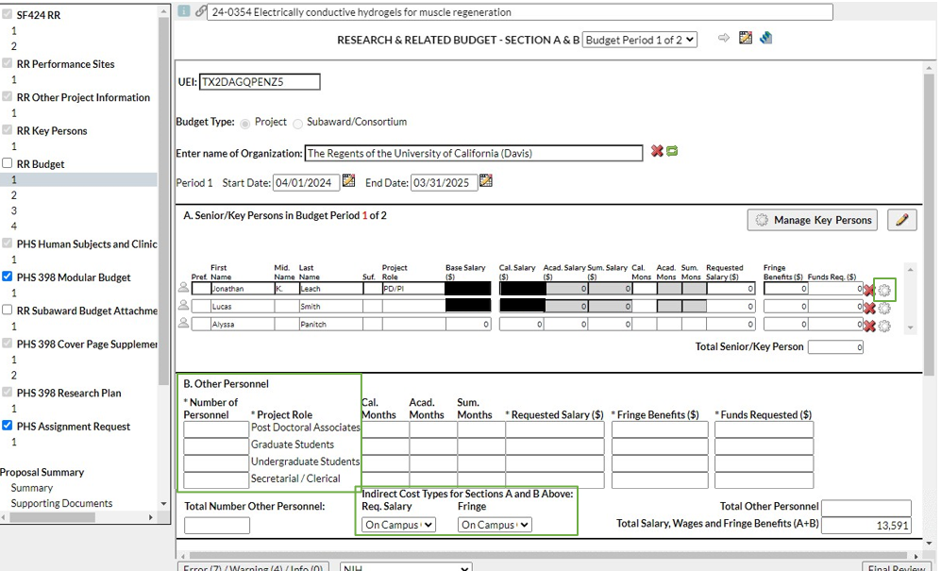
To revise an individual’s effort here in the budget, click the gear icon  above.

For Other Personnel add a total number for each role rather than list individuals.

As you go through the budget, be sure to select the correct Indirect Cost Type for each section.
- Common: On Campus Org Research MTDC

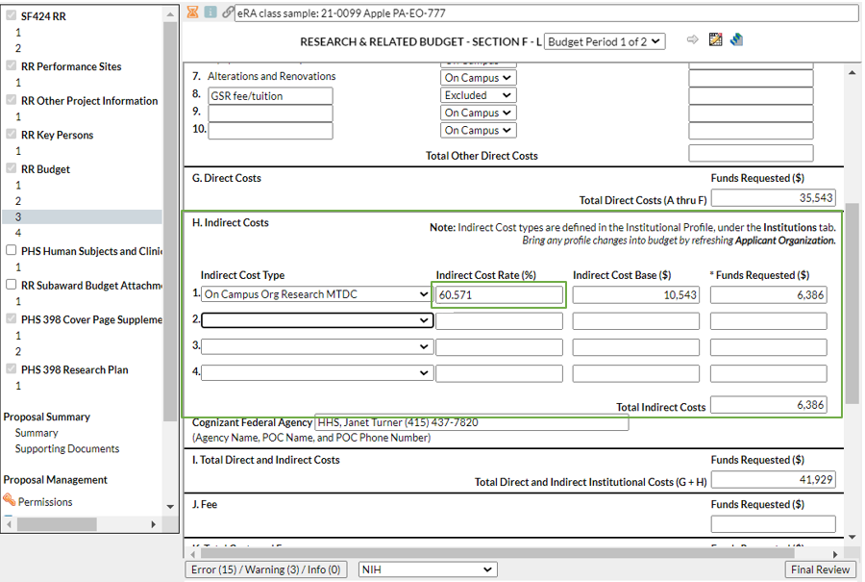
Completing a Proposal (RR Budget page 3)

You may need to update split rates for indirect costs:

- Cayuse 424 automatically combines split rates into an average for the budget period.
  - In this example, 60% for the 1st part of the budget period was combined with 61% for the 2nd part for an average of 60.571%.

- Many sponsors do not allow average rates.

- Instead, you should identify the Indirect Cost Base for each of the two rates.

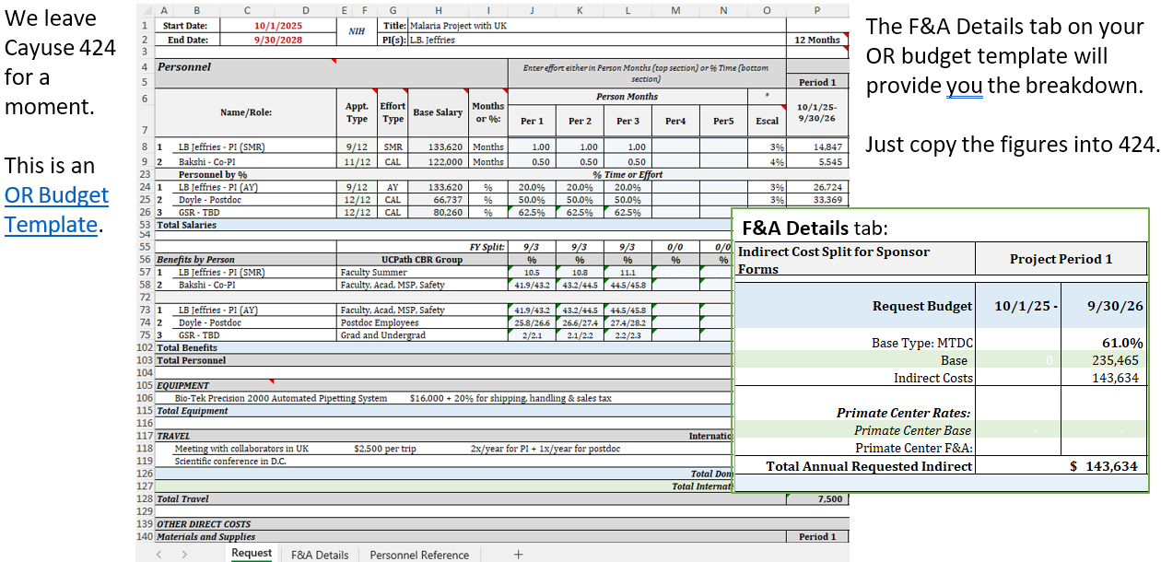
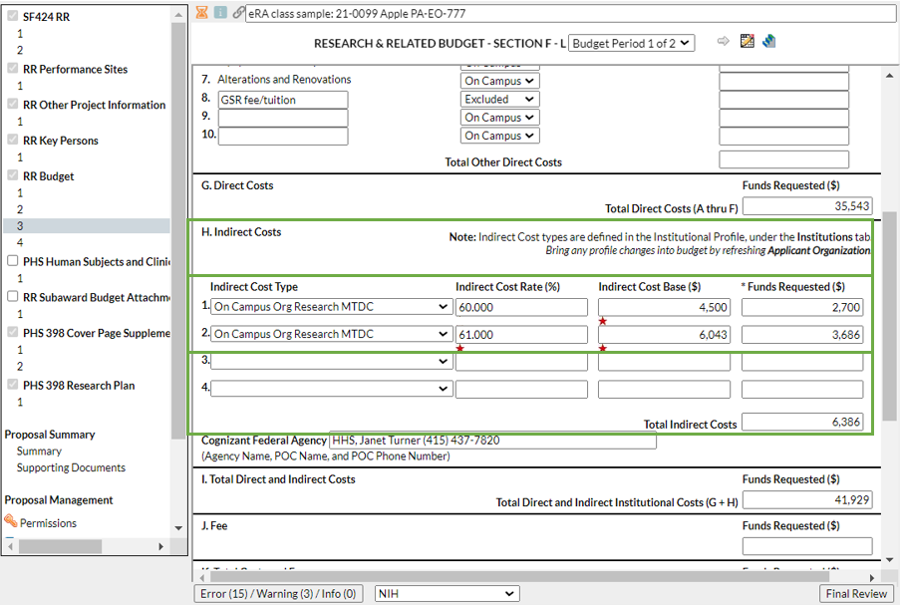

When working with split rates:

Populate the first line with the 1st indirect cost rate and base, then create a second line with the 2nd rate and base.

Be sure the Total Indirect Costs matches the internal budget.

Completing a Proposal (Proposal Summary)

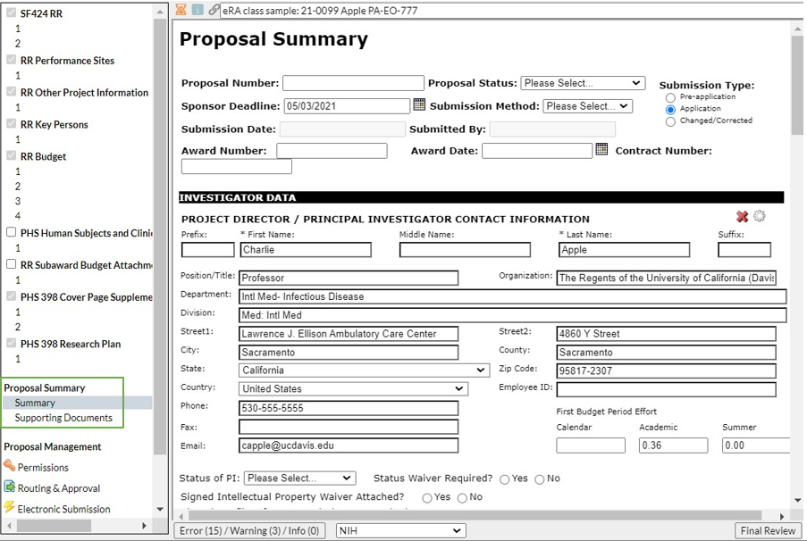

Ignore the Proposal Summary.

It is not needed and can cause unnecessary confusion.

Completing a Proposal (Proposal Management)
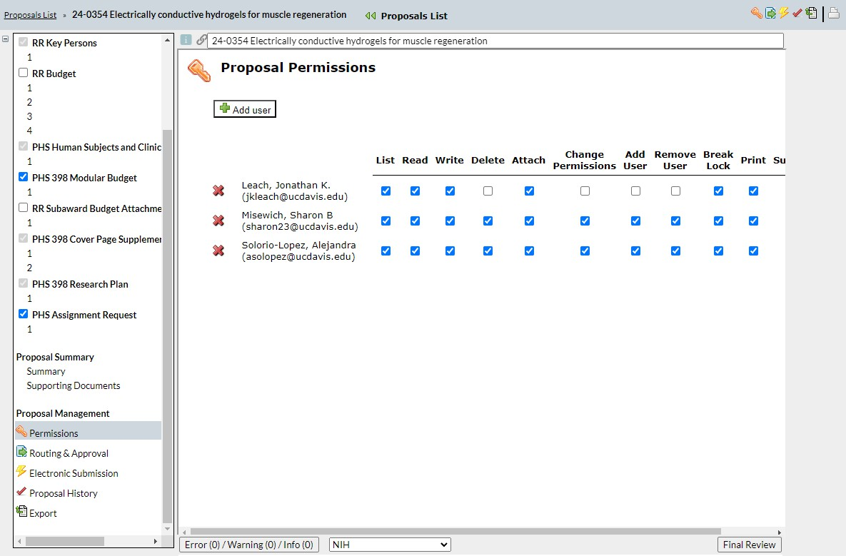

Proposal Management icons are found both at the bottom of the left column and in the top toolbar.
- With the Permissions icon, you can manage user access and permissions for this proposal.

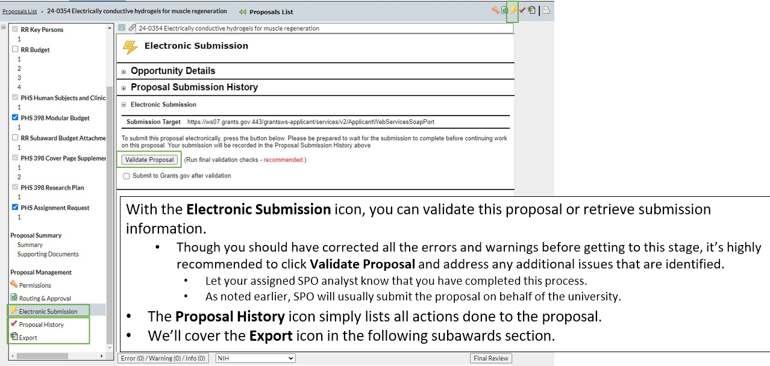
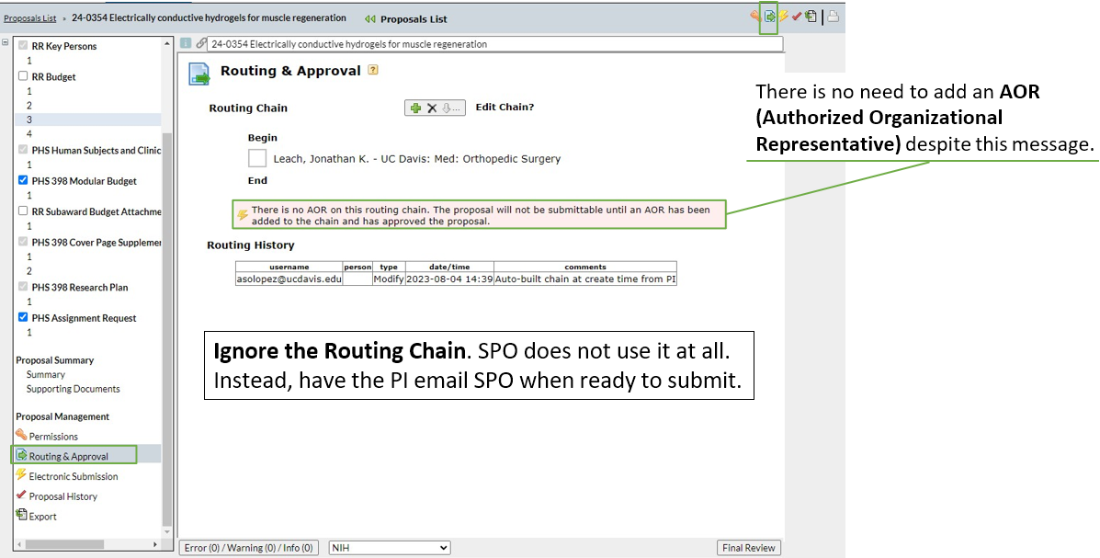

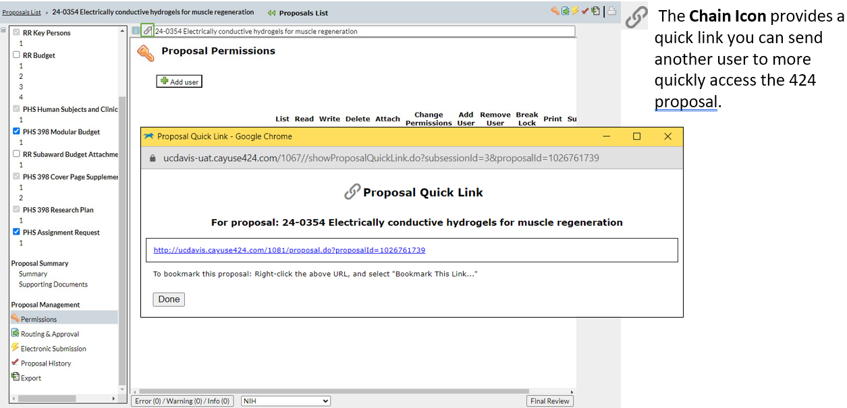

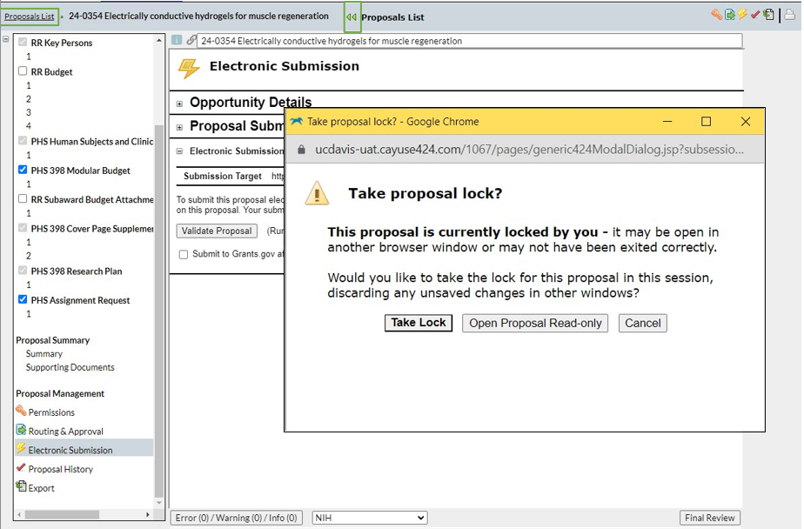
Exiting a Proposal

Always use the green arrows or the Proposal List link to exit an application to avoid locking it.

If locked, you will be asked Take proposal lock?

Do this only if you know someone is not possibly in the document and editing it at this time.

Activity: Prepare a Proposal in Cayuse 424
If you’re unable to access the UAT:
- Use actual Cayuse 424 (https://ucdavis.cayuse424.com/)
- Search for Opportunity: PA-20-272 (for R’s)
- Proposal Name: 25-5555 Carter PA-20-272 (for training purposes)
- PI: Cameron Carter & Co-PI: Jeff Gibeling (you’ll need to overwrite auto-populated salary/fringe)
- Login to Cayuse “sandbox” (UAT): https://ucdavis-uat.cayuse424.com
  - Username: amieadmin Password: training

- Select Cayuse 424
- Search for Opportunity: PA-HO-777 for R01 [NIH]
- Select the green + symbol to begin proposal
  - Scenario details on next screen

- Helpful link: Institutional Information
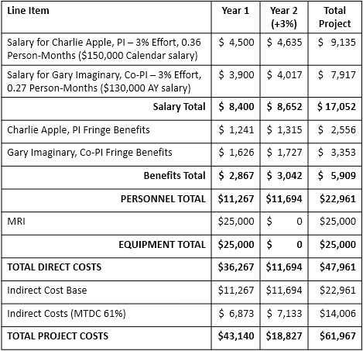
RFA: PA-HO-777 R01 [NIH]
Proposal Name: Cayuse SP Proposal # [use 25-5555] Apple PA- HO-777 R01
Project Title: Socio-ecological factors in Malaria transmission
Sponsor Deadline: 1/7/25 (5pm local time)
Project Dates: 5/1/2025 – 4/30/2027
Applicant Info: The Regents of the University of California (Davis)* Sponsored Programs Office, 1 Shields Ave. Davis, CA 95616-5270
Person to be Contacted/Authorized Representative: SPO Proposal Analyst Amie Admin.
1 Shields Ave. Davis, CA 95616-5270.
530-574-5555 proposals@ucdavis.edu & aadmin@ucdavis.edu
Location of activity: Lawrence J. Ellison Ambulatory Care Center 4860 Y St., Sacramento, CA 95817-2307
IRB Application #: 00004557, approved 10/10/24
IACUC Protocol: A3433-01, approved 11/1/24 (bovine)
Other Project Info & Cover Page Supplement questions: Assume you need to check with PI

* Full legal name is actually The Regents of the University of California, on behalf of its Davis campus

Answers:
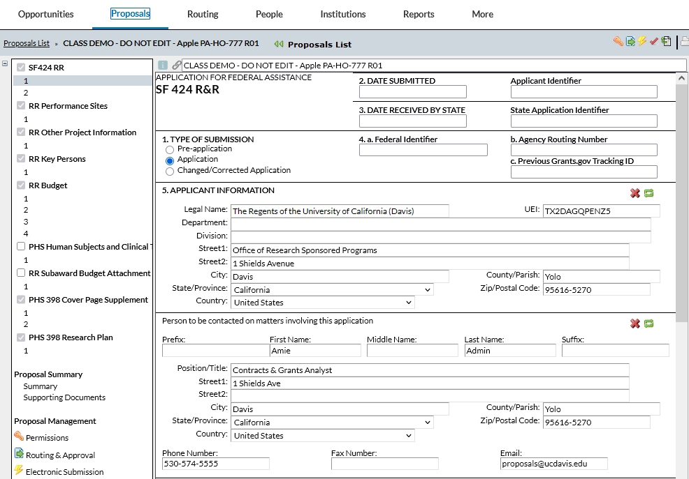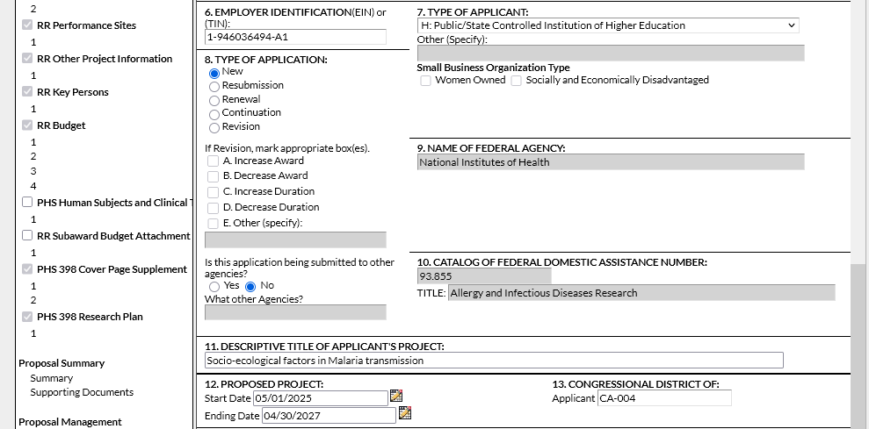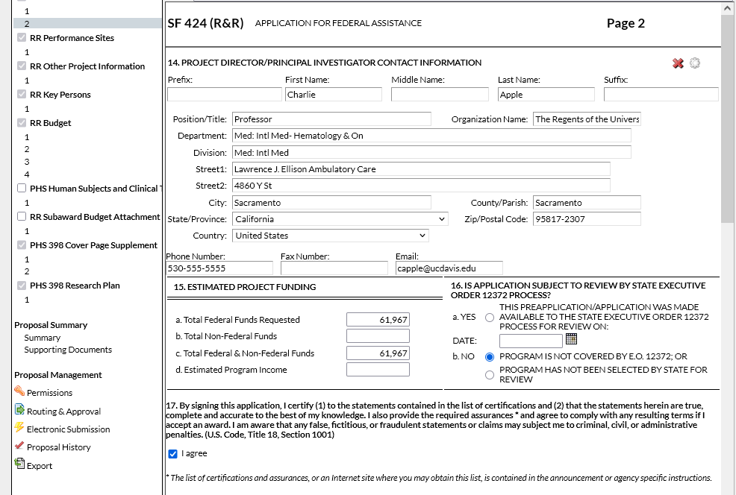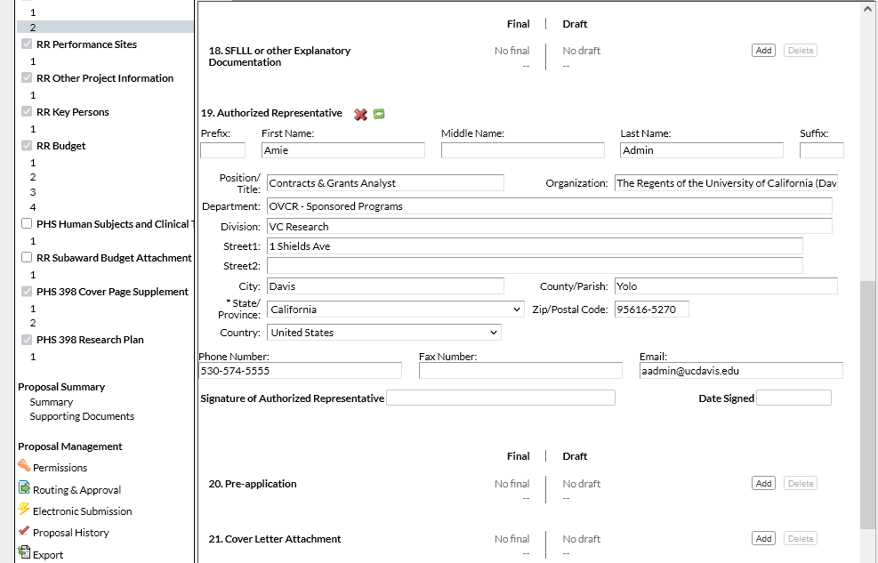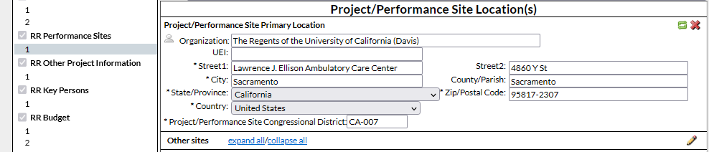

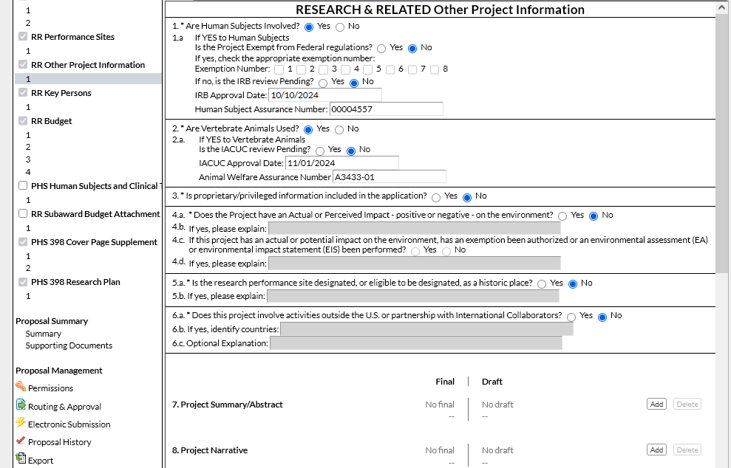
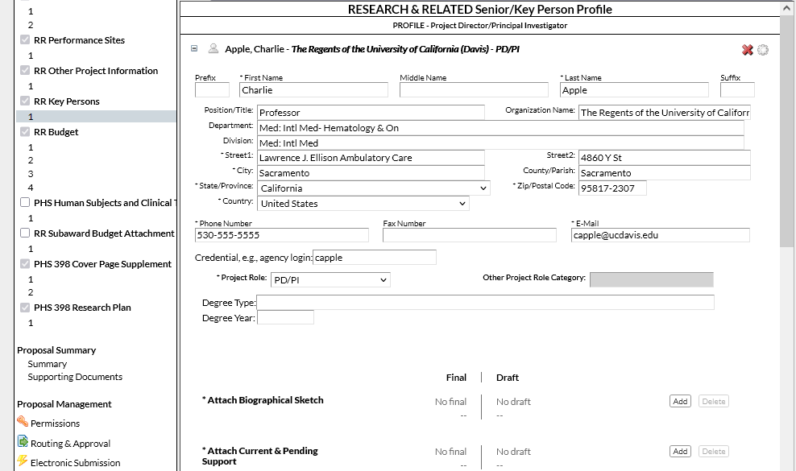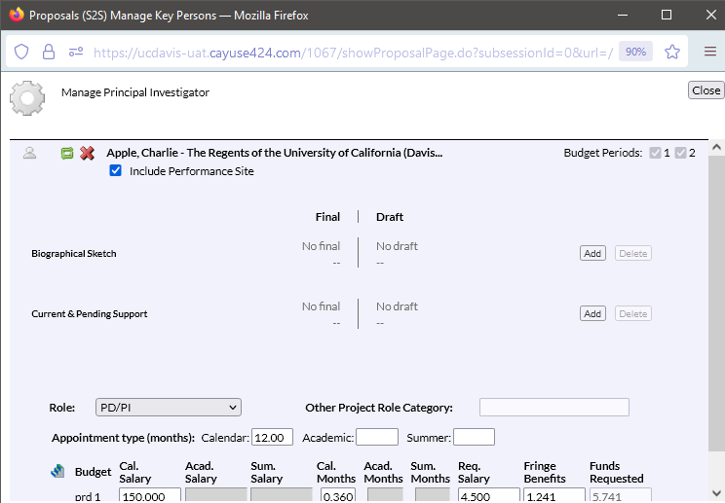
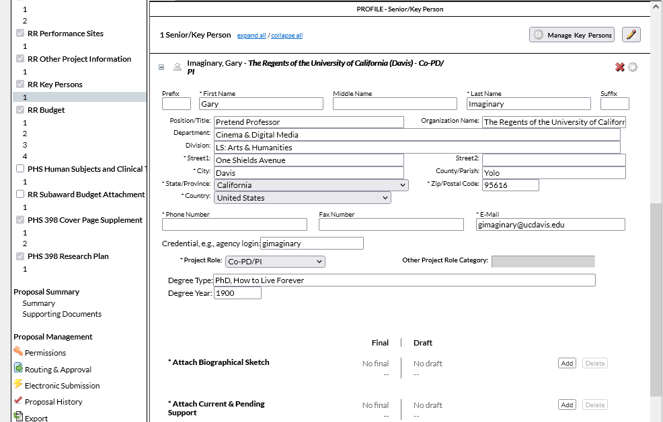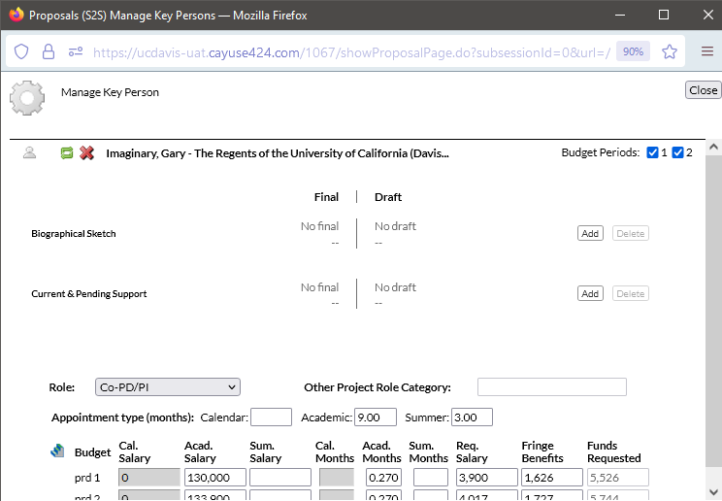
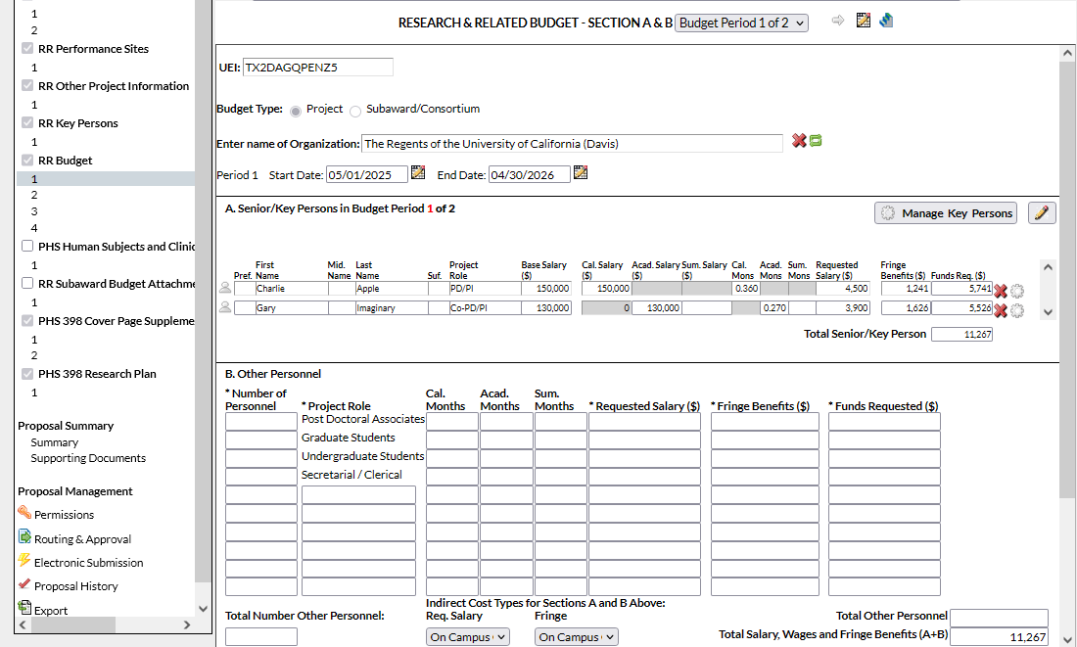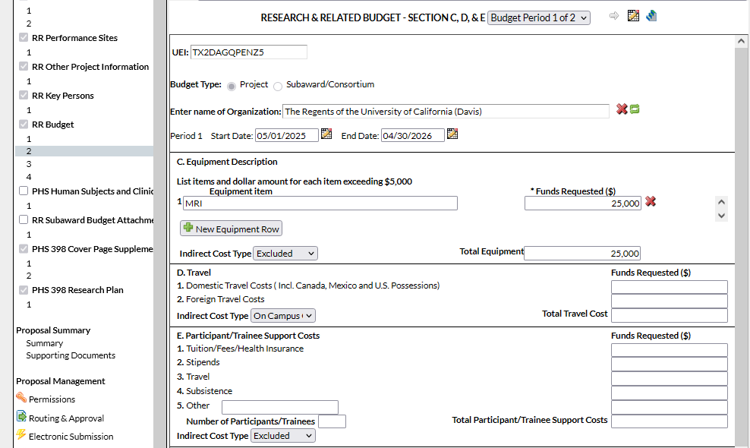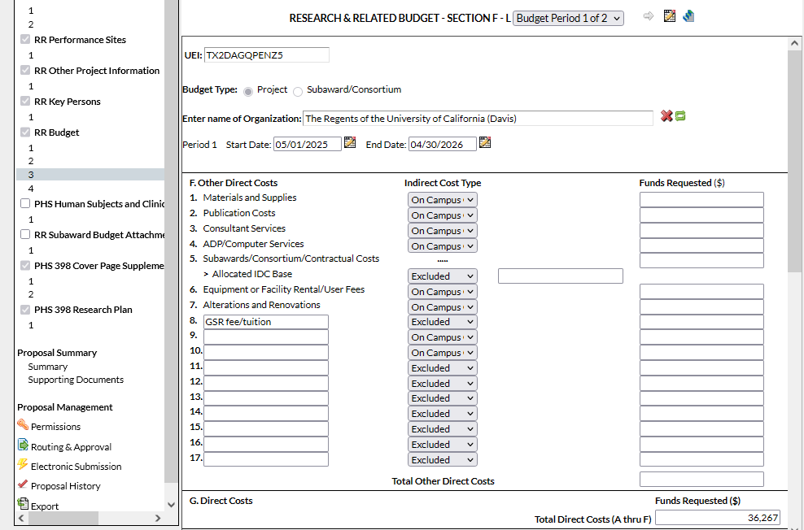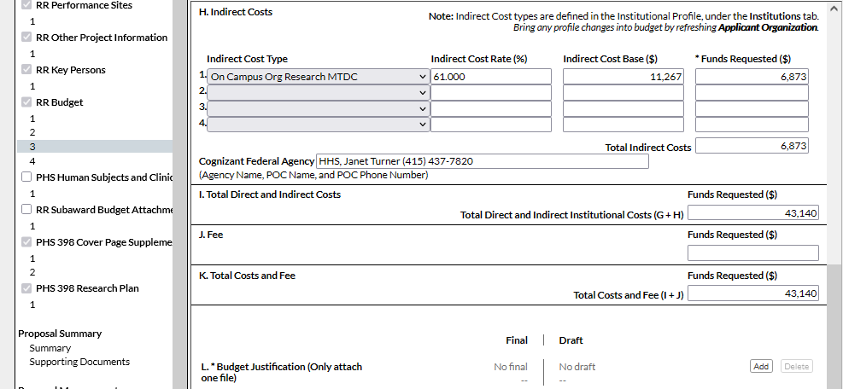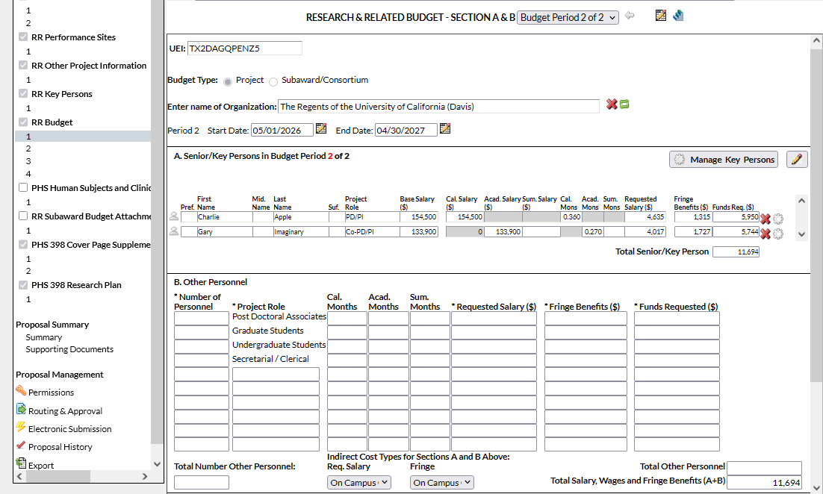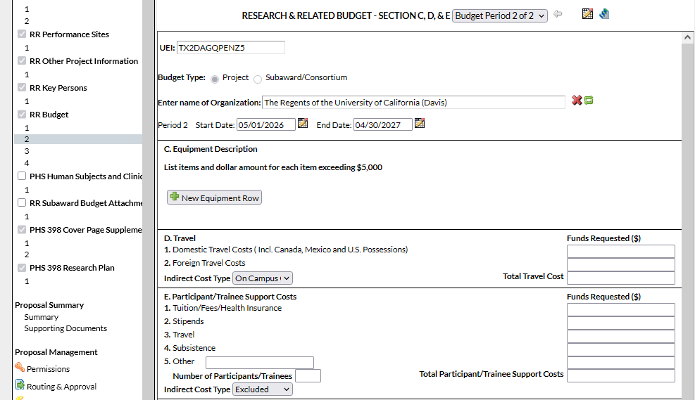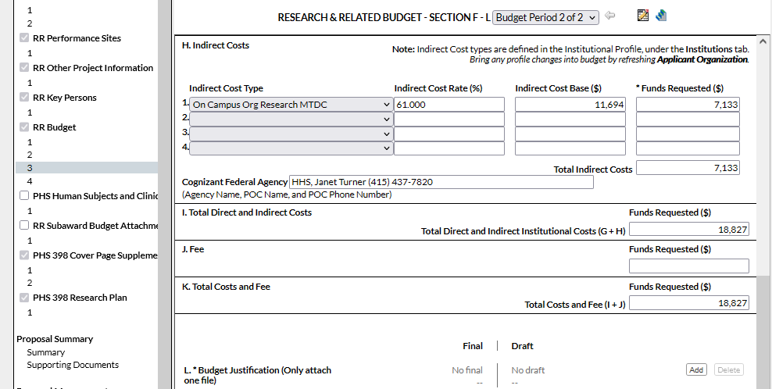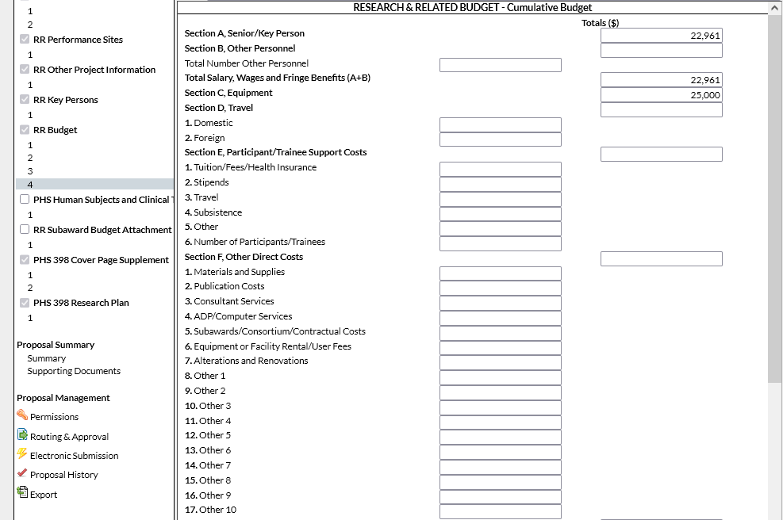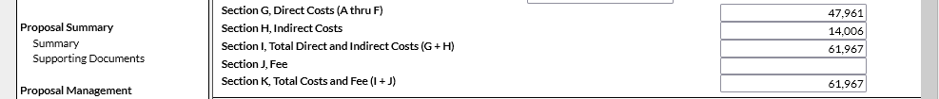
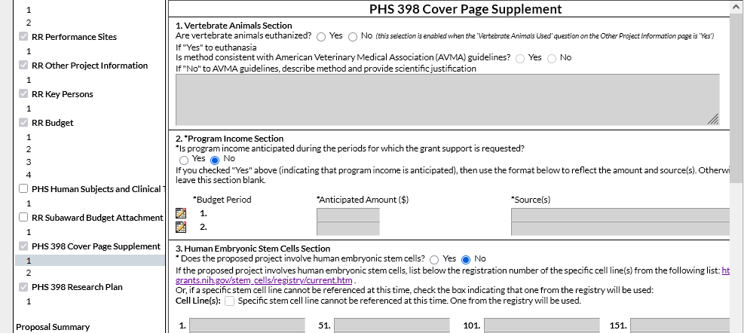

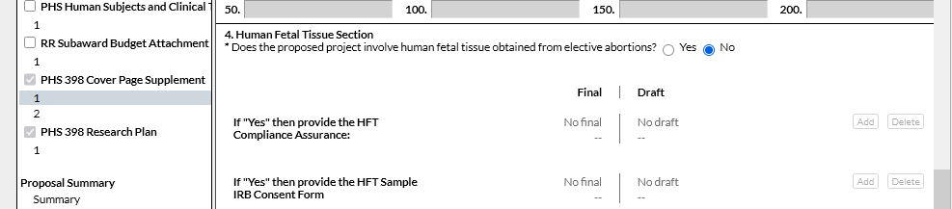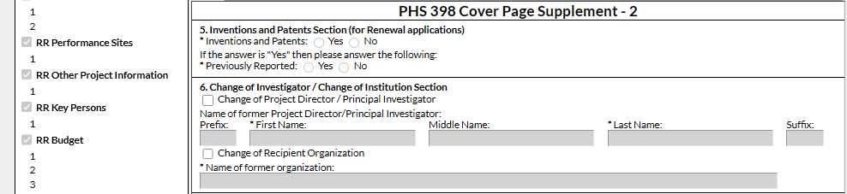
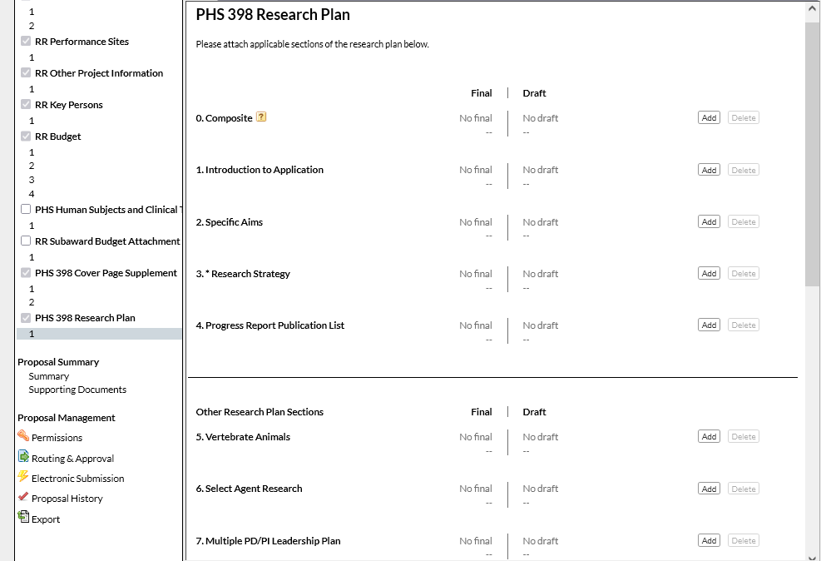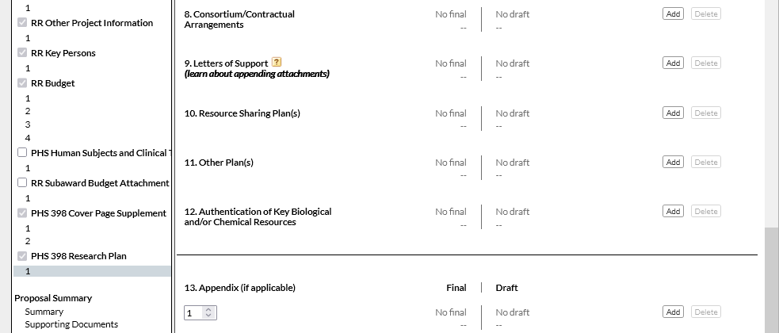

Preparing a Subaward Proposal
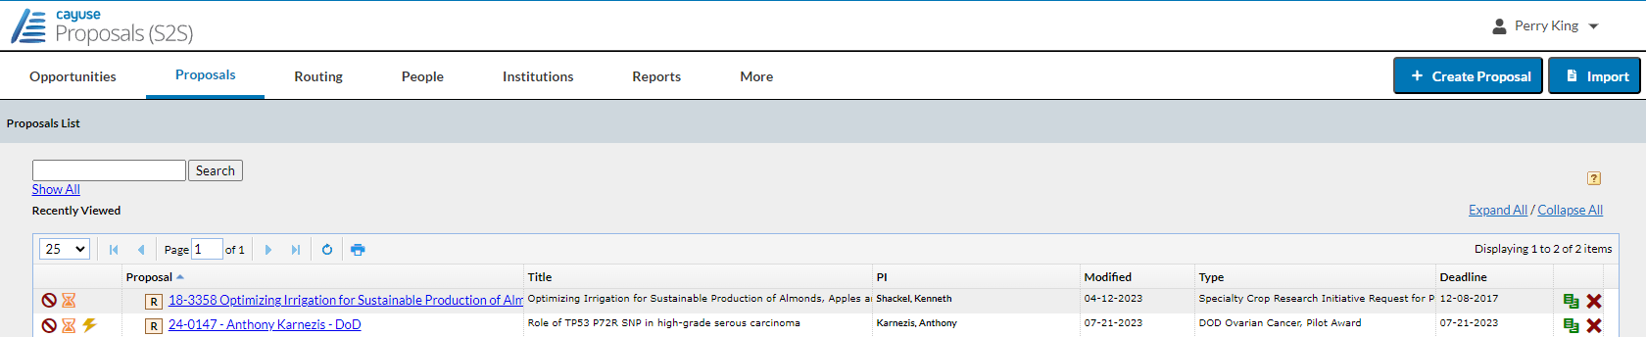

As described earlier, when UC Davis is a subrecipient on another institution’s proposal, start the subaward proposal by clicking + Create Proposal.
- The reason for this is that the prospective subaward will not be found under Opportunities.
  - Opportunities lists Federal public funding announcements.

When you click + Create Proposal, this pop-up will appear.
- Select either Research Subaward Proposal or Training Subaward Proposal, then click Create.

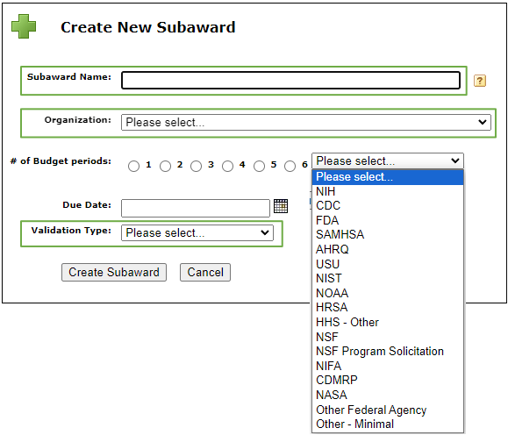
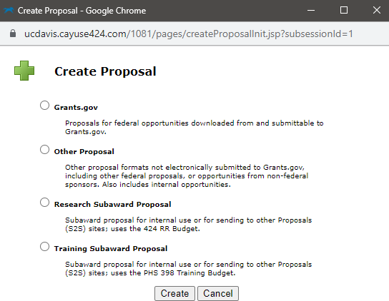
The next pop-up to appear is similar to the one you see when you start a proposal from the Opportunities list.
- Subaward Name: In addition to items already suggested for Proposal Name, add the prime sponsor.
  - Example: 24-5555 Apple UCLA NIH
- Organization: Select the organization from a list.
  - If your organization is not yet listed, leave it blank and email
ORCayuseHelp@ucdavis.edu to ask it be added.
  - In your email, include all the info you have about the subawarding organization.
- Validation Type: This can auto-populate based on the organization.
  - If not, select the most appropriate entry.
- Click Create Subaward.

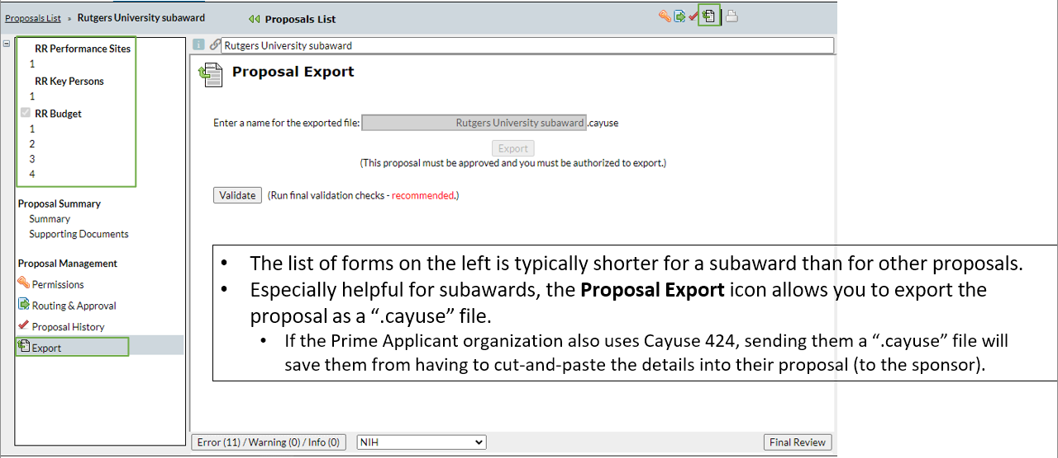

Cayuse Professional Profiles

Professional Profiles Overview

All Cayuse users need a Professional Profile:
- PIs, Co-PIs and senior personnel
- Anyone who prepares/assists with preparing proposals
- Anyone who approves IPFs:
  - Unit heads (Role: IPF Approver), Pre-Award Spending Approvers
- Anyone who needs access to proposals, awards and subawards in Cayuse SP

Professional Profiles include details that import into Cayuse SP IPFs and Cayuse 424 proposals:
- Appointment Information
  - Default home unit, appointment type and contact information
- Budget Information
  - Salary and benefits codes
- Cayuse Role
  - PI – anyone who may be added to a proposal as an investigator
  - Assistant - anyone who may help prepare a proposal

All users should verify the accuracy of their Professional Profiles.
- A wrong unit affiliation can hold up the routing of an IPF for approvals.
  - You can change the unit and other information on a proposal-by-proposal basis in both Cayuse SP and 424.
- Improve the accuracy of budget calculations by keeping salary and appointment information current.

To prevent duplications, do not create a Professional Profile for someone else (unless for someone not at UCD whom you have searched for with spelling confirmed).

How to Check a Professional Profile

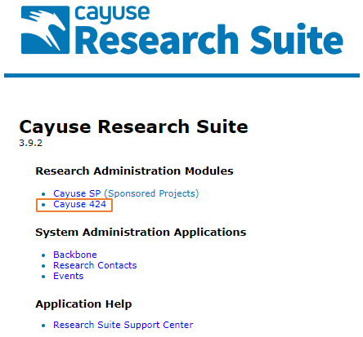

Select Cayuse 424 on the Cayuse front page (https://ucdavis.cayuse424.com/)

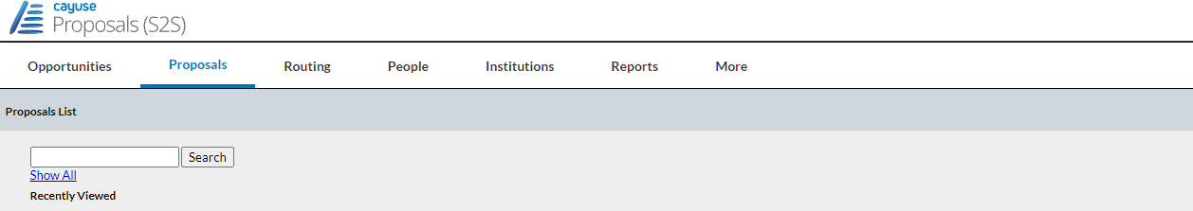
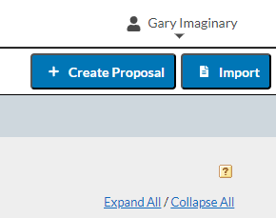
On the Cayuse 424 top toolbar, select People.
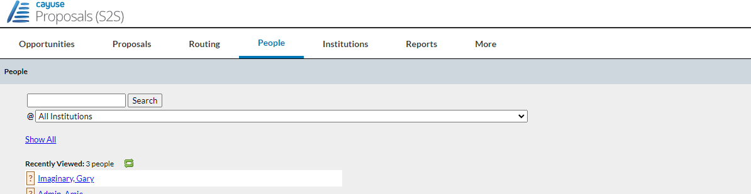

The first step is always to confirm whether a Professional Profile already exists.
- Look under Recently Viewed. If there, just click on name to open the profile.
- If name not there, enter last name in search field
- To speed the search, click on All Institutions and select The Regents of the University of California (Davis)
- Then click Search.
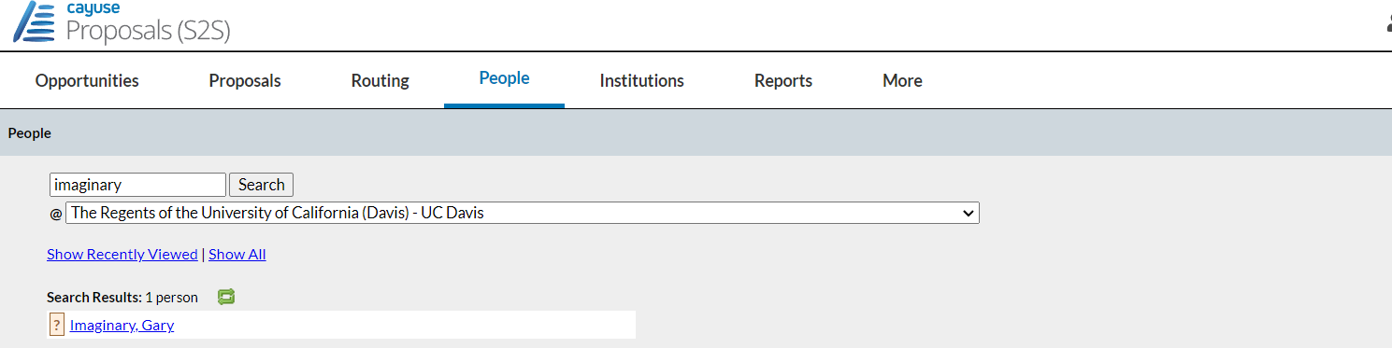
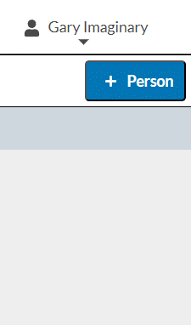
If the Professional Profile already exists, it will appear in the Search Results, and you can simply click on the name.
- If no name, search again by a different spelling or by all institutions.

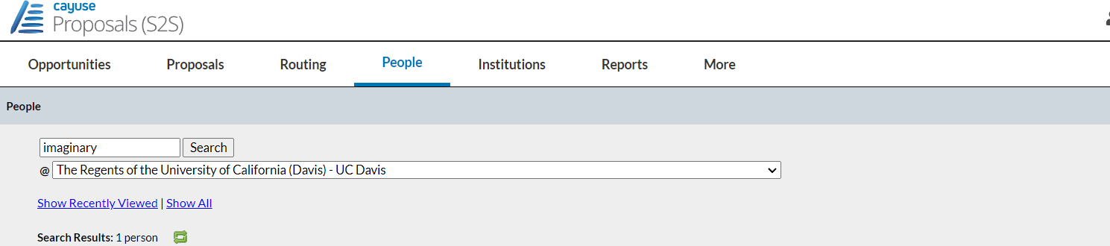
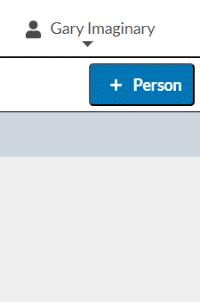
If the name still doesn’t appear, a Professional Profile will need to be created.
- Never create a profile for someone at UC Davis.

To add UC Davis personnel, email request to orcayusehelp@ucdavis.edu. Include this information:

- First and last name
- Kerberos username (if known; can differ from email address)
- UCD email address
- Department
- PI status: will they be submitting as PI at some point, Yes or No?

Note: Added personnel will not have access to Cayuse SP until an overnight update takes place.
To add someone into Cayuse who isn’t at UC Davis, such as a PI at a subrecipient institution, click
+ Person and follow the prompts.
- When assigned role of PI, this individual will immediately be able to be selected and added to a Cayuse 424 proposal.
  - This individual will not, however, have appropriate permissions to access the UC Davis Cayuse Research Suite.

Activity 2: Your Professional Profile

Login to Cayuse as yourself (Actual Cayuse, not UAT): https://ucdavis.cayuse424.com

- Use your Kerberos login & passphrase
- Select Cayuse 424
- Select People tab in top toolbar

Find Your Professional Profile in the People tab:

- Enter your last name in the search field.
- Change the Institution to The Regents of the University of California (Davis) – UC Davis.
- Select Search.
- Select your name if it is on the list and make any needed updates.

If you do not have a Professional Profile you will be unable to log into Cayuse.

In this case, email ORCayuseHelp@ucdavis.edu to request a Profile and provide the following information:
- First Name:
- Last Name:
- Kerberos username (if known):
- UC Davis Email address:
- Dept:
- PI status (Will you be submitting as PI at some point (Yes/No)):

Permissions
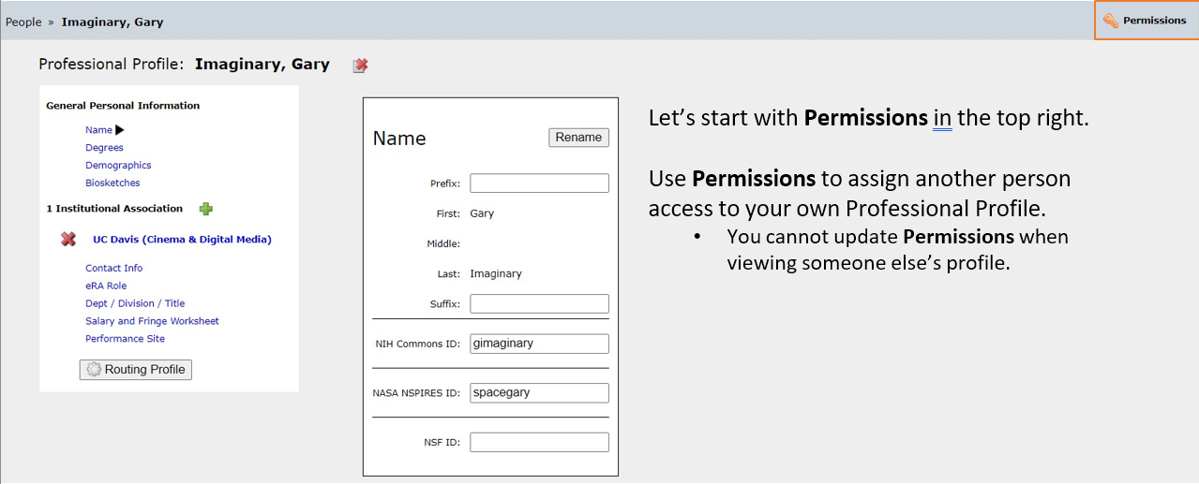

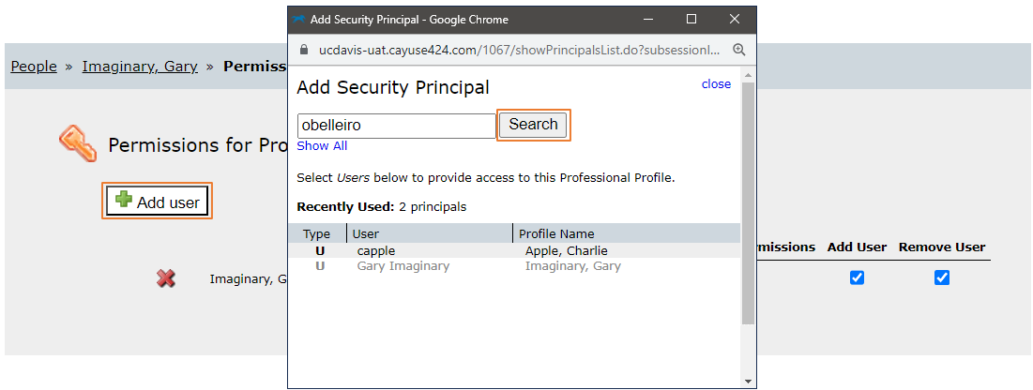
To add permissions:
- Click Add user
- In pop-up, type last name of individual to receive permissions
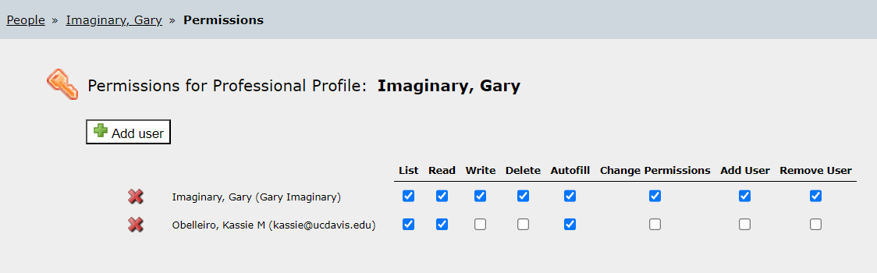

- Click Search. Then click on name in search results.

- Click checkboxes to add/remove permissions
- Or click red X to remove an individual
- When ready to return to profile, click Profile in the top right

Name Field
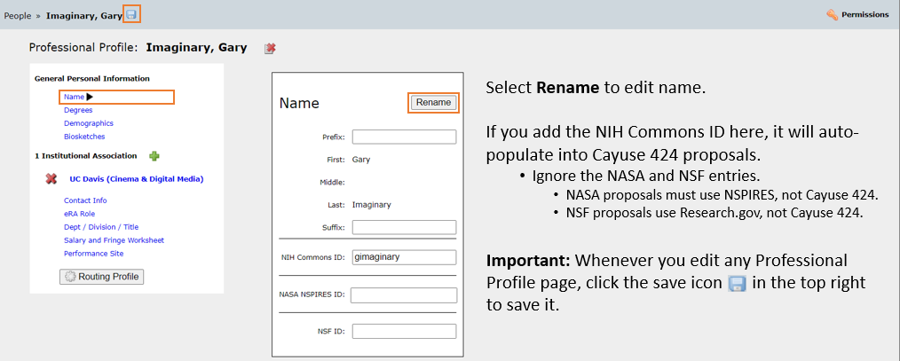

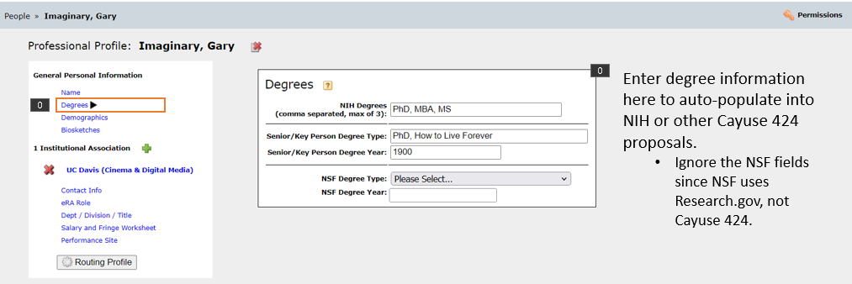
Degrees Field

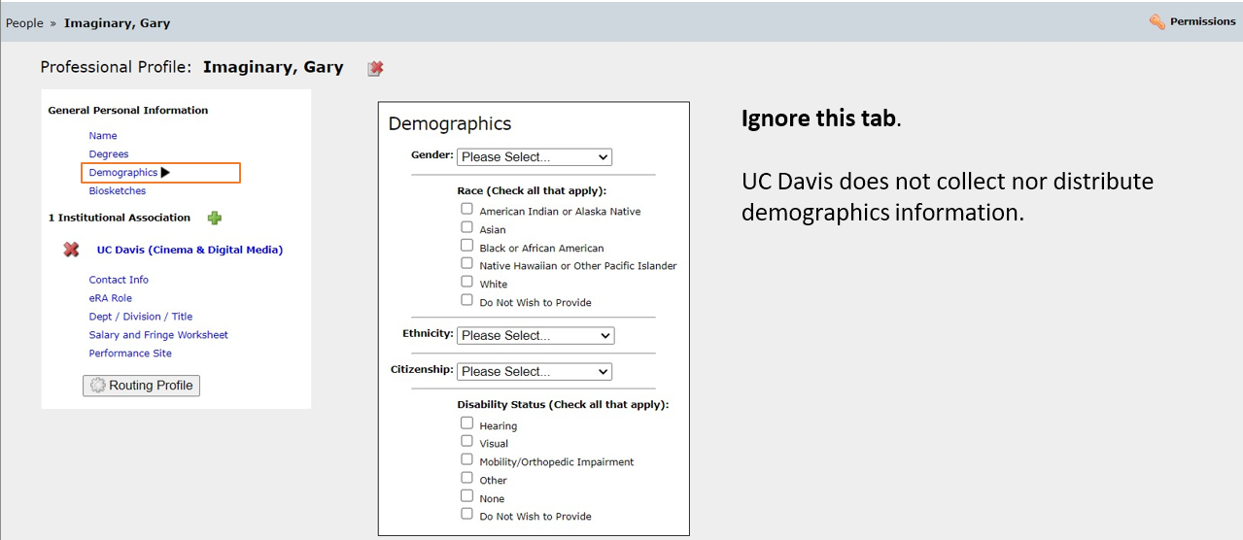
Demographics Field

Biosketches & Institutional Association
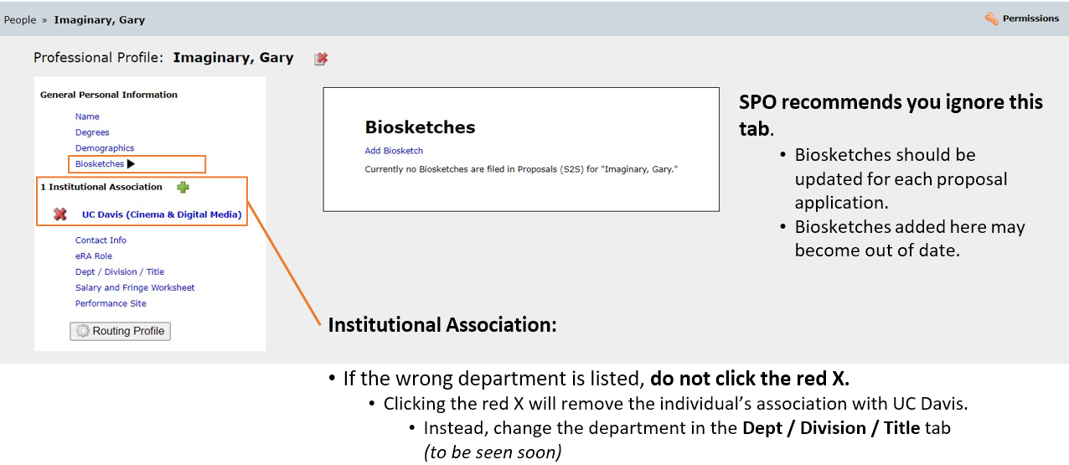

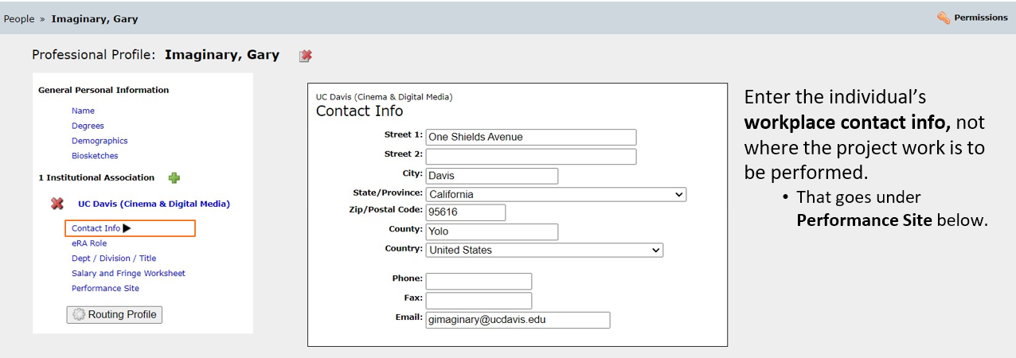
Contact Info

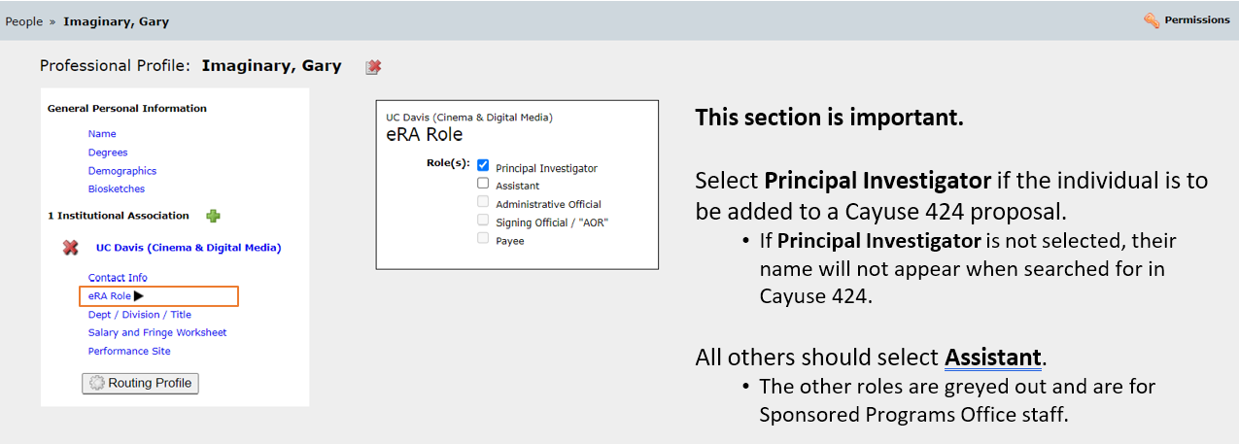
eRA Role

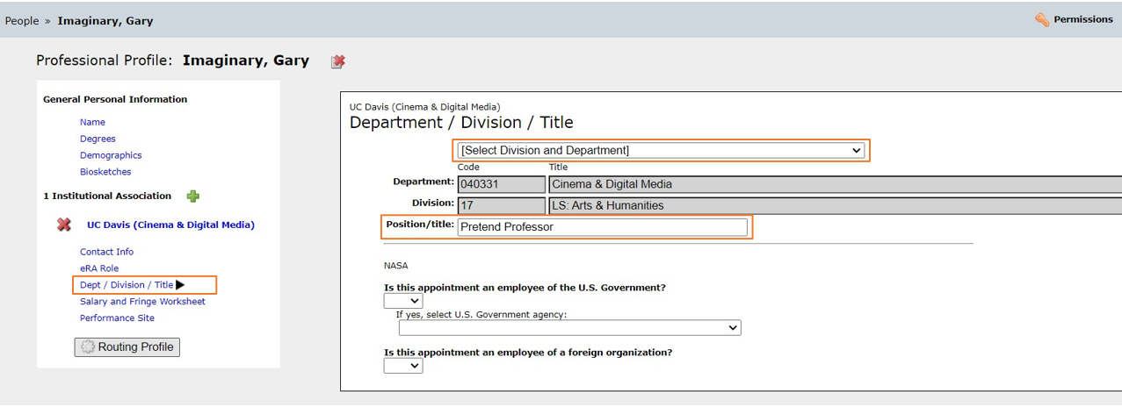
Dept / Division / Title

- If needed, search for and select an updated Division and Department
- You can also add the individual’s Position/title
- Ignore the NASA section

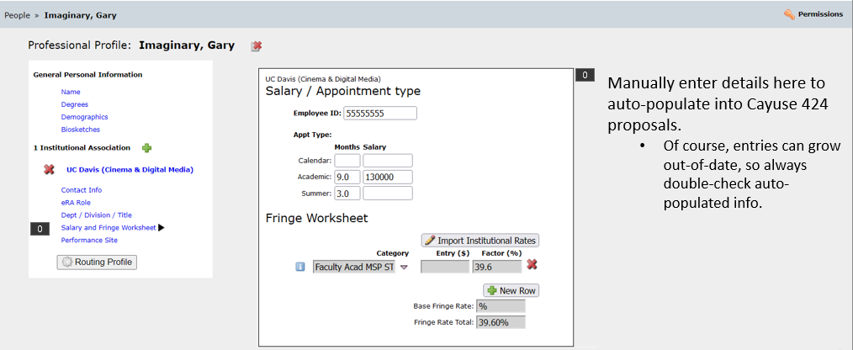
Salary and Fringe Worksheet

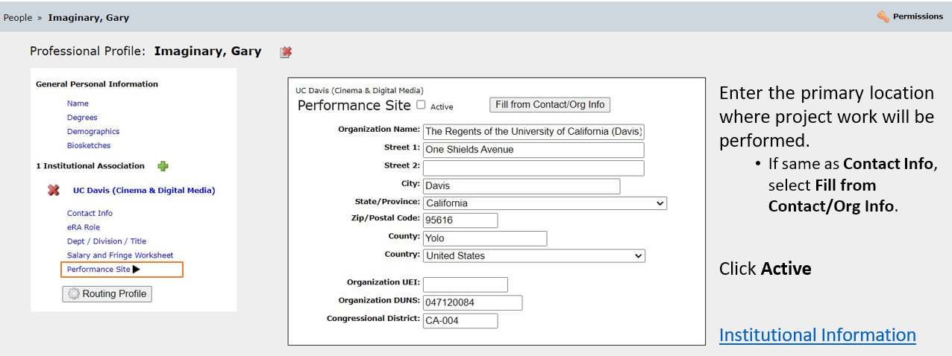
Performance Site

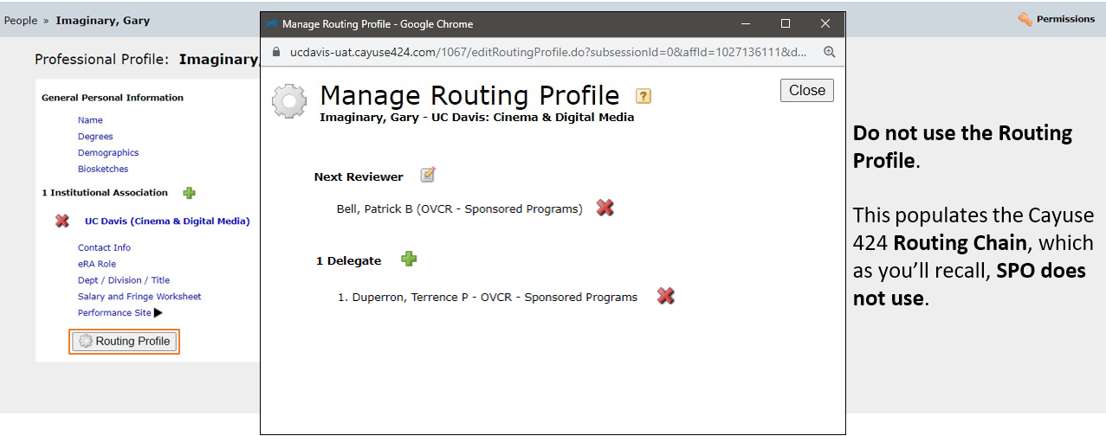
Routing Profile

Resources

Contact Us

Let us know how we did: https://ucdavis.co1.qualtrics.com/jfe/form/SV_0N7ipLAZI1yT8TI

Shanna Nation Jose
Proposals Team Analyst
Tel: 530 754 8318
Email: snation@ucdavis.edu
Perry King
Training Officer
Tel: 530 304 8137
Email: pking@ucdavis.edu

424 Resources

- Learn: Cayuse 424 page
  - Written materials:
    - Cayuse 424 Tips – 1-page list of Cayuse 424 reminders & tips for department administrators
    - Setting up Your Cayuse Professional Profile – 12-page document with screenshots on setting up your professional profile in Cayuse 424
    - Cayuse 424 User Guide – Comprehensive (but outdated) 136-page document on all aspects of Cayuse 424 usage.
      - Cayuse will not be publishing an updated user guide. They are instead using the Cayuse Help Center (free account required).
  - YouTube videos:
    - Note: if a video doesn’t start on the first try, refresh the video and it should then work.
    - How to Prepare a Cayuse 424 Proposal – YouTube video short (12:33)
    - Managing Professional Profiles – YouTube video short (10:25)

Common Acronyms

- AMRC: Anatomic Materials Review Committee
- BAA: Broad Agency Announcement
- BUA: Biological Use Approval
- CGA: Contracts and Grants Accounting
- COI: Conflict of Interest
- eRA: Electronic Research Administration
- F&A: Facilities & Administrative rates, aka indirect cost rates
- FOA: Funding Opportunity Announcement
- IACUC: Institutional Animal Care and Use Committee
- ICR: Indirect Cost Rate
- IDC: Indirect Costs
- IPF: Internal Processing Form (Cayuse SP “proposal”)
- IP: Intellectual Property
- IRB: Institutional Review Board (Human Subjects)
- PHS: Public Health Service
- PI: Principal Investigator
- RCR: Responsible Conduct of Research
- RECO: Research Ethics and Compliance Office
- RFA: Request for Applications
- RFP: Request for Proposals
- RPPR: Research Performance Progress Reports
- SBIR: Small Business Innovation Research
- SPO: Sponsored Programs Office
- STTR: Small Business Technology Transfer

SPO Contacts & Links

- Proposals: proposals@ucdavis.edu
- Awards: awards@ucdavis.edu
- Subawards: subawards@ucdavis.edu
- Closeouts: closeouts@ucdavis.edu
- eRA Help: SPOeRAhelp@ucdavis.edu
- Cayuse Help Desk: ORCayuseHelp@ucdavis.edu
- Training: SPOTraining@ucdavis.edu
- Negotiations: OR-SPO-Negotiation-Team@ad3.ucdavis.edu

- SPO Contact Us webpage
- Sponsored Programs Office (SPO)
- SPO Proposal and Award Learning Resources

SPO Office Hours & Training Opportunities

SPO Office Hours: Bring your questions and join our knowledgeable staff for guidance and training on preparing and submitting proposals for extramural funding.
- Drop in via Zoom the 1st Thursday of each month between 10 and 11am https://ucdavis.zoom.us/j/96045587567?pwd=MnVMTXN5SDRuM0RITzlKUjNmdjl5Zz09

All SPO training opportunities at https://research.ucdavis.edu/research-support/proposals/spo-proposal/spo-training/training-opps/

Research Administration Forum

Forum for department research administrators to:

Hear updates Ask questions Provide feedback

Sponsored Programs Office (SPO)
IRB Administration
IACUC
Technology Transfer
Contracts and Grants Accounting (CGA)
Research Ethics and Compliance Office (RECO)

Join via Zoom
4th Wednesday of each month ( Jan – Oct)
8:30 am

Access videos of previous forums and related materials on the Forum webpage

Office of Research Listservs

Contracts & Grants (OVCR-cg) listserv
- The primary mechanism for informing the campus community of the latest research administration news.
- Click this link to subscribe (UC Davis emails)

SPO Cayuse info listserv
- Cayuse SP and 424 info and announcements, as well as training opportunities from the Sponsored Programs office.
- Click this link to subscribe (UC Davis emails)

Other Office of Research Listservs

UC Learning Center classes

SPO offers classes individually or as a series:
- Research Administration Certificate Series (RACS)
- eRA Train the Trainer Certificate Series
- Individual classes (under “Grants and Sponsored Programs”)

Thank you!

Follow SPO on X and YouTube!

Addendum

How to Pull Content from Cayuse SP to Paste into 424

