**Cayuse SP: Awards and Post-Award Actions**

Presented by the UC Davis Sponsored Programs Office

**Learning Objectives**

After this class, you should know:

1. What an After-the-Fact (ATF) award is and how to submit one to SPO
2. How to check award status, attachments & your assigned awards analyst in Cayuse SP
3. How to request and endorse advance accounts (pre-award spending)
4. How to submit modifications

Helpful resource: [SPO Key Terms](https://research.ucdavis.edu/wp-content/uploads/SPO_KeyTerms.pdf) *(abbreviations and definitions)*

*Use* ***CTRL + Click*** *on row below to jump to that section*

Contents

Awards in Cayuse SP 3

Overview: Contract & Grant Funding Process 3

Notice of Award 3

After-the-Fact (ATF) Awards 4

ATF IPF in Cayuse SP 4

Awards in Cayuse SP 6

SPO Award Review 6

SPO Award Processing 7

Cayuse SP Statuses for Awards 7

Checking Award Status in Cayuse SP 8

Accessing Award Documents in Cayuse SP 8

Activity: Check Award Status (Poll) 8

Once an Award is Active 9

Advance Accounts (pre-award spending) 10

Advance Account/Pre-Award Spending Criteria 10

Advance Account Process 10

To Request an Advance Account 10

Advance Account in Cayuse 11

Advance Account in Cayuse 11

Advance Account Form 12

Activity: Add an Advance Account Request Form 12

Advance Account Request Status 12

How to Authorize an Advance Account Request 13

Award Modifications 14

Terms 14

Award Modifications 14

Activity: Co-PI Change 15

Resources 17

Contact Us 17

Cayuse SP and 424 17

Electronic Research Administration (eRA) Systems 17

UC Davis (& UC) Websites and Online Documents 17

Common Acronyms 18

SPO Contacts & Links 18

SPO Office Hours & Training Opportunities 19

Research Administration Forum 19

Office of Research Listservs 19

UC Learning Center classes 19

Thank you! 20

# Awards in Cayuse SP

## Overview: Contract & Grant Funding Process

Subject of this class

## Notice of Award

Email any Notice of Award you receive to [awards@ucdavis.edu](mailto:awards@ucdavis.edu)

When SPO receives the NOA, they will take one of two actions:

1. **If an IPF was previously routed in Cayuse SP**, they will email the PI/you that a SPO Awards Analyst has been assigned to review the award.
2. **If no IPF was previously routed in Cayuse SP**, SPO will request you/the PI route an IPF to solicit required approvals for the project.

## After-the-Fact (ATF) Awards

Typical reasons for ATF awards (when no proposal was routed, reviewed or approved):

* **No proposal materials required by sponsor**
* Award given based on **Letter of Intent (LOI)** or **Pre-Proposal**
* **Proposal erroneously submitted directly by PI**

ATF awards can be problematic since the following weren’t approved prior to the offer of an award:

* **Budget**, including **indirect cost rates**
* **Department/college support**
* **Terms & conditions** normally reviewed at the proposal stage

SPO will not review an ATF unless:

* **An NOA has been received** by UC Davis
* It needs to take action to receive an award

## ATF IPF in Cayuse SP

To complete an **Internal Processing Form** in Cayuse SP for an **After-the-Fact** award:

1. Access the **Cayuse Research Suite** at <https://ucdavis.cayuse424.com/>
2. Select **Cayuse SP**

1. Select **Start New Proposal**

## Awards in Cayuse SP

Once SPO has both an NOA and its corresponding IPF, your Awards Analyst (different from the analyst who helped you at the Proposal stage) will set up a new **award in Cayuse SP**.

In Cayuse SP there are three types of numbers affiliated with a project:

Cayuse SP allows you to check the status of your award, remind yourself of your assigned analyst and/or access attached documents.

## SPO Award Review

**Your assigned SPO Awards Analyst** will review both the award and any documents attached in Cayuse SP, then **request from the PI any outstanding documents/actions**, such as:

* **PI concurrence** to the terms and conditions of the award
* An **updated budget**
* **Cost-share certification**
* Financial **Conflict of Interest** disclosures
  + **PHS disclosures** or training
* Compliance approvals:
  + **IRB** (human subjects) or **IACUC** (animal subjects) approvals
  + Biological Use Authorizations (**BUAs**)
  + Stem Cell Research Oversight (**SCRO**) approval
  + Anatomical Materials Review Committee (**AMRC**) approval
* A completed **Research Security Assessment Context Questionnaire** for Federal Information Security Management Act (**FISMA**)/National Institute of Standards and Technology (**NIST**) provisions
* An **Informed Participation Agreement** for exceptional terms the university is willing to accept as long as the PI agrees to them

## SPO Award Processing

When the PI (or you on the PI’s behalf) has completed all outstanding actions, SPO will either:

1. Reach out to the sponsor to **negotiate problematic terms and conditions**.
2. **Sign the award to accept it on behalf of UC Davis** then return the award to the sponsor for countersignature.
3. Make the ‘**Pending**’ award ‘**Active**’ in Cayuse SP if no signatures are necessary.

## Cayuse SP Statuses for Awards

Reporting Designations:

* **Obligated** Sponsor has committed funding
* **Anticipated** Funding is expected but not yet committed

So if a multi-year award arrives but only year 1 is currently funded by the sponsor, SPO will indicate:

* Pending & Obligated for Year 1. Once the award is accepted, it will become Active & Obligated.
* Pending & Anticipated for all subsequent years. Subsequent awards become Pending & Obligated.

## Checking Award Status in Cayuse SP

**Check Award Status and Assigned Analyst** video: <https://www.yout-ube.com/watch?v=qhLg1Yp1p6o> (length: 2min 19sec)

## Accessing Award Documents in Cayuse SP

The Award Administration screen:

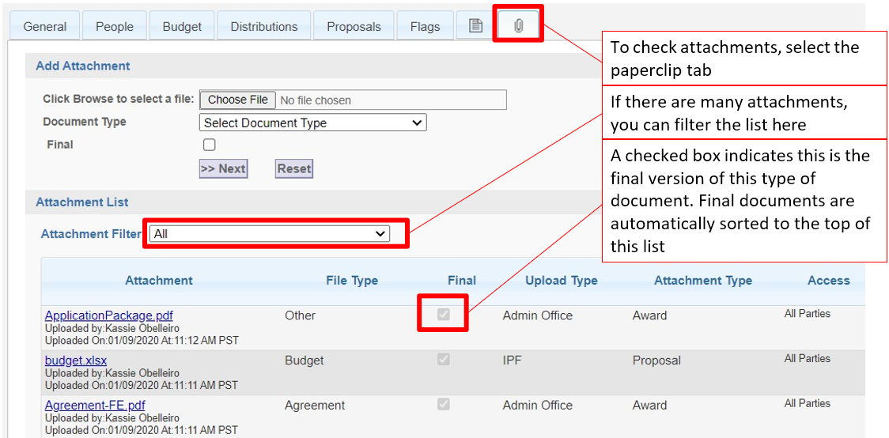

## Activity: Check Award Status (Poll)

* Login to <https://ucdavis-uat.cayuse424.com> and   
  Username: **amieadmin** Password: **training**
* Go to **Cayuse SP**
  + **Amie Admin** (whose role you are assuming) is on the **Investigator/Research Team** in Cayuse SP.

Her proposals and awards will therefore be under **My Proposals** and **My Awards**

Poll questions:

1. Find submitted Proposal # 20-2525. Has an NOA been received?

Yes

1. Find Award # A21-0730-001. Has the award been fully-executed?

Yes

1. Has the final award agreement been uploaded to Award # A21-0730-001?

Yes

Checkmark in ‘Final’ column is blue when your role permits you to revise it, grey when it does not.

## Once an Award is Active

Actions that can be initiated once an award is **Active** in Cayuse SP:

1. Issue an [outgoing subaward](https://research.ucdavis.edu/research-support/awards/subawards/) (links to page with info and forms)
   * **Outgoing subawards:** When UC Davis (the **prime recipient**) forwards to another institution (the **subrecipient**) a portion of an award it has received from a sponsor (the **prime sponsor**)
     + **The outgoing subaward process does not commence automatically**, even when the subrecipient (and subaward amount) are included in the proposal and award.
       - This is because PI’s sometimes prefer to control when the subrecipient participates in the project.
     + To start an outgoing subaward, the **PI must email a completed** [**Subaward Request Form**](http://research.ucdavis.edu/wp-content/uploads/Subaward-Request-form-FINAL.pdf) **(with required documents) to** [subawards@ucdavis.edu](mailto:subawards@ucdavis.edu).
       - This process is covered in detail in the Processing Subawards (Cayuse) class ([eCourse](https://uc.sumtotal.host/rcore/c/pillarRedirect?relyingParty=LM&url=app%2fmanagement%2fLMS_ActDetails.aspx%3fActivityId%3d508928%26UserMode%3d0&domain=8) or [instructor-led training over Zoom](https://uc.sumtotal.host/rcore/c/pillarRedirect?isDeepLink=1&relyingParty=LM&url=https%3A%2F%2Fuc.sumtotal.host%2Flearning%2Fcore%2Factivitydetails%2FViewActivityDetails%3FUserMode%3D0%26ActivityId%3D339392%26ClassUnderStruct%3DFalse%26CallerUrl%3D%2Flearning%2Flearner%2FHome%2FGoToPortal%3Fkey%3D0%26SearchCallerURL%3Dhttps%253A%252F%252Fuc.sumtotal.host%252Fcore%252FsearchRedirect%253FViewType%253DList%2526SearchText%253Dprocessing%25252520subawards%25252520%252528cayuse%252529%2526startRow%253D0%26SearchCallerID%3D2))
2. Request an **advance account** (pre-award spending)

# Advance Accounts (pre-award spending)

## Advance Account/Pre-Award Spending Criteria

Though NOT encouraged, pre-award spending is sometimes allowed by sponsors and appropriate. Requests must meet the following criteria:

* **Allowed by Sponsor**
* **Committed Award**
* **Compelling Reason** (project-related)
* **Appropriate Expenditures**
* **Appropriate Dates**
* **Available Funds**

## Advance Account Process

* All compliance items must be complete, such as

* + IRB certifications
  + IACUC certifications
  + eCOI disclosures
  + BUAs
  + etc.

## To Request an Advance Account

In the Cayuse SP IPF (Proposal):

1. Upload required documents
   * This must include evidence of firm commitment from the sponsor.
2. Complete the Advance Account Request Form accessed from the IPF.
   * Provide:
     + Sponsor contact
     + PI/department account number
     + Requested amount
     + Compelling justification for the request

## Advance Account in Cayuse

1. In [Cayuse SP](https://ucdavis.cayuse424.com/), start by finding the desired proposal under either **My Proposals** or **Proposals in My Unit**.
   * Under **My Proposals** select the **Submitted Proposals** tab.
   * **A screenshot of a computer

     Description automatically generated**Under **Proposals in My Unit**, the IPF **Status** has to at least be **Submitted to Sponsor**.

## Advance Account in Cayuse

1. Once you click on the desired proposal, in the row of tabs on the **Proposal Routing Status** screen:
   1. Select the **paperclip tab** to upload required documents.
   2. Select the **Advance Account** tab.
      * Then select **Add Advance Account Request to Proposal**.

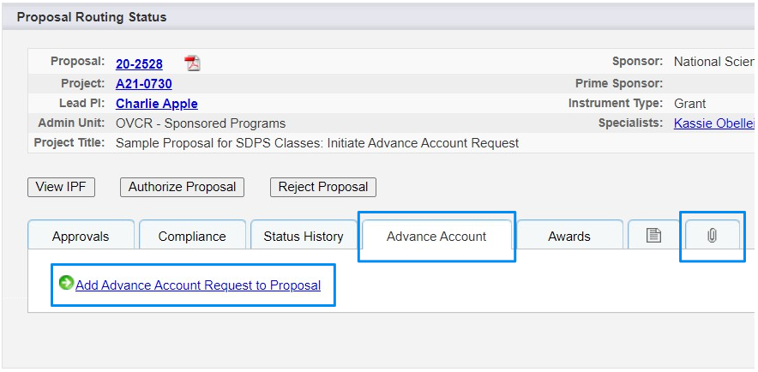

## Advance Account Form

1. Complete form:

* Description of firm funding commitment from sponsor
* Sponsor contact info
* Advance amount requested
* Reason the advance is necessary
* Alternate source of funds if award is not finalized
* Etc.

1. Then select **Submit Advance Account Request for Processing**.

Short [how-to video](https://www.yout-ube.com/watch?v=-VnMc-w63AQ) on requesting an

Advance Account

## Activity: Add an Advance Account Request Form

Log back in to <https://ucdavis-uat.cayuse424.com>. Go to **Cayuse SP**

Username: **amieadmin** Password: **training**

1. Select **My Proposals**, then the **Submitted Proposals** tab.

Select a proposal number with a status of **Submitted to Sponsor** or **Funded**

1. Add an **Advance Account Request form**
2. Feel free to populate and submit the form

## Advance Account Request Status

You can track the request status under the same **Advance Account** tab.

Statuses:

* **Submitted:** Awaiting department and dean approval, if applicable
* **Authorized:** Used rarely, and if used, it’s when assigned to SPO analyst
  + - * If SOM or SVM request, may be awaiting SPO assignment
* **Funded:** SPO approved
* **Deleted:** Not approved by SPO or withdrawn because no longer needed
* **Rejected:** Rejected by the department and/or dean’s office

## How to Authorize an Advance Account Request

**Authorize an Advance Account Request** video: <https://www.yout-ube.com/watch?v=GQSalmf-E2U> (length: 3min 8 sec)

# Award Modifications

## Terms

**Award amendment**

* Also referred to as an **award modification**, this is when either party (sponsor or PI/you) makes a revision to a primary award or to earlier amendments/supplements.

**Award supplement**

* When a sponsor awards additional funding for a supplemental proposal to a primary award, or
* When a sponsor provides additional funds not noted in the primary award, such as an add-on.

Award **amendments and supplements** received from a sponsor **are processed like regular awards**.

If you receive a Notice of Award for an amendment or supplement, email the NOA to [awards@ucdavis.edu](mailto:awards@ucdavis.edu).

## Award Modifications

**Review sponsor guidelines:**

* To ensure the modification is allowed
* To determine the sponsor process required to effect the change.
* Some actions require prior approval.

Ensure all required reports and deliverables have been provided to the sponsor.

**Submit the request in Cayuse SP if the request requires department/ dean approval**, such as:

* Administering unit change
* Key personnel change
* Cost-share commitment change
* Significant budget revision

Otherwise, simply email the modification request to [awards@ucdavis.edu](mailto:awards@ucdavis.edu).

Examples:

* Carryforward request
* No-Cost Extension

## Activity: Co-PI Change

For this next activity, you will enter an IPF in the Cayuse UAT sandbox to request a Co-PI change.

Login to the Cayuse UAT (“sandbox”) at <https://ucdavis-uat.cayuse424.com>

Username: **amieadmin** Password: **training**

Complete the **General Information** (first page) and **Investigators/Research Team** pages for this Co-PI change:

1. You are requesting SPO submit a Prior Approval request to the sponsor to replace Co-PI **Gary Imaginary** from **Cinema & Digital Media**, who is separating from UC Davis, with Co-PI **Mastewal Abuhay** from **Med: Intl Med – Hematology & Oncology**.
   * Professor Abuhay will match Professor Imaginary’s effort.
2. You can copy existing proposal **23-0044**. Find it under **My Proposals**, then **Submitted Proposals**.
   * Once found, before clicking it open, select **Copy** in the far right.
   * You will see an **error message** (a Cayuse quirk). Just **click the back arrow** and you will see the copied proposal at the top of the **Unsubmitted Proposals** screen (There will be a bunch of them, all titled “03/01/2022 Apple NSF”! Pick one).
   * **Short Project Name:** Be sure to reference Cayuse proposal **23-0044** + Action + PI Name + Sponsor
   * **Activity Code:** 01 Basic Research *(you would find this if you checked original 23-0044)*
   * **Proposal Type:** Be sure to change **New** to **Prior Approval**
   * **Submission Method:** **Other**. Add **“Already submitted”**
   * **Affiliated Unit:** Add **Cinema & Digital Media** (Dr. Imaginary’s unit) so they can approve the change.
3. The **Investigators/Research Team** tab will be blank (not copied), so copy the info from the screenshot below.
   * In real life, click on the still open **Cayuse Research Suite** window tab, then click **Cayuse SP** again to open another browser tab, search for proposal **23-0044**, then click on the **PDF icon** on the far right to view all the details to copy.

# Resources

## Contact Us

Let us know how we did: <https://ucdavis.co1.qualtrics.com/jfe/form/SV_9oBThct7P01J2XI>

Terry Duperron

eRA Analyst

Emails: [SPOeRAHelp@ucdavis.edu](mailto:SPOeRAHelp@ucdavis.edu)

[ORCayuseHelp@ucdavis.edu](mailto:ORCayuseHelp@ucdavis.edu)

Perry King

Training Officer

Phone: 530-304-8137

Email: [pking@ucdavis.edu](mailto:pking@ucdavis.edu)

## Cayuse SP and 424

* SPO Proposal and Award Learning Resources (FAQs, written materials, videos & trainings):
  + [Learn: Cayuse SP](https://research.ucdavis.edu/research-support/proposals/spo-proposal/proposal-submission/cayuse-sp/)
  + [Learn: Managing Roles in Cayuse](https://research.ucdavis.edu/research-support/proposals/spo-proposal/proposal-submission/roles/)
  + [Learn: Cayuse 424](https://research.ucdavis.edu/research-support/proposals/spo-proposal/proposal-submission/spo-training-grant-subs/)
* [Cayuse 424 Professional Profiles](https://research.ucdavis.edu/wp-content/uploads/Cayuse-Setting-up-your-professional-profile.pdf) (How to set up)
* [Cayuse SP Handbook for Dept. Contract & Grant Staff, PIs and Approvers](https://research.ucdavis.edu/wp-content/uploads/End-users-v13.pdf)
* [Handbook for Role Managers](https://research.ucdavis.edu/wp-content/uploads/Handbook-Role-Managers-022618.pdf)
* [Cayuse Quick Reference](https://research.ucdavis.edu/wp-content/uploads/SP-PIs-and-Dept-Admins-Quick-Reference.pdf)
* [Cayuse SP Tips](https://research.ucdavis.edu/wp-content/uploads/Cayuse-SP-Tips.pdf)

## Electronic Research Administration (eRA) Systems

#### **UC Davis**

* Cayuse 424 and SP: <https://ucdavis.cayuse424.com/> *(copy and paste address into browser)*
* [Biological Use Authorization (BUA) Application](http://safetyservices.ucdavis.edu/article/biological-use-authorization-bua)
* [Electronic Conflict of Interest (eCOI) System](https://or-forms.ucdavis.edu/) ([Instructions](https://research.ucdavis.edu/policiescompliance/coi/))
* [Institutional Animal Care and Use Committee (IACUC) Application](https://iacuc.ucdavis.edu/protocol/)
* [IRBNet (Human Subjects Protocols)](https://www.irbnet.org/release/index.html)
* [Human Anatomical Specimen and Tissue Oversight Committee (HASTOC) Resources](https://research.ucdavis.edu/policiescompliance/human-anatomical-specimen-tissue-oversight/)

## UC Davis (& UC) Websites and Online Documents

* [UC Davis Guide to Research Compliance](https://goo.gl/nxVt67)
* [Contracts and Grants Accounting (CGA)](https://financeandbusiness.ucdavis.edu/finance/contracts-grants-accounting)
* [Office of Research](http://research.ucdavis.edu/)
* Checklists (PDFs):
  + [Call for Proposals Checklist](https://research.ucdavis.edu/wp-content/uploads/03-Call-for-Proposals-Checklist.pdf)
  + [New Proposals Checklist](https://research.ucdavis.edu/wp-content/uploads/02-New-Proposal-Checklist.pdf)
  + [Proposal Preparation Checklist](https://research.ucdavis.edu/wp-content/uploads/Proposal-Preparation-Checklist_v2SPO-Clean.pdf)
  + [Budget Justification Checklist](https://research.ucdavis.edu/wp-content/uploads/Budget-Justification_Checklist.pdf)
  + [Subaward Processing Checklist](https://research.ucdavis.edu/wp-content/uploads/Subaward_PI-Department_Checklist.pdf)
  + [CGA Award Closeout Checklist](https://ucdavis.app.box.com/s/vb1dagm1w558k7ecxoj4r87onltw0cf5)
* [Sponsors/Agencies that have adopted PHS regulations for COI](https://research.ucdavis.edu/wp-content/uploads/List-of-Covered-Entities-for-PHS-COI-Rule.pdf) (PDF)
* [Principles Regarding Rights to Future Research Results](https://www.ucop.edu/research-policy-analysis-coordination/policies-guidance/future-research-results/index.html)

## Common Acronyms

* **AMRC:** Anatomic Materials Review Committee
* **BAA:** Broad Agency Announcement
* **BUA:** Biological Use Approval
* **CGA:** Contracts and Grants Accounting
* **COI:** Conflict of Interest
* **eRA:** Electronic Research Administration
* **F&A:** Facilities & Administrative rates, aka indirect cost rates
* **FOA:** Funding Opportunity Announcement
* **IACUC:** Institutional Animal Care and Use Committee
* **ICR:** Indirect Cost Rate
* **IDC:** Indirect Costs
* **IPF:** Internal Processing Form (Cayuse SP “proposal”)
* **IP:** Intellectual Property
* **IRB:** Institutional Review Board (Human Subjects)
* **PHS:** Public Health Service
* **PI:** Principal Investigator
* **RCR:** Responsible Conduct of Research
* **RECO:** Research Ethics and Compliance Office
* **RFA:** Request for Applications
* **RFP:** Request for Proposals
* **RPPR:** Research Performance Progress Reports
* **SBIR:** Small Business Innovation Research
* **SPO:** Sponsored Programs Office
* **STTR:** Small Business Technology Transfer

## SPO Contacts & Links

* Proposals: [proposals@ucdavis.edu](mailto:proposals@ucdavis.edu)
* Awards: [awards@ucdavis.edu](mailto:awards@ucdavis.edu)
* Subawards: [subawards@ucdavis.edu](mailto:subawards@ucdavis.edu)
* Closeouts: [closeouts@ucdavis.edu](mailto:closeouts@ucdavis.edu)
* eRA Help: [SPOeRAhelp@ucdavis.edu](mailto:SPOeRAhelp@ucdavis.edu)
* Cayuse Help Desk: [ORCayuseHelp@ucdavis.edu](mailto:ORCayuseHelp@ucdavis.edu)
* Training: [SPOTraining@ucdavis.edu](mailto:SPOTraining@ucdavis.edu)
* Negotiations: [OR-SPO-Negotiation-Team@ad3.ucdavis.edu](mailto:OR-SPO-Negotiation-Team@ad3.ucdavis.edu)
* [SPO Contact Us webpage](https://research.ucdavis.edu/about/offices/spo-office/#ci)
* [Sponsored Programs Office (SPO)](https://research.ucdavis.edu/about/offices/spo-office/)
* [SPO Proposal and Award Learning Resources](https://research.ucdavis.edu/research-support/proposals/spo-proposal/spo-training/training-opps/)

## SPO Office Hours & Training Opportunities

**SPO Office Hours:** Bring your questions and join our knowledgeable staff for guidance and training on preparing and submitting proposals for extramural funding.

* Drop in via Zoom the 1st Thursday of each month between 10 and 11am <https://ucdavis.zoom.us/j/96045587567?pwd=MnVMTXN5SDRuM0RITzlKUjNmdjl5Zz09>

**All SPO training opportunities** at <https://research.ucdavis.edu/research-support/proposals/spo-proposal/spo-training/training-opps/>

## Research Administration Forum

Forum for department research administrators to:

**Hear updates Ask questions Provide feedback**

Sponsored Programs Office (SPO)

IRB Administration

IACUC

Technology Transfer

Contracts and Grants Accounting (CGA)

Research Ethics and Compliance Office (RECO)

**Join via** [**Zoom**](https://ucdavis.zoom.us/j/99842677540)

**4th Wednesday of each month ( Jan – Oct)**

**8:30 am**

Access videos of previous forums and related materials on the [Forum](https://research.ucdavis.edu/research-support/proposals/spo-proposal/spo-training/research-administration-forums/) webpage

## Office of Research Listservs

**Contracts & Grants (OVCR-cg) listserv**

* The primary mechanism for informing the campus community of the latest research administration news.
* Click this [link](https://lists.ucdavis.edu/sympa/subscribe/ovcr-cg) to subscribe (UC Davis emails)

**SPO Cayuse info listserv**

* Cayuse SP and 424 info and announcements, as well as training opportunities from the Sponsored Programs office.
* Click this [link](https://lists.ucdavis.edu/sympa/subscribe/spo_cayuse_info) to subscribe (UC Davis emails)

[Other Office of Research Listservs](https://research.ucdavis.edu/about/connect-with-us/listserv-subscriptions/)

## UC Learning Center classes

SPO offers classes individually or as a series:

* [Research Administration Certificate Series (RACS)](https://hr.ucdavis.edu/departments/learning-dev/certificate/research-admin)
* [eRA Train the Trainer Certificate Series](https://hr.ucdavis.edu/departments/learning-dev/certificate/eRA)
* [Individual classes](https://hr.ucdavis.edu/departments/learning-dev/course-catalog/research) (under “Grants and Sponsored Programs”)

## Thank you!

Follow SPO on [X](https://x.com/UCDavisSPO) and [YouTube](https://www.youtube.com/channel/UC5tWJ6oF2G5nYarcdAK9SwQ)!