**Processing Subawards (Cayuse)**

Presented by the UC Davis Sponsored Programs Office

**Learning Objectives**

By the end of this training, you should know how to…

1. Define a subaward
2. Distinguish between incoming and outgoing subawards
3. Submit an incoming subaward to SPO
4. Submit a proposal with outgoing subawards
5. Initiate an outgoing subaward once an award is received
6. Identify the assigned SPO analyst and check subaward status

Helpful resource: [SPO Key Terms](https://research.ucdavis.edu/wp-content/uploads/SPO_KeyTerms.pdf) *(abbreviations and definitions)*

*Use* ***CTRL + Click*** *on row below to jump to that section*

Contents

Subawards Overview 3

Key Terms 3

3 Flavors of Subaward 3

Is it a Subaward? 4

Is it a Subaward? 4

Activity 1: Subaward or Vendor/Service Agreement? 5

UC Davis as a Subrecipient 6

Incoming Subawards 6

Completing the IPF in Cayuse SP 6

Minimum Proposal Documents for SPO Assignment 7

Cayuse SP: IPF Preparation & Routing 8

SPO Proposal Review 8

Activity: Identify Sponsor Information 8

Utilizing Cayuse 424 9

Award Process for Incoming Subawards 11

SPO Award Review 11

UC Davis as a Prime Applicant 12

Outgoing Subwards Website 12

Proposal Preparation Process 12

Minimum Proposal Documents for SPO Assignment 13

Subrecipient F&A Costs 13

Subrecipient Monitoring Requirements 13

Completing the Cayuse SP IPF 14

Completing the Cayuse SP IPF 15

Cayuse 424 for Outgoing Subawards 15

Cayuse 424: Institutional Profile 16

Subaward in Cayuse 424 Proposal 17

Create a Subaward 17

Add a Site PI/PD in Cayuse 424 20

Import a Subaward 20

View in Prime Application 21

Link Subaward 22

UC Davis as a Prime Recipient 23

Outgoing Subaward Process 23

Subaward Request Form 23

Subaward Request Documents 24

Subaward Review 25

Checking Subaward Status in Cayuse SP 25

Subaward Statuses 25

Resources 26

Contact Us 26

Cayuse SP and 424 26

Electronic Research Administration (eRA) Systems 26

UCD/UC Websites & Online Documents 27

Common Acronyms 27

SPO Contacts & Links 27

SPO Office Hours & Training Opportunities 28

Research Administration Forum 28

Office of Research Listservs 28

UC Learning Center classes 29

Thank you! 29

# Subawards Overview

## Key Terms

**Subaward:** an agreement to send funding from one institution (Prime Recipient) to another (Subrecipient) to perform work associated with a Prime Award

**Sponsor/Prime Sponsor:** Entity that requests/receives proposals for and provides funding to the Prime Applicant/ Recipient

**Prime Applicant/Recipient:** Institution that applies for/receives funding from the Prime Sponsor

**Subrecipient:** Institution that applies for/receives funding from the Prime Recipient

**Prime Award:** Award funded by the (Prime) Sponsor and provided to the Prime Applicant

**Lead Principal Investigator (PI)/ Project Director (PD):** Lead PI/PD for the entire sponsored project

**Site PI/PD:** Principal Investigator/Project Director from the subrecipient institution.

The subrecipient entity is **an organization**, not an individual

## 3 Flavors of Subaward

## Is it a Subaward?

## Is it a Subaward?

A subaward may be appropriate if the **Scope of Work** meets one or more of the following:

1. Performance represents an **intellectually significant portion of the overall programmatic effort** and is
2. measured against the objectives of the sponsor’s program
3. Will use the funds to carry out a program for a **public purpose**, as opposed to providing goods or services for the benefit of UC Davis
4. There is **an identified PD/PI for the subrecipient** who has responsibility for making programmatic decisions. This **Site PD/PI**:
   1. May do work that results in the development of **intellectual property**
   2. May author or co‐author **publications** on the results of the work
   3. Will need **animal and/or human subject approval** for the work
   4. May receive **cost sharing** or **matching funds** from his/her institution
   5. Is responsible for adhering to **applicable program and other requirements specified in the award**

**If none of these terms are met, it’s a contractor/vendor or consulting agreement**

If still unsure, email SPO at [proposals@ucdavis.edu](mailto:proposals@ucdavis.edu) for guidance.

Helpful Resources:

* [Subrecipient, Contractor/Vendor, Consultant?](https://research.ucdavis.edu/wp-content/uploads/Sub-Table.pdf)
* [Subrecipient vs. Vendor](https://research.ucdavis.edu/wp-content/uploads/Subaward-v-Vendor-Guidance-Document.pdf)

## Activity 1: Subaward or Vendor/Service Agreement?

1. Professor Smith is performing a research project to determine the effects of consuming coffee on human DNA. As part of the project, he will purchase instant coffee and coffee beans from a coffee roaster.

**Vendor Agreement**

1. As part of the project described above, UC Merced will compare the effects of instant coffee on human DNA. They will recruit human subjects. UC Merced will analyze the DNA of the human subjects before and after they consume instant coffee.

**Subaward**

1. Professor Pulis is performing a research project to analyze the protein compounds in milk alternatives compared to milk and milk derivatives to determine how they compare for human consumption.

As part of this project, she will utilize the services of a laboratory to provide a report on the protein compounds in milk alternatives she identifies, as well as 2% milk. The laboratory will provide Professor Pulis with a report of the protein compounds but will not perform an analysis.

Professor Pulis will perform an analysis to determine how the protein compounds would affect human consumption.

**Vendor Agreement**

# UC Davis as a Subrecipient

Incoming subawards – SPO treats these the same as other proposals and awards

## Incoming Subawards

**UC Davis is a Subrecipient**

UC Davis submits a proposal for funding to the Prime Applicant/Recipient.

Once funded by the Prime Sponsor, the Prime Recipient will then forward a subaward to UC Davis.

**Submission**

1. Submit an Internal Processing Form (IPF; aka “proposal”) in [Cayuse SP](https://ucdavis.cayuse424.com/) for required internal review/approvals.
2. Submit the approved subaward proposal to the Prime Applicant using their recommended external submission system/method.

## Completing the IPF in Cayuse SP

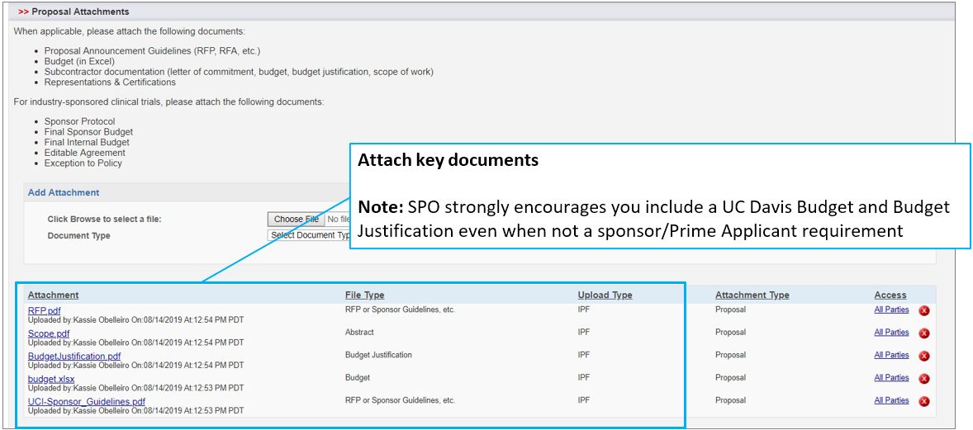

## Minimum Proposal Documents for SPO Assignment

**Completely Certified and Authorized IPF**

Complete IPF with Lead PI and co-PI Certifications and IPF Authorizations and indication of all subrecipients on the subrecipients tab

**Sponsor Guidelines**

Sponsor’s request for proposals or other guidelines for the prime application and

subrecipient proposals

**Prime Applicant Guidelines**

Instructions provided by the Prime Applicant regarding their requirements for subrecipient proposals

**UC Davis Subrecipient Proposal**

UC Davis Scope of Work, Budget, Budget Justification and any other materials required by the Prime Applicant

## Cayuse SP: IPF Preparation & Routing

## SPO Proposal Review

**UC/UC Davis Requirements**

* + IPF Certifications and Authorizations
  + Budget and Budget Justification
  + Accurate F&A Rate and Base
  + Accurate calculations
  + Allowable and allocable costs
  + Budget and budget justification match
  + Scope of Work

**Sponsor and Program Administrative Compliance**

* + Required proposal components
  + Eligibility
  + Budget limitations and other restrictions

**Regulatory Compliance**

* + Human and/or animal subjects
  + Stem cells
  + Biohazardous materials
  + Human anatomical specimens

**Financial COI**

* Form 800 e-disclosure
* PHS e-disclosure and online training

## Activity: Identify Sponsor Information

For each of the following scenarios:

* A screenshot of a computer screen

  Description automatically generated**Who is the Sponsor?**
* **Who is the Prime Funding Agency?**
* **What is the appropriate Sponsor Deadline?**

1. Stanford University is submitting an NSF proposal with a deadline of 8/8/23, 11:59 PM EST. They will partner with UC Davis Professor C. Titus Brown in Population Health and Reproduction to conduct correlated studies on sea urchins and have requested his application to include in their submission to NSF by 7/29/23, 5:00PM PST.
2. Professor Gary Imaginary is submitting a proposal due to UCSF on 6/3/23 via email by 5:00 PM for their 6/9/23 by 5:00 PM PST submission to the National Cancer Institute (NIH).
3. The Andrew W. Mellon Foundation awarded UCLA an award to conduct research on nicotine addiction but UCLA has no rhesus macaques for the first leg of the study. To utilize UC Davis’s primates, they have asked CNPRC director Dr. John Morrison to submit a subaward application by 4/27/23.

**Answers:**

1. Sponsor: Stanford University

Prime Funding Agency: NSF

Appropriate deadline: 7/29/23, 5:00PM PST

1. Sponsor: UCSF

Prime Funding Agency: NIH National Cancer Institute

Appropriate deadline: 6/3/23, 5:00PM

1. Sponsor: UCLA

Prime Funding Agency: Andrew W. Mellon Foundation

Appropriate deadline: 4/27/23

## Utilizing Cayuse 424

Cayuse 424, linked to Grants.gov, is used for external submission of proposals to most federal agencies.

The Prime Applicant may request you submit the subrecipient proposal via Cayuse 424

You may also prefer to create the subrecipient proposal in 424 even if not requested by the Prime Applicant.

Once approved by SPO, you can send it to them as a Cayuse export file (or PDF).

1. **Subaward Name**is best entered as:
   1. Corresponding **Cayuse SP Proposal # +**
   2. **Submission date** to Prime Applicant (MM/DD/YY) +
   3. **PI last name** +
   4. **Prime Applicant acronym** or short name +
   5. **Sponsor acronym** or short name
      1. Example: 25-1234 05/17/25 Smith UMich NIH
2. **Organization: For incoming subawards only,** if you enter the Prime Applicant here (as you do in Cayuse SP), you may be locked out from adding indirect costs.
   1. Therefore, search for and select **“The Regents of the University of California (Davis)”**
3. **Validation Type** refers to the Prime Sponsor
4. Attach all **required sponsor forms**

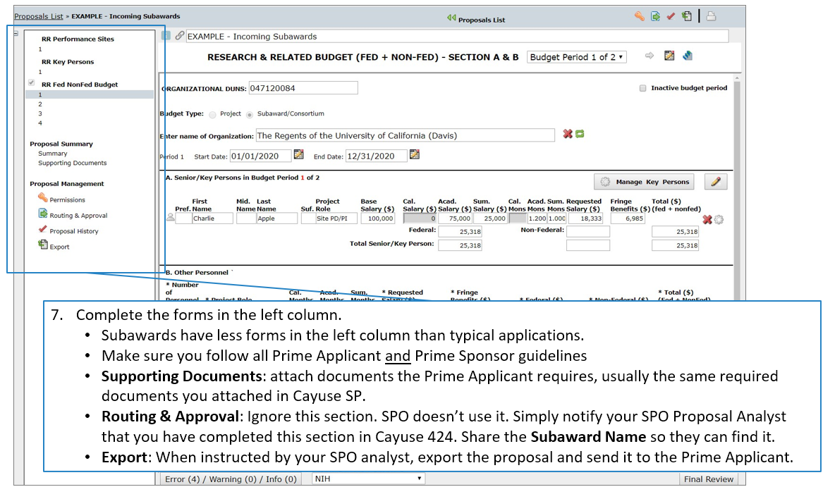

## Award Process for Incoming Subawards

As with other awards, the award process for an incoming subaward begins when **SPO receives Notice of Award (NOA)**

If you or the PI receive the NOA, email it to [awards@ucdavis.edu](mailto:awards@ucdavis.edu).

## SPO Award Review

**Required proposal documents**

The SPO Award analyst will confirm that all required proposal documents are on file and request any that are outstanding

**Compliance documents**

SPO will ensure all required compliance items are in place

**Award agreement**

Does it comply with:

* UC/UC Davis policies & regulations
* [Principles Regarding Rights to Future Research Results in University Agreements with External Parties](https://www.ucop.edu/research-policy-analysis-coordination/policies-guidance/future-research-results/index.html)

**Award Negotiation and Acceptance**

If needed, SPO will negotiate acceptable terms and conditions with the Prime Recipient (the Sponsor in Cayuse SP)

SPO will accept the award on behalf of the UC Regents

# UC Davis as a Prime Applicant

Outgoing Subawards –

UC Davis submits a proposal to a sponsor that includes subaward(s) to other institutions

## Outgoing Subwards Website

The UC Davis [Outgoing Subwards](https://research.ucdavis.edu/research-support/awards/subawards/) website provides all necessary materials and step-by- step instructions.

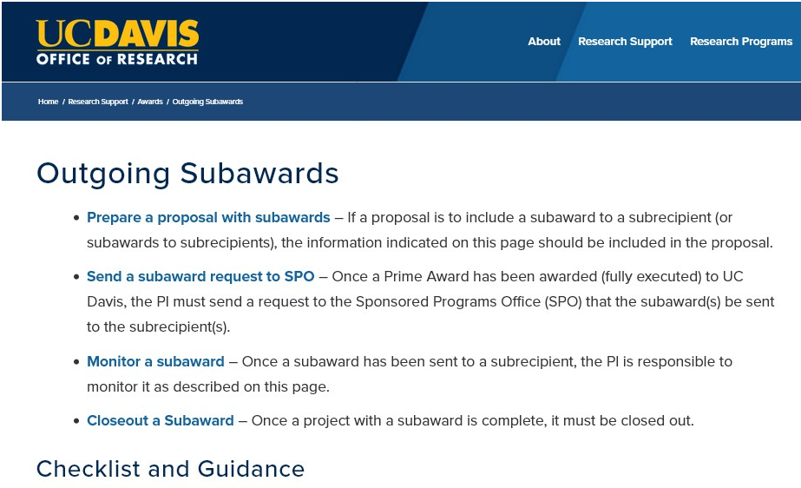

## Proposal Preparation Process

## Minimum Proposal Documents for SPO Assignment

**Prime Application: the usual 4 items**

* IPF (certified and authorized)
  + All subrecipients should be indicated on the **Subrecipients** tab
* Scope of Work (SOW)
* Budget
* Budget Justification

**Subrecipient Commitment Form** (1 of the following)

* [Federal Demonstration Partnership (FDP) Supplemental Information Form](https://research.ucdavis.edu/wp-content/uploads/FDP_Subrecipient_Pilot-Supplemental_Project_Info_Form.pdf)
  + Can check whether the subrecipient participates at <https://fdpclearinghouse.org>
* [Subrecipient Commitment Form](https://research.ucdavis.edu/wp-content/uploads/UCD_Subrecipient-Commitment-Form_final.pdf), or
* [Multiple Campus Award (MCA) Commitment Form](https://research.ucdavis.edu/wp-content/uploads/MCA_Commitment_Form.pdf)

**Subrecipient Proposal(s)**

* Scope of Work, proposed timelines and deliverables
* Budget and Budget Justification
  + Subrecipient’s F&A information
* Additional info required by the Sponsor

## Subrecipient F&A Costs

**UC Davis F&A (indirect cost) Base**

* Include the **first $25,000** of each subaward as indirects
* Do not include any subawards to other UC campuses

**Subrecipient F&A Rate and Base**

For federally-funded awards, they should use their federally negotiated (NICRA*) rate and base

If they do not have a NICRA rate they may:

* Negotiate a rate with the federal agency
* Elect to not charge F&A
* Use a de minimis rate of 15% MTDC
  + This will be applied to all future subawards from UCD

If they are a foreign institution, NIH caps F&A at 8% MTDC

*\* Negotiated Indirect Cost Rate Agreement*

## Subrecipient Monitoring Requirements

**The PI has responsibility** throughout the term of the subaward **to ensure awarded funds are used in furtherance of project goals, comply with regulations** and with **university and prime sponsor policies**.

The PI must:

* **Review, certify, and approve all subrecipient invoices**, ensuring that invoices adhere to the subaward requirements and that invoices include sufficient detail to ensure appropriateness of charges.
* **Review all progress, technical, and financial reports** to ensure they are complete and comply with the
* content the frequency/timeframe requirements stipulated in the subaward.
* **Seek clarification or additional information/documentation from the subrecipient** as may be necessary for any submitted invoice or report.
* **Keep detailed documentation of unsatisfactory performance** by the subrecipient.
* **Retain all invoices and reports** in the department’s files for audit purposes.

Additional information can be found on the [Monitor a Subaward](https://research.ucdavis.edu/research-support/awards/manage-an-award/monitor-a-subaward/) webpage.

## Completing the Cayuse SP IPF

Add each subrecipient to the Subrecipients tab.

If the subrecipient is not listed:

* Select **‘Miscellaneous Sponsors’**
* Add a **Submission Note** with their institution name, address, UEI number, F&A rate(s) and F&A base(s)/types

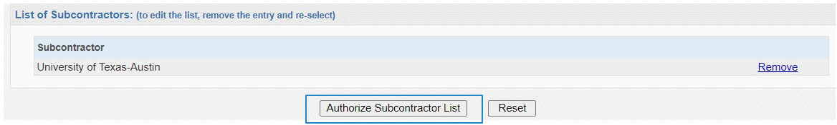

**Cayuse SP Tip**

* Do not include the Subrecipient location in “Location of Sponsored Activities”

## Completing the Cayuse SP IPF

**Upload required subaward documents as Proposal Attachments**

Upload 2 PDFs per subaward:

1. Commitment Form
2. Subaward Proposal *(use Adobe Acrobat feature: Combine Files into a Single PDF)*
   * Subrecipient’s scope of work, budget (with F&A rate/base) & budget justification
   * Sole Source Justification (if proposal is a federal contract (as opposed to a grant or cooperative
   * agreement))
   * Any additional elements required by prime sponsor for inclusion in the proposal

## Cayuse 424 for Outgoing Subawards

Create the proposal from the Opportunity as usual

## Cayuse 424: Institutional Profile

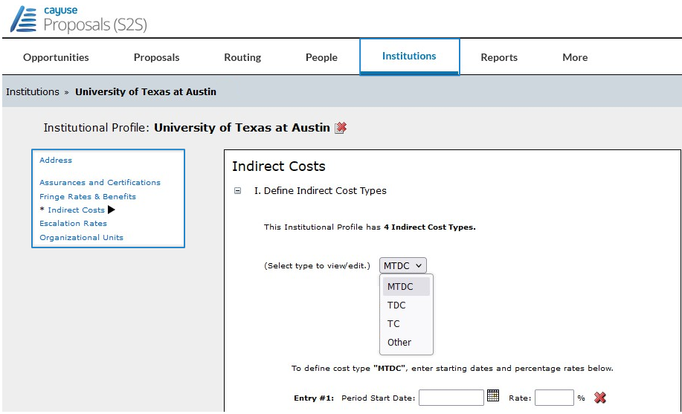**Best practice:**

As a first step, check whether the subrecipient appears as an Institution in Cayuse 424.

**To do this:**

In **Cayuse 424**, select **Institutions** in the top tool bar, then **Search** for the subrecipient institution.

If the institution is found, click through the sections to confirm the info is accurate.

* Ensure the **Indirect Cost Type** to be used is indicated.

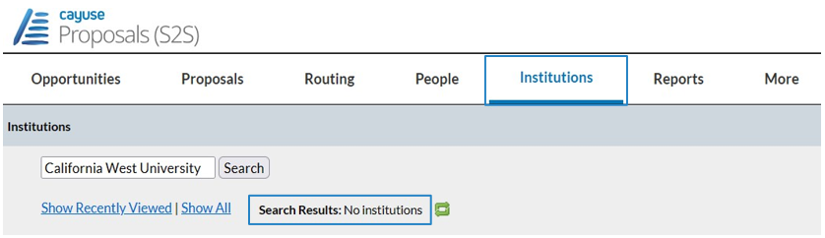

If info is wrong or if the subrecipient’s Organization is not found, write [ORCayuseHelp@ucdavis.edu](mailto:ORCayuseHelp@ucdavis.edu) for assistance.

To request a new

**Institutional Profile**, provide

as much info about the subrecipient organization as possible:

* Institution name
* Institution address
* Unique Entity Identifier # (UEI)
* Or other institutional ID numbers
* Type of institution (e.g., Private Institution of Higher Education)
* Indirect cost types and rates
* If known or applicable:
  + Human Subjects/Animal Welfare Assurance Numbers
  + Dates of HHS certifications
  + Institution base fringe rate (and other fringe categories)
  + Escalation rates for budget items
  + Organizational units

## A screenshot of a computer Description automatically generatedSubaward in Cayuse 424 Proposal

## Create a Subaward

## Add a Site PI/PD in Cayuse 424

## Import a Subaward

Request that the subrecipient send you a Cayuse 424 proposal.

If they do not have Cayuse access, they can use the Cayuse website: <https://subawards.com/>.

Once the Cayuse export file is added, you will be able to see subaward information in the Prime Application.

## View in Prime Application

* Here you can see that the subaward location, though incomplete, has been added to the Prime Application Performance Site form
* Add any missing information or edit other information in the subaward (select “view on subaward”)

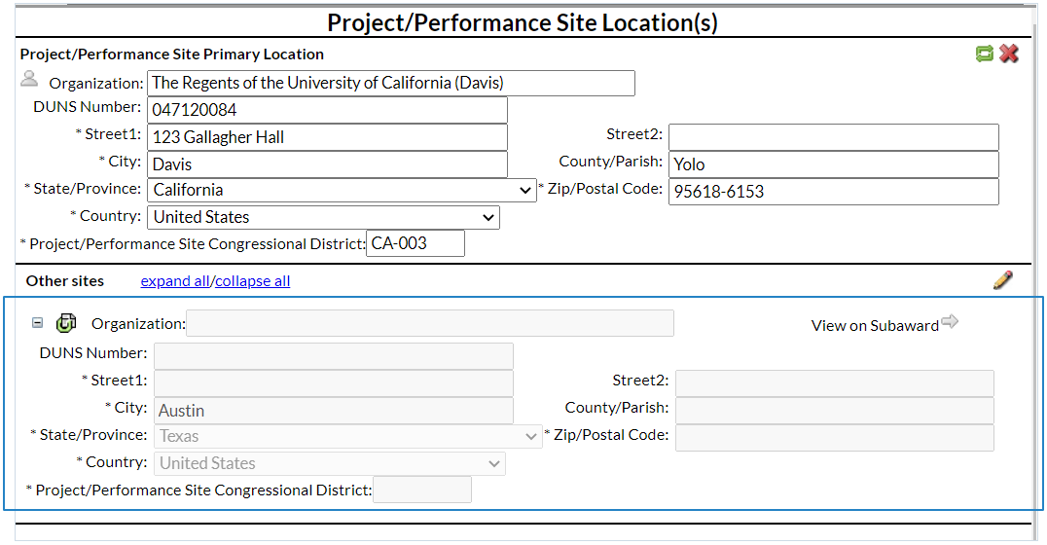

* Here you can see that the subaward site PD/PI is now listed on the Key Personnel form

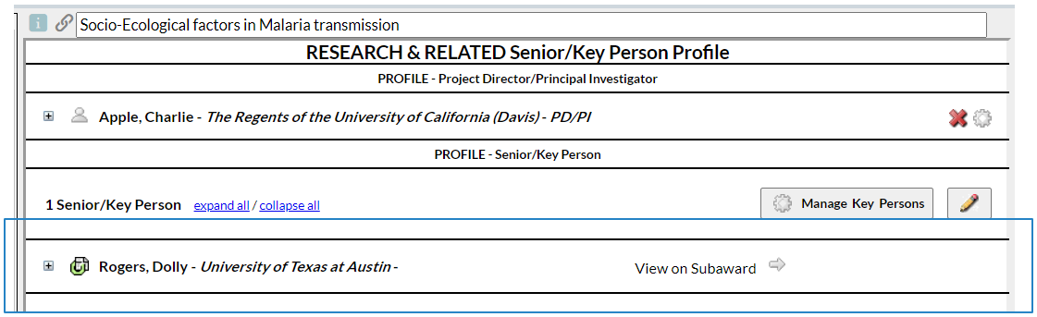

## Link Subaward

When you select **Link Subaward**, you are able to search for and then link a previously imported or created subaward file.

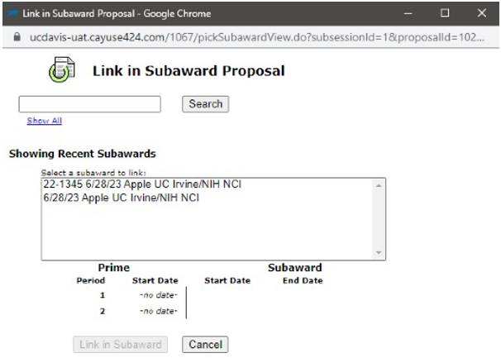

# UC Davis as a Prime Recipient

Outgoing Subawards -

UC Davis may issue subawards after an award has been received

## Outgoing Subaward Process

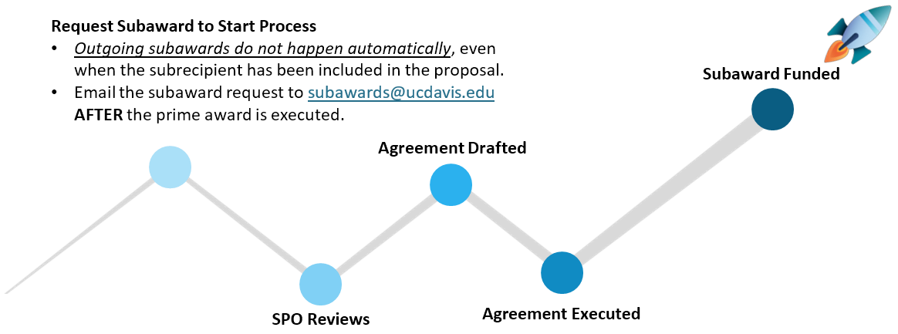

## Subaward Request Form

Find it on SPO’s [Outgoing Subawards](https://research.ucdavis.edu/research-support/awards/subawards/) page, under Forms ([Form Instructions](https://research.ucdavis.edu/wp-content/uploads/Subaward_Request_Form_Instructions.pdf)).

**Best practices:**

* Do not wait
* Submit request as soon as award account is created
* Set calendar reminder to submit amendment one year from end date
* Ensure all fields are completed on the request form

On the 2nd page are two helpful sections.

The **Subaward Specific Requirements** section allows you to enter additional important information or to add explanations for other completed sections.

* The information you provide here can expedite the process by saving the SPO analyst from having to come to you for additional information or clarification.

Additionally, the last section of the form provides live links to other documents that may be required.

* Pay attention to this section to ensure you provide all needed documents.

## Subaward Request Documents

Use the PI/Dep[t Subaward Checklist](https://research.ucdavis.edu/wp-content/uploads/Subaward_PI-Department_Checklist.pdf)

Submit **one Subaward per email** to [subawards@ucdavis.edu](mailto:subawards@ucdavis.edu)

Include the Cayuse SP Project/Award # **and** Lead PI’s name

**First PDF**

* [**Subaward Request Form**](https://research.ucdavis.edu/wp-content/uploads/Subaward-Request-form-FINAL.pdf) ([instructions](https://research.ucdavis.edu/wp-content/uploads/Subaward_Request_Form_Instructions.pdf))
  + Include the Cayuse SP Project No. & the Lead PI’s name

**Second PDF** *(To combine PDFs in Adobe: select ’File’ then ‘Create’ then ‘Combine Files into a Single PDF’)*

* **Commitment Form** (one of the following):
  + [Subrecipient Commitment Form](https://research.ucdavis.edu/wp-content/uploads/UCD_Subrecipient-Commitment-Form_final.pdf)
  + [Multiple Campus Award (MCA) Commitment Form](https://research.ucdavis.edu/wp-content/uploads/MCA_Commitment_Form.pdf)
  + [FDP Supplemental Information Form](https://research.ucdavis.edu/wp-content/uploads/FDP_Subrecipient_Pilot-Supplemental_Project_Info_Form.pdf) (simplified form for participating organizations)
    - * + [Federal Demonstration Partnership (FDP) participating organizations](https://fdpclearinghouse.org/organizations)
* [**Mini-Audit Questionnaire**](https://research.ucdavis.edu/wp-content/uploads/Mini-Audit-Questionnaire1.pdf) (if “no” is selected in Section D of the Subrecipient Commitment Form)
* [**Sole Source Justification Form**](https://research.ucdavis.edu/wp-content/uploads/Sole_Source_Justification_Form.pdf) (if prime sponsor is Federal and subrecipient was not designated at proposal stage)
* **Subrecipient’s Statement of Work**
* **Subrecipient’s Budget and Budget Justification**
* **Subrecipient COI** (see Section C of (UC Davis) Subrecipient Commitment Form)

## Subaward Review

Your assigned **SPO Subawards Analyst will review** the subaward request, **draft** the subaward agreement,

and **negotiate** with the subrecipient as necessary. Some of the items they will review:

**Selection Basis**

* Provide the Sole Source Justification if the Prime award is a Federal contract and the subrecipient was not designated at the proposal stage.
* If the Subrecipient was selected competitively it’s probably not a Subaward.

**Risk Assessment and Compliance**

* SAM/Visual Compliance: Debarred List,
* Delinquent Federal Debt
* Risk Assessment / Continuing Assessment Tool
* Audit: FDP Clearinghouse, Federal Audit Clearinghouse, Mini-Audit Questionnaire
* F&A Rate Determination
* Financial Conflict of Interest (COI) disclosures
* FFATA (Federal Funding Accountability and Transparency Act) Reporting

## Checking Subaward Status in Cayuse SP

**Check Outgoing Subaward Status and SPO Analyst Assignment** video: <https://www.youtube.com/watch?v=4I5X4WLAwDg> (length: 1min 31sec)

## Subaward Statuses

These are the various subaward statuses

[Handbook for Accessing Subawards](https://research.ucdavis.edu/wp-content/uploads/Handbook-Accessing-Subawards-v4.pdf)

# Resources

## Contact Us

Let us know how we did:

<https://ucdavis.co1.qualtrics.com/jfe/form/SV_9QZk1mNDmeBAlaS>

Jamie Robin Fletcher

Contracts & Grants Analyst, Subawards

Tel: 530-754-3732

Email: [jafletcher@ucdavis.edu](mailto:jafletcher@ucdavis.edu)

Perry King   
Training Officer   
Tel: 530-304-8137

Email: [pking@ucdavis.edu](mailto:pking@ucdavis.edu)

## Cayuse SP and 424

* SPO Learning Resources (FAQs, written materials, videos & trainings):
  + [Learn: Cayuse SP](https://research.ucdavis.edu/research-support/proposals/spo-proposal/proposal-submission/cayuse-sp/)
  + [Learn: Managing Roles in Cayuse](https://research.ucdavis.edu/research-support/proposals/spo-proposal/proposal-submission/roles/)
  + [Learn: Cayuse 424 and NIH ASSIST](https://research.ucdavis.edu/research-support/proposals/spo-proposal/proposal-submission/spo-training-grant-subs/)
* [Cayuse 424 Professional Profiles](https://research.ucdavis.edu/wp-content/uploads/Cayuse-Setting-up-your-professional-profile.pdf) (How to set up)
* [Cayuse SP Handbook for Dept. Contract & Grant Staff, PIs and Approvers](https://research.ucdavis.edu/wp-content/uploads/End-users-v13.pdf)
* [Handbook for Role Managers](https://research.ucdavis.edu/wp-content/uploads/Handbook-Role-Managers-022618.pdf)
* [Cayuse Quick Reference](https://research.ucdavis.edu/wp-content/uploads/SP-PIs-and-Dept-Admins-Quick-Reference.pdf)
* [Cayuse SP Tips](https://research.ucdavis.edu/wp-content/uploads/Cayuse-SP-Tips.pdf)

## Electronic Research Administration (eRA) Systems

**UC Davis**

* **Cayuse 424 and SP:** <https://ucdavis.cayuse424.com/>
* [**Biological Use Authorization (BUA) Application**](http://safetyservices.ucdavis.edu/article/biological-use-authorization-bua)
* [**Electronic Conflict of Interest (eCOI) System**](https://or-forms.ucdavis.edu/)([Instructions](https://research.ucdavis.edu/policiescompliance/coi/))
* [**Institutional Animal Care and Use Committee (IACUC) Application**](https://iacuc.ucdavis.edu/protocol/)
* [**IRBNet (Human Subjects Protocols)**](https://www.irbnet.org/release/index.html)
* [**Human Anatomical Specimen and Tissue Oversight Committee (HASTOC) Resources**](https://research.ucdavis.edu/policiescompliance/human-anatomical-specimen-tissue-oversight/)

## UCD/UC Websites & Online Documents

* [**UC Davis Guide to Research Compliance**](https://goo.gl/nxVt67)
* [**Contracts and Grants Accounting (CGA)**](https://financeandbusiness.ucdavis.edu/finance/contracts-grants-accounting)
* [**Office of Research**](http://research.ucdavis.edu/)
* **Checklists (PDFs):**
  + [Call for Proposals Checklist](https://research.ucdavis.edu/wp-content/uploads/03-Call-for-Proposals-Checklist.pdf)
  + [New Proposals Checklist](https://research.ucdavis.edu/wp-content/uploads/02-New-Proposal-Checklist.pdf)
  + [Proposal Preparation Checklist](https://research.ucdavis.edu/wp-content/uploads/Proposal-Preparation-Checklist_v2SPO-Clean.pdf)
  + [Budget Justification Checklist](https://research.ucdavis.edu/wp-content/uploads/Budget-Justification_Checklist.pdf)
  + [Subaward Processing Checklist](https://research.ucdavis.edu/wp-content/uploads/Subaward_PI-Department_Checklist.pdf)
  + [CGA Award Closeout Checklist](https://ucdavis.app.box.com/s/vb1dagm1w558k7ecxoj4r87onltw0cf5)
* [**Sponsors/Agencies that have adopted PHS regulations for COI**](https://research.ucdavis.edu/wp-content/uploads/List-of-Covered-Entities-for-PHS-COI-Rule.pdf) **(PDF)**
* [**Principles Regarding Rights to Future Research Results**](https://www.ucop.edu/research-policy-analysis-coordination/policies-guidance/future-research-results/index.html)

## Common Acronyms

* **AMRC:** Anatomic Materials Review Committee
* **BAA:** Broad Agency Announcement
* **BUA:** Biological Use Approval
* **CGA:** Contracts and Grants Accounting
* **COI:** Conflict of Interest
* **eRA:** Electronic Research Administration
* **F&A:** Facilities & Administrative rates, aka indirect cost rates
* **FOA:** Funding Opportunity Announcement
* **IACUC:** Institutional Animal Care and Use Committee
* **ICR:** Indirect Cost Rate
* **IDC:** Indirect Costs
* **IPF:** Internal Processing Form (Cayuse SP “proposal”)
* **IP:** Intellectual Property
* **IRB:** Institutional Review Board (Human Subjects)
* **PHS:** Public Health Service
* **PI:** Principal Investigator
* **RCR:** Responsible Conduct of Research
* **RECO:** Research Ethics and Compliance Office
* **RFA:** Request for Applications
* **RFP:** Request for Proposals
* **RPPR:** Research Performance Progress Reports
* **SBIR:** Small Business Innovation Research
* **SPO:** Sponsored Programs Office
* **STTR:** Small Business Technology Transfer

## SPO Contacts & Links

* Proposals: [proposals@ucdavis.edu](mailto:proposals@ucdavis.edu)
* Awards: [awards@ucdavis.edu](mailto:awards@ucdavis.edu)
* Subawards: [subawards@ucdavis.edu](mailto:subawards@ucdavis.edu)
* Closeouts: [closeouts@ucdavis.edu](mailto:closeouts@ucdavis.edu)
* eRA Help: [SPOeRAhelp@ucdavis.edu](mailto:SPOeRAhelp@ucdavis.edu)
* Cayuse Help Desk: [ORCayuseHelp@ucdavis.edu](mailto:ORCayuseHelp@ucdavis.edu)
* Training: [SPOTraining@ucdavis.edu](mailto:SPOTraining@ucdavis.edu)
* Negotiations: [OR-SPO-Negotiation-Team@ad3.ucdavis.edu](mailto:OR-SPO-Negotiation-Team@ad3.ucdavis.edu)
* [SPO Contact Us webpage](https://research.ucdavis.edu/about/offices/spo-office/#ci)
* [Sponsored Programs Office (SPO)](https://research.ucdavis.edu/about/offices/spo-office/)
* [SPO Proposal and Award Learning Resources](https://research.ucdavis.edu/research-support/proposals/spo-proposal/spo-training/training-opps/)

## SPO Office Hours & Training Opportunities

**SPO Office Hours:** Bring your questions and join our knowledgeable staff for guidance and training on preparing and submitting proposals for extramural funding.

* Drop in via Zoom the 1st Thursday of each month between 10 and 11am <https://ucdavis.zoom.us/j/96045587567?pwd=MnVMTXN5SDRuM0RITzlKUjNmdjl5Zz09>

**All SPO training opportunities** at <https://research.ucdavis.edu/research-support/proposals/spo-proposal/spo-training/training-opps/>

## Research Administration Forum

Forum for department research administrators to:

**Hear updates Ask questions Provide feedback**

Sponsored Programs Office (SPO)

IRB Administration

IACUC

Technology Transfer

Contracts and Grants Accounting (CGA)

Research Ethics and Compliance Office (RECO)

**Join via** [**Zoom**](https://ucdavis.zoom.us/j/99842677540)

**4th Wednesday of each month ( Jan – Oct)**

**8:30 am**

Access videos of previous forums and related materials on the [Forum](https://research.ucdavis.edu/research-support/proposals/spo-proposal/spo-training/research-administration-forums/) webpage

## Office of Research Listservs

**Contracts & Grants (OVCR-cg) listserv**

* The primary mechanism for informing the campus community of the latest research administration news.
* Click this [link](https://lists.ucdavis.edu/sympa/subscribe/ovcr-cg) to subscribe (UC Davis emails)

**SPO Cayuse info listserv**

* Cayuse SP and 424 info and announcements, as well as training opportunities from the Sponsored Programs office.
* Click this [link](https://lists.ucdavis.edu/sympa/subscribe/spo_cayuse_info) to subscribe (UC Davis emails)

[Other Office of Research Listservs](https://research.ucdavis.edu/about/connect-with-us/listserv-subscriptions/)

## UC Learning Center classes

SPO offers classes individually or as a series:

* [Research Administration Certificate Series (RACS)](https://hr.ucdavis.edu/departments/learning-dev/certificate/research-admin)
* [eRA Train the Trainer Certificate Series](https://hr.ucdavis.edu/departments/learning-dev/certificate/eRA)
* [Individual classes](https://hr.ucdavis.edu/departments/learning-dev/course-catalog/research) (under “Grants and Sponsored Programs”)

## Thank you!

Follow SPO on [X](https://x.com/UCDavisSPO) and [YouTube](https://www.youtube.com/channel/UC5tWJ6oF2G5nYarcdAK9SwQ)!