**Proposal Preparation and Submission**

Presented by the UC Davis Sponsored Programs Office

**Learning Objectives**

After this class, you should:

1. Understand the extramural proposal process at UC Davis
2. Be able to identify key information from sponsor guidelines to begin proposal preparation
3. Know how to submit a proposal to the Sponsored Programs Office (SPO)
4. Know how to work with SPO on proposal review and submission to sponsor

Helpful resource: [SPO Key Terms](https://research.ucdavis.edu/wp-content/uploads/SPO_KeyTerms.pdf) *(abbreviations and definitions)*

*Use* ***CTRL + Click*** *on row below to jump to that section*

Contents

Proposal Process 3

Sponsored Programs Office (SPO) 3

Overview: Contract & Grant Funding Process 3

Proposal Internal Routing Timeline 4

PI/Co-PI Certifications 4

Proposal Review and Submission Timeline 5

Sponsor Guidelines 5

Sponsor Guidelines 5

PI Eligibility 5

Institutional Eligibility 6

Important Dates 6

Budget Information 6

Budget Terms 7

Departmental Responsibilities 7

Proposal Development & Preparation 8

Call for Proposals Checklist 8

Proposal Development 8

Coordinate and Prepare 9

The Budget 9

OR Budget Templates 10

Budget Template Worksheets 10

Effectively Using the OR Budget Template 12

Internal Documents, as applicable 12

Financial Conflict of Interest (COI) Requirements 12

Disclose Financial COI 13

Subawards 13

Subrecipient, Contractor/ Vendor, Consultant? 13

Outgoing Subawards 13

Cayuse SP 14

Proposal Preparation 14

Cayuse SP Best Practices 18

Cayuse Research Contacts 18

Review & Submission to Sponsor 19

Minimum Proposal Documents for SPO Assignment 19

SPO Proposal Review Levels 19

SPO Review 20

Submission to Sponsor 20

Checking IPF Status and SPO Assignment 21

Cayuse SP Proposal Statuses 21

Resources 22

Contact Us 22

Common Acronyms 22

Sponsored Programs Contacts & Links 22

Electronic Research Administration Systems 23

UC Davis (& UC) Websites and Documents 23

SPO Office Hours & Training Opportunities 23

Research Administration Forum 23

Office of Research Listservs 24

UC Learning Center classes 24

Thank you! 24

# Proposal Process

## Sponsored Programs Office (SPO)

Per UC policy, all proposals for extramural funding must be submitted through SPO.

Exceptions:

* Limited submission pre-proposals
* Letters of Intent (LOIs) or pre-proposals that do not require:
  + A budget,
  + Institutional signature
  + Agreement to terms & conditions

Some sponsors require the PI submit. In these cases, SPO will return the approved proposal to the PI for submission.

All financial management of awards/subawards is handled by **Contracts & Grants**

**Accounting (CGA)**, not SPO.

Relevant Policies:

* [C&G Manual 2-200](https://www.ucop.edu/research-policy-analysis-coordination/resources-tools/contract-and-grant-manual/chapter2/chapter-2-200.html)
* [UC Contract and Grant Manual 1-500 Principal Investigator Guidelines](https://www.ucop.edu/research-policy-analysis-coordination/resources-tools/contract-and-grant-manual/chapter1/chapter-1-500.html)
* [Memo – Operating Guidance No. 95-1](https://policy.ucop.edu/doc/2500500/ReqSubmitProp-Awar)
* [Standing Orders of The Regents of the University of California – Duties of the President of the University](https://regents.universityofcalifornia.edu/governance/standing-orders/so1004.html)

## A diagram of a company's company's company Description automatically generated with medium confidenceOverview: Contract & Grant Funding Process

## A close-up of a computer screen Description automatically generatedProposal Internal Routing Timeline

IPF = Internal Processing Form. This is the electronic document you complete and route in

Cayuse SP along with attachments. Folks often refer to it as the “proposal.”

## A screenshot of a computer Description automatically generatedPI/Co-PI Certifications

## Proposal Review and Submission Timeline

# Sponsor Guidelines

## Sponsor Guidelines

**Multiple Sets**

Sponsors may require applications adhere to multiple sets of guidelines

* Program Solicitations
* Sponsor Overarching Guidelines
* Sponsor Funding Program Guidelines
* Project Scope-Specific Guidelines
* Some FAQs, such as from Foundations

**Use the Sponsor Resources**

* Review the sponsor websites

**Be Thorough**

* Avoid submission rejections

**Respect Deadlines**

* Federal sponsors request applications two (2) business days before deadline

## PI Eligibility

Sponsors may limit eligible individuals for funding based on a variety of factors:

**Professional Appointment**

* Early-stage investigator
* Tenure-track
* Established investigator

**Experience**

• Publications

• Research or education projects

**Education**

* Highest degree earned
* Specific discipline

If the investigator is eligible per the sponsor but does not have PI eligibility at UC Davis:

* Submit [Form 105](https://research.ucdavis.edu/wp-content/uploads/Form-105_2018.pdf) to SPO with the proposal.

## Institutional Eligibility

**Internal Coordination**

Sponsors may require coordination at the applicant institution before proposal submission.

* **Limited Submissions** limit the number of applications an entity may submit
* **Coordinated Submissions** may restrict multiple applications for similar projects

**Eligible Applicant Institutions**

Sponsors may restrict entities that may apply.

UC Davis is an **Eligible Applicant Institution** as follows (assuming it meets other eligibility requirements):

* Institution of Higher Education (IHE)
* Public Institution of Higher Education
* 1862 Land Grant University
* Non-Profit Institution; 501c3

## Important Dates

Program solicitations and other sponsor guidelines include important dates.

* **Due Dates**
  + May be specified or standard dates, such as NIH uses
* **Project Start Date Expectations**
* **Project Periods**

## Budget Information

Follow all sponsor guidelines regarding the budget.

* **Award Period Number/Length**

This affects rate calculations and escalations, if included.

* **Budget Limitations**

The sponsor may limit direct costs, total costs or indicate some costs are not allowed.

* **F&A (Indirect) Cost Rates**

In general, the [Federally Negotiated (NICRA) rates](https://research.ucdavis.edu/research-support/proposals/budget-development/indirect-cost-fringe-benefit-rates/) should be used. However, there are some exceptions.

## Budget Terms

* **Direct costs:** Expenses that are clearly associated with and necessary to complete a sponsored project.
* **Indirect costs:** Also known as Facilities and Administration (F&A) costs, these costs are associated with the general operation of UC Davis and cannot be readily assigned to individual projects. These costs include:
  + General purpose equipment
  + Routine postage
  + Building maintenance and utilities
  + Library expenses
  + Facilities and maintenance
  + General and departmental administration
  + Clerical and administrative salaries and fringe benefits
  + General office supplies
* **F&A Cost Rate:** The proportion of indirect costs each project/program should bear using sound administrative principles.
  + The university commonly uses federally negotiated indirect cost rates (“NICRA”) though rates may vary based on sponsor policy and program guidelines.
* **F&A Cost Base:** The amount of direct costs that should be used to determine F&A costs.
  + **Modified Total Direct Costs (MTDC)** is the most commonly used F&A cost base at UC Davis.

**Excluded from MTDC base:**

* Equipment
* Scholarships and fellowships
* Rental costs of off-site facilities
* Capital expenditures
* Charges for patient care
* Student tuition remission
* The portion of each subaward in excess of $25,000

**Included in MTDC base:**

* Salaries and wages
* Fringe benefits (i.e., employee benefits)
* Travel
* Materials and supplies
* Services
* The first $25,000 of each subaward

MTDC info on page 2 of the UC Davis F&A and Fringe [Benefits Rate Agreement](https://research.ucdavis.edu/wp-content/uploads/FA-Rate-Agreement.pdf)

* + **TDC:** Total Direct Costs. All direct costs are included when determining indirect costs.
* **AY:** Academic Year (9 mos)
* **FY:** Fiscal Year (12 mos - from July 1 to June 30 of following year)
* **PY:** Project Year (annual period during which project will/is planned to occur)

## Departmental Responsibilities

**Appropriate Formatting**

* Table of Contents
* Page margins
* Font/pitch
* Line spacing
* Characters per inch
* Page limitations
* Spelling and grammar

**Required Components Included**

All forms, documents and information

Some components may be required based on the

project scope:

* Human and animal subjects
* Use of pathogenic materials
* International involvement

**Sponsors may reject proposals without review for not following administrative guidelines.**

# Proposal Development & Preparation

## Call for Proposals Checklist

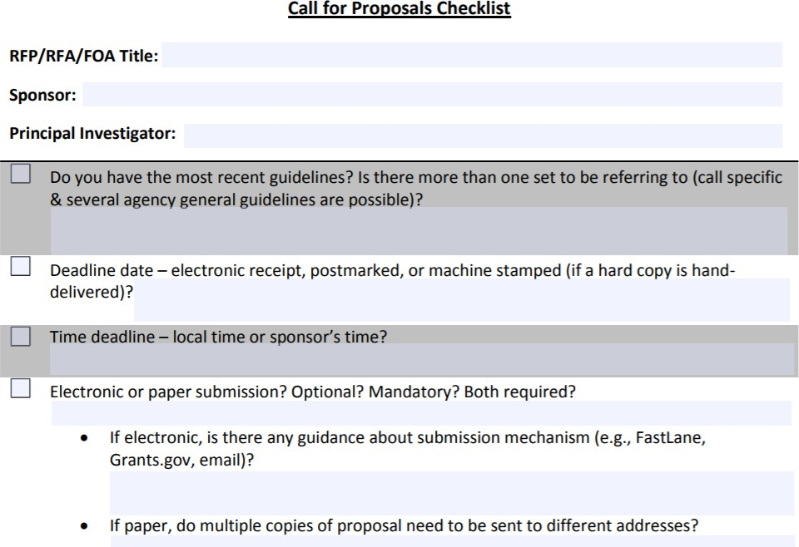

As you **read sponsor and UC Davis guidelines**, consider using our   
[Call for Proposals Checklist](https://research.ucdavis.edu/wp-content/uploads/03-Call-for-Proposals-Checklist.pdf).

This document is designed to help   
you extract key information.

## Proposal Development

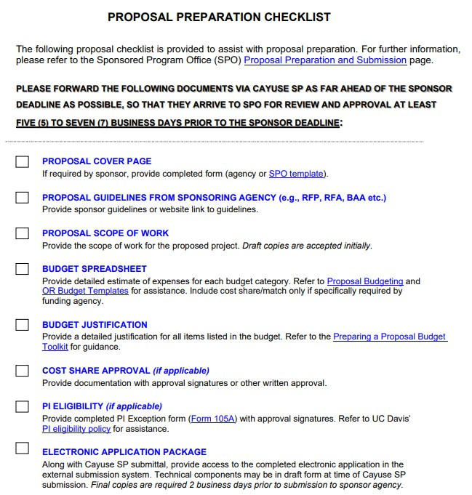

As you **determine required components** and **set deadlines**:

* Coordinate with the PI
* Use checklists, timelines and/or production calendars
* Consider using our [Proposal Preparation Checklist](https://research.ucdavis.edu/wp-content/uploads/Proposal-Preparation-Checklist_v2SPO-Clean.pdf)

## Coordinate and Prepare

Common proposal components

## The Budget

* Start early!
* Use an **OR Budget Template** *(more on next slide)*
* Reference the [Preparing a Proposal Budget Handbook](https://research.ucdavis.edu/wp-content/uploads/Preparing-a-Proposal-Budget-Toolkit.pdf)
* Pay attention to **indirect (or F&A) costs**
  + [Federally negotiated (NICRA) F&A rates](https://research.ucdavis.edu/research-support/proposals/budget-development/indirect-cost-fringe-benefit-rates/)
  + The Cayuse SP Internal Processing Form (IPF) includes a pop-up with current F&A rates
  + Some costs are not subject to indirect costs (such as equipment)
* Don’t forget the **Budget Justification**
  + Strongly encouraged even when not required by the sponsor

Learn more about budgeting:

* **Preparing a Proposal Budget: Basics** [eCourse](https://uc.sumtotal.host/rcore/c/pillarRedirect?relyingParty=LM&url=app%2fmanagement%2fLMS_ActDetails.aspx%3fActivityId%3d119437%26UserMode%3d0&domain=8)
* **Preparing a Proposal Budget: Lab** [instructor-led training over Zoom](https://uc.sumtotal.host/rcore/c/pillarRedirect?isDeepLink=1&relyingParty=LM&url=https%3A%2F%2Fuc.sumtotal.host%2Flearning%2Fcore%2Factivitydetails%2FViewActivityDetails%3FUserMode%3D0%26ActivityId%3D58096%26ClassUnderStruct%3DFalse%26CallerUrl%3D%2Flearning%2Flearner%2FHome%2FGoToPortal%3Fkey%3D0%26SearchCallerURL%3Dhttps%253A%252F%252Fuc.sumtotal.host%252Fcore%252FsearchRedirect%253FViewType%253DList%2526SearchText%253Dproposal%25252520preparation%25252520and%25252520submission%2526startRow%253D0%26SearchCallerID%3D2)
  + The **Basics** course is a required prerequisite

## OR Budget Templates

<https://docs.or.ucdavis.edu/spo/>

**Benefits:**

**Improved Accuracy**

* Current Rates and Fees
  + - * Facilities and Administration (F&A)
      * Fringe Benefits
      * Single IRB Fees
* Built-in Formulas
* Split Rates
* Data for Sponsor Forms

**Can customize for your project**

* Appointment Type (months)
* Escalations
* F&A Rates
* F&A Bases

Contact [proposals@ucdavis.edu](mailto:proposals@ucdavis.edu) to request a customized template.

## Budget Template Worksheets

Each Budget Template includes several worksheets (tabs in footer)

**Request** tab:

* The detailed budget spreadsheet you upload into Cayuse SP.

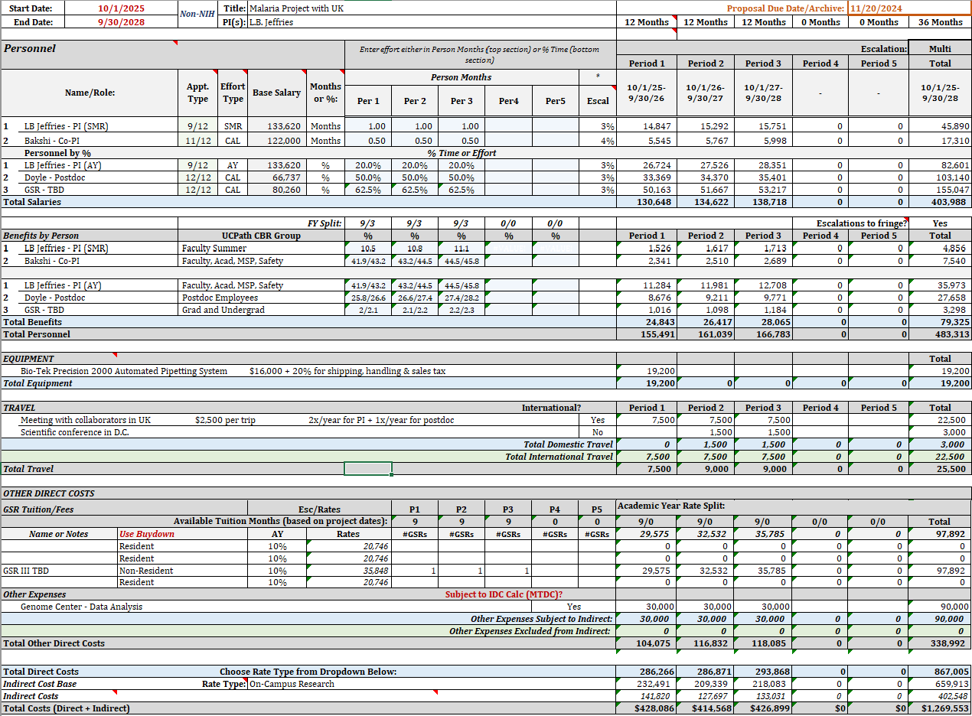

**F&A Details** tab:

* Breakdown of F&A rates, bases and costs for each Project Period and the entire project

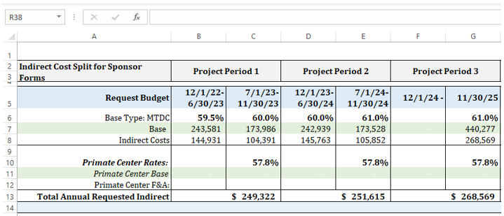

**Personnel Reference** tab:

* Data by personnel type for sponsor forms:
  + Salary
  + Fringe
  + Person Months
* Location of **Custom Escalation** fields
* Data on each individual for sponsor forms:
  + Base Salary with escalations
  + Person Months
  + Annual effort in percentages
  + Salary plus fringe benefits

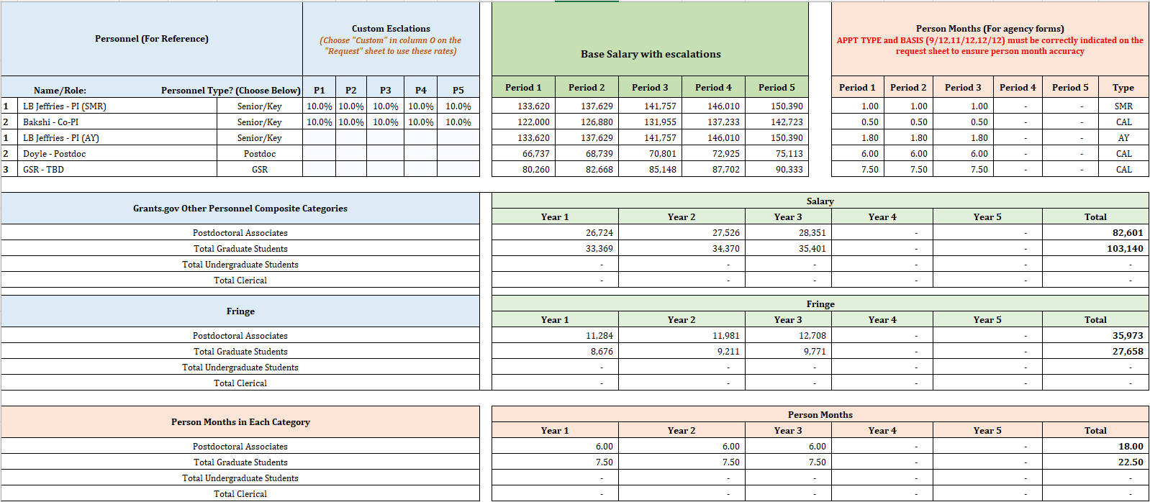

## Effectively Using the OR Budget Template

✓

✓

**Use Current Version**

**Use as Designed**

Use the built-in formulas to maintain calculation accuracy

Copy and paste **values** and **plain text** only

**Hide and un-hide** lines instead of deleting/adding

**Check Calculations**

Check budget calculations for **“red flags”**

If there are errors, look for fields no longer auto-calculating

✓

Download the template for **each project** to ensure current F&A and Fringe Benefit rates

## Internal Documents, as applicable

* Letters of support required for **cost share commitments**
  + Cost share is not always allowed   
    ([Cost Sharing Guidance](https://research.ucdavis.edu/wp-content/uploads/Cost-Sharing-Guidance_060418.pdf))
* **Exception to PI Status**
  + [Form 105](https://research.ucdavis.edu/wp-content/uploads/Form-105_2018.pdf)
  + If the form is attached to the IPF prior to routing, the departmental/dean authorizations will suffice in place of required signatures.
* **Informed Participation/Special Individual Agreement**
  + Facilitate signatures if form requested by SPO
* [**Protocol Certifications**](https://research.ucdavis.edu/wp-content/uploads/Protocol_Certification_Form-FINAL.pdf), if requested by SPO
  + IRB, IACUC, HASTOC, BUA, etc.

## Financial Conflict of Interest (COI) Requirements

**Award Stage**

* Form 700-U (State of California requirement)
  + Awards from non-governmental sources not on the exempt list
  + Signed at award acceptance (no more than 30 days before award acceptance)
* Statement of Economic Interests Supplemental Form
  + Positive disclosures
  + Required before award can be released

**Proposal Stage**

* Form 800
  + Awards from the NSF, CIRM and UCOP Special Programs
  + Non-PHS awards that involve human subjects
* PHS COI
  + Awards from any PHS agency or [other sponsor that has adopted](https://research.ucdavis.edu/wp-content/uploads/List-of-Covered-Entities-for-PHS-COI-Rule.pdf) the PHS regulations
  + Online Training (required every 4 years) and annual PHS e-disclosure

## Disclose Financial COI

* File disclosures [online](https://or-forms.ucdavis.edu/)
* Investigator must initiate and submit
  + Can establish one admin contact
  + Do not list the SPO analyst as the admin contact
* Need help? Contact [or_coi@ucdavis.edu](mailto:or_coi@ucdavis.edu)

## Subawards

* Awards issued from a **Prime Recipient** institution to another institution (**Subrecipient**) to carry out part of a **Prime Award**
* A Subaward is appropriate if the **Scope of Work** is for research and meets one or more of the following:
* Performance represents an **intellectually significant portion of the overall programmatic effort** and is measured against the sponsor’s objectives
* There is **an identified principal investigator for the subrecipient** who has responsibility for making programmatic decisions
* Will use the funds to carry out a program for a **public purpose**, as opposed to providing goods or services for the benefit of UCD
* Subrecipient entity is **an institution** (not an individual)

## Subrecipient, Contractor/ Vendor, Consultant?

Helpful document: <https://research.ucdavis.edu/wp-content/uploads/Sub-Table.pdf>

## Outgoing Subawards

**Appropriate Subrecipient Commitment Form (PDF 1)**

* **Subrecipient Commitment Form:** Subrecipient is not participating in the [FDP Expanded Clearinghouse](https://fdpclearinghouse.org/organizations)
* **FDP Subrecipient Pilot – Supplemental Project Information Form:** Subrecipient participating in the FDP Expanded Clearinghouse
* **Multiple Campus Award (MCA) Commitment Form:** Subrecipient is another UC campus

**Additional Key Documents (PDF 2)**

* Subrecipient’s Statement of Work
* Subrecipient’s Budget and Budget Justification
* Subrecipient’s Conflict of Interest (COI) documentation

**Subrecipient’s F&A Cost Information (3)**

* F&A rate and base
* Include the subrecipient’s policy

***To combine multiple documents in one PDF:*** *In Adobe, select* ***File*** *then* ***Create*** *then* ***Combine Files into a Single PDF****.*

## Cayuse SP

<https://ucdavis.cayuse424.com/>

Used to route proposals (and some award modifications) for internal approvals:

* Lead PI/co-PI certification
* Dept Chair/unit head (and Dean) authorization
* SPO review/approval

## Proposal Preparation

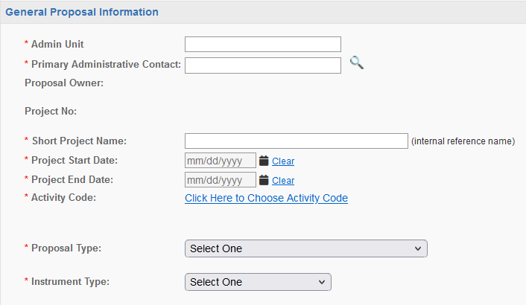

Usually you, the person in the department who can answer questions about the proposal.

Selecting the appropriate **Proposal Type** can help avoid confusion (and wasted time).

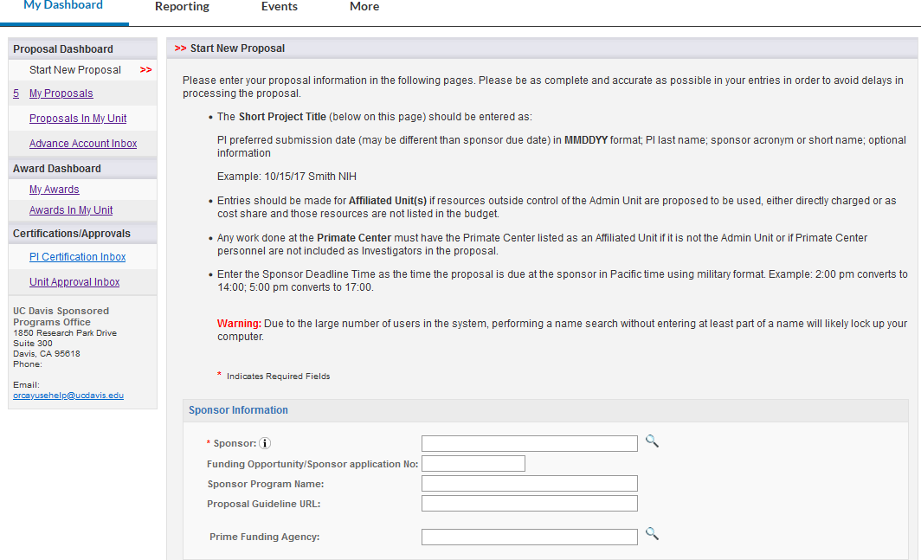

It can speed proposal review if you complete as many fields as possible, not just required ones.

If **Sponsor** is not found (check spelling), select **Miscellaneous Sponsors** then add all sponsor details you have to **Submission Notes** tab.

* It can speed the process if you email [ORCayuseHelp@ucdavis.edu](mailto:ORCayuseHelp@ucdavis.edu) with sponsor details and request it be added.

Only use when submitting a proposal for a subaward (i.e., UCD is subrecipient).

Note the instructions for how to enter the **Short Project Title** (aka **Short Project Name**).

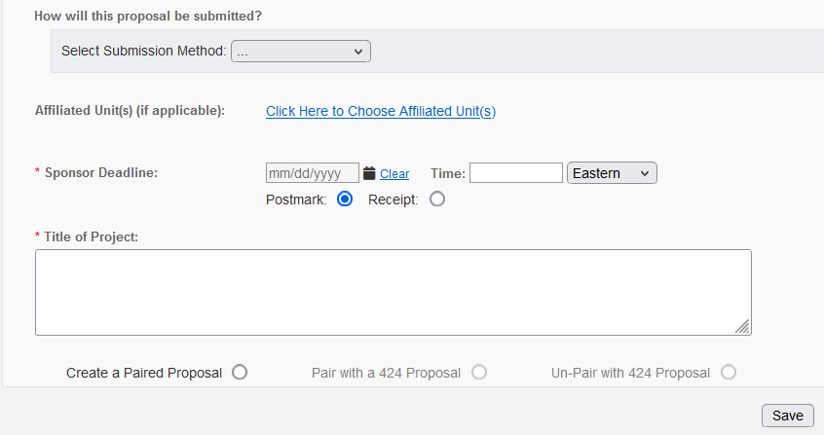

Rarely used, but if you’re submitting a PI or Admin unit change, here is where you’d enter the former PI’s unit or Admin unit so they can review and approve the change.

Regardless of sponsor submission time, SPO will only submit up to 17:00 PST.

Change to **Receipt**.

**Do not pair**. Creates technical issues.

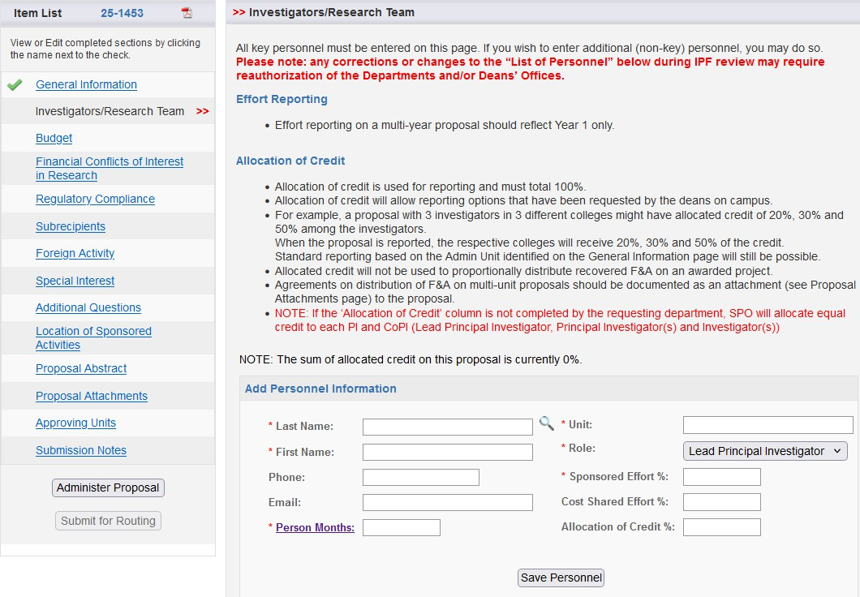

Work your way down, page by page, until all have green checkmarks (though **Submission Notes** doesn’t need one). Then you can **Submit for Routing**.

Though not required, please enter **Allocation of Credit**.

The first name you add will be the **Lead Principal Investigator**.

Clicking this link will download an Excel doc (from NIH) to convert % into Person-Months.

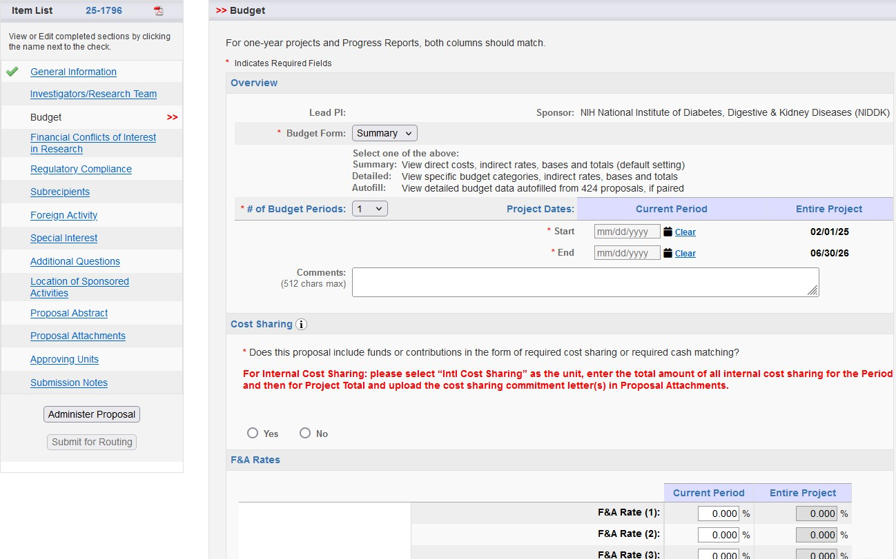

Keep **Summary**.

* You’ll be attaching a detailed internal budget.

Select **No**.

* SPO prefers to add the cost-sharing to Cayuse SP themselves.
* Attach a signed letter from the unit/3rd party committing the cost share.
* Add a **Submission Note** to indicate you’ve left it to SPO to add the cost-share.

Clicking these fields will take you to table to choose appropriate F&A rate(s).

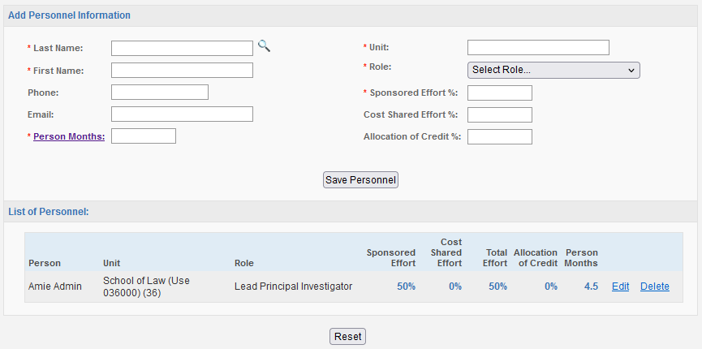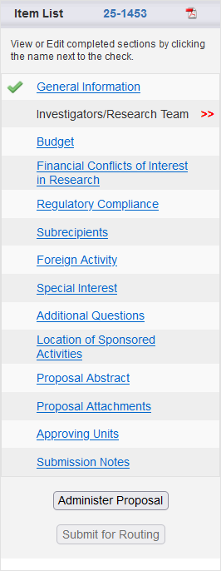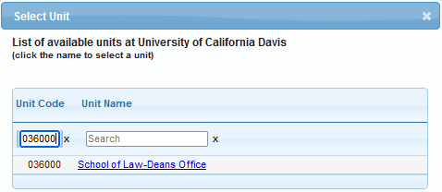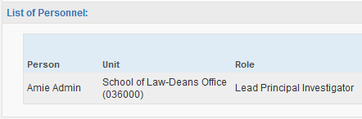

If an investigator’s **Unit** indicates “(Use [other Unit Code])” use **Edit** to revise the individual’s unit as instructed.

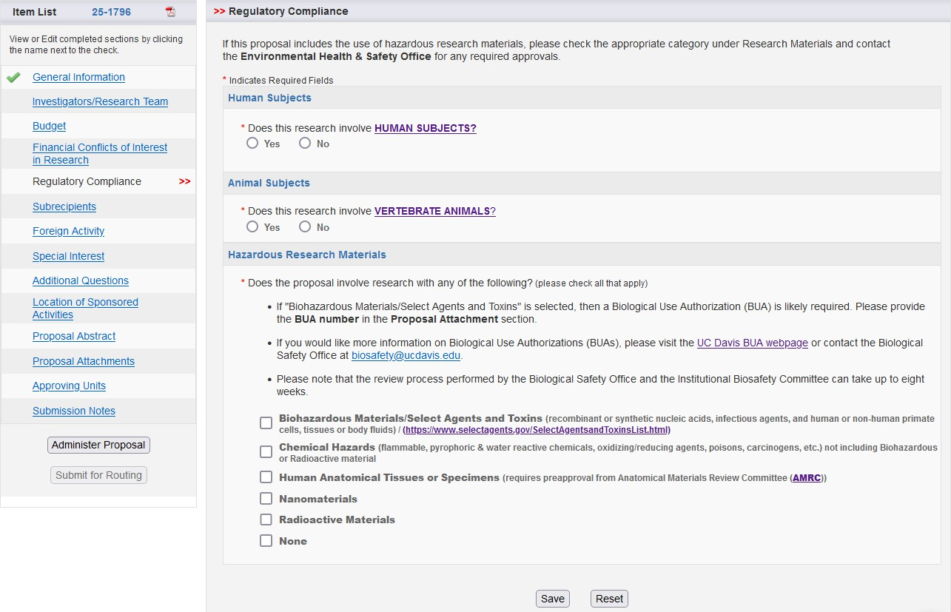

For other pages in proposal, enter accurate information. The PI will be certifying that the information in this proposal is accurate.

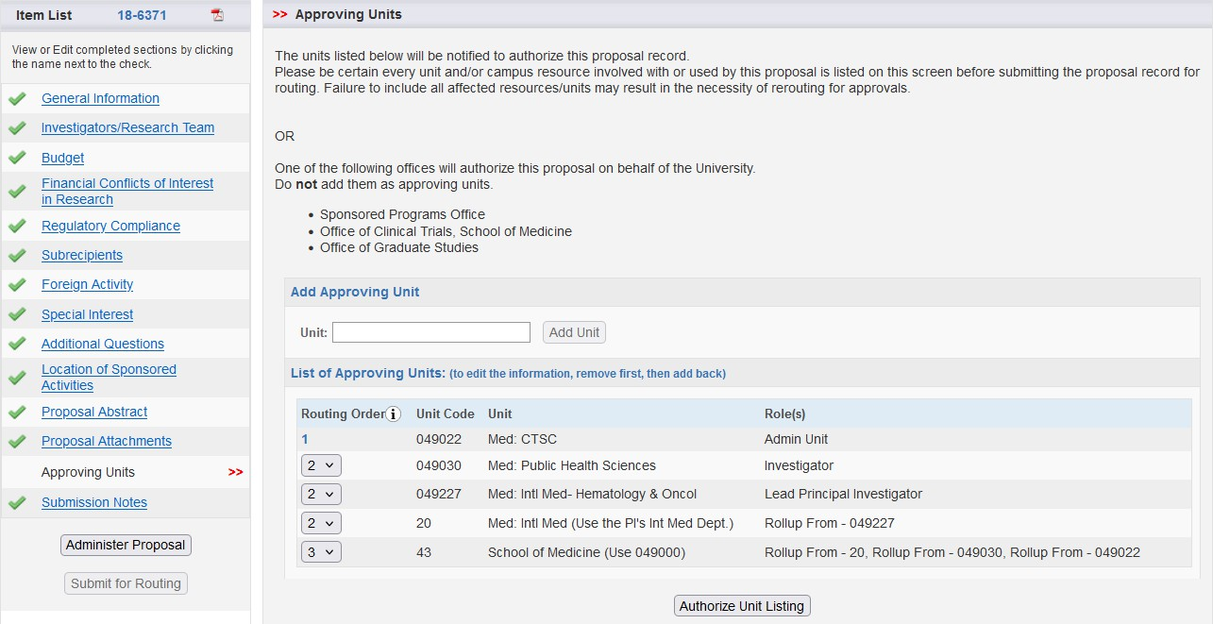

Verify the **Approving Units** look correct.

* Each investigator’s home unit is added.

Add any Submission Notes that can help the SPO analyst expedite the review.

## Cayuse SP Best Practices

**Use the Resources**

Review [Training Materials](https://research.ucdavis.edu/research-support/proposals/spo-proposal/proposal-submission/cayuse-sp/)

**Monitor Routing**

Check the status and ensure the fully certified/authorized IPF is received by SPO **at least 5 business days** before deadline

**Be Thorough**

Provide required information & documents

**Confirm IPF Approvers**

All **Approving Units** require an IPF Approver –

*Don’t worry about “****Rollups****”*

* To check, in Cayuse SP select **More** in top toolbar
* Then select **View Roles By Unit**
* Search for unit (can use CTRL + F)
* Click **View**
* Under **Roles**, look for “IPF Approver”

## Cayuse Research Contacts

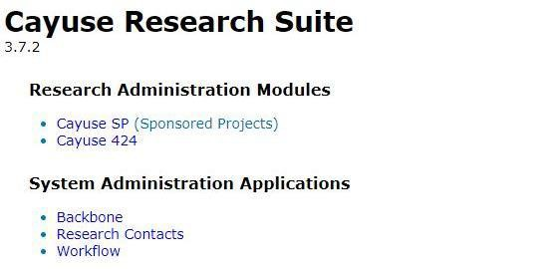

An additional method to **view role assignments** for admin units

# Review & Submission to Sponsor

## Minimum Proposal Documents for SPO Assignment

If these items are not included, they will be requested, delaying the process.

1. **Completely Routed and Authorized IPF**

Complete IPF with Lead PI and co-PI Certifications and IPF Authorizations

1. **Budget Spreadsheet**

STRONGLY ENCOURAGED even if not required by the sponsor

* If the PI refuses to add a budget or justification, add a note in the Submission Notes that indicates none will be provided.

1. **Budget Justification**

STRONGLY ENCOURAGED even if not required by the sponsor

1. **Scope of Work**

May submit a draft and provide the final before submission to sponsor

## SPO Proposal Review Levels

Sponsored Programs is open M-F, 8am to 5pm.

**All proposals must be submitted to sponsors before 5pm, even if the sponsor has a later submission time.**

## SPO Review

**SPONSOR AND REGULATORY COMPLIANCE**

**Eligibility**

* Is UC Davis eligible based on program guidelines?
* Is the PI eligible?
* If the program is a limited submission, was the PI selected to apply through the Limited Submission process?

**Sponsor and Program Administrative Guidelines**

* Are required proposal components provided?
* Are there any errors (in the eRA system) that would result in the submission being rejected?

**Financial Conflicts of Interest**

* Were required e-disclosures filed?
  + i.e., Form 800, Form 700-U, PHS COI disclosure

**TERMS AND CONDITIONS**

**If terms and conditions must be agreed to at the proposal stage, they must be:**

* Acceptable to the UC Regents
* Acceptable to the PI
  + The PI may be asked to sign an **Informed Participation Agreement** if potentially problematic terms are identified.

**CAMPUS REQUIREMENTS**

**Budget Information**

* Appropriate F&A rate and base accurately applied?
* Accurate calculations and rates, including benefits and GSR tuition and fees?
* Allowable and allocable costs?
* Matching budget and budget justification?
* Accurate subaward costs?
* Cost-sharing documentation?

**Scope of Work**

* Appropriate F&A rate (per Activity Type) applied?
* Are appropriate compliance protocols in place (i.e., IRB, IACUC)?
  + If applicable, they will be required at the Just-in-Time (JIT) or award phase

**Subaward/Subcontract Information**

* Subrecipient identified on the Subcontractor tab (in Cayuse SP)?
* All required subrecipient attachments included?

## Submission to Sponsor

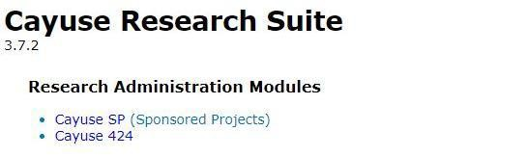

As mentioned earlier, once you have routed the Cayuse SP IPF for internal approvals:

1. **Copy the information from the IPF into the external eRA system** for submission to the sponsor, and

Use to submit applications

to most Federal sponsors

1. **Provide your SPO Proposal Analyst access to this eRA system.**
   * [A close up of a sign

     Description automatically generated](https://www.research.gov/research-web/)They will already have access to proposals in   
     Cayuse 424.

**Always** submit to **NSF** in

[Research.gov](https://www.research.gov/research-web/)

Your Proposal Analyst will additionally review the proposal in the sponsor’s submission system and when approved, submit it on behalf of the university.

**Always** submit to **NASA**

in [NSPIRES](https://nspires.nasaprs.com/external/)

* If the sponsor requires the submission to come from the PI, SPO will provide the approved package to the PI for submission.

## Checking IPF Status and SPO Assignment

Find the IPF from **My Proposals** or **Proposals in My Unit.**

Video: <https://www.yout-ube.com/watch?v=UTQDFoxmI3o> (length: 3:52)

* *If the video doesn’t start on the first try — “This video is unavailable” — simply refresh the video and it should work.*

## Cayuse SP Proposal Statuses

# Resources

## Contact Us

**Course Evaluation**

Please let us know how we did

<https://ucdavis.co1.qualtrics.com/jfe/form/SV_5aT4bDexvSSYJrE>

Perry King

Training Officer

Email: [pking@ucdavis.edu](mailto:pking@ucdavis.edu)

Jeff Grandy

Contract and Grant Analyst

Email: [jmgrandy@ucdavis.edu](mailto:jmgrandy@ucdavis.edu)

## Common Acronyms

* **AMRC:** Anatomic Materials Review Committee
* **BAA:** Broad Agency Announcement
* **BUA:** Biological Use Approval
* **CGA:** Contracts and Grants Accounting
* **COI:** Conflict of Interest
* **eRA:** Electronic Research Administration
* **F&A:** Facilities & Administrative rates, aka indirect cost rates
* **FOA:** Funding Opportunity Announcement
* **IACUC:** Institutional Animal Care and Use Committee
* **ICR:** Indirect Cost Rate
* **IDC:** Indirect Costs
* **IPF:** Internal Processing Form (Cayuse SP “proposal”)
* **IP:** Intellectual Property
* **IRB:** Institutional Review Board (Human Subjects)
* **PHS:** Public Health Service
* **PI:** Principal Investigator
* **RCR:** Responsible Conduct of Research
* **RECO:** Research Ethics and Compliance Office
* **RFA:** Request for Applications
* **RFP:** Request for Proposals
* **RPPR:** Research Performance Progress Reports
* **SBIR:** Small Business Innovation Research
* **SPO:** Sponsored Programs Office
* **STTR:** Small Business Technology Transfer

## Sponsored Programs Contacts & Links

* Proposals: [proposals@ucdavis.edu](mailto:proposals@ucdavis.edu)
* Awards: [awards@ucdavis.edu](mailto:awards@ucdavis.edu)
* Subawards: [subawards@ucdavis.edu](mailto:subawards@ucdavis.edu)
* Closeouts: [closeouts@ucdavis.edu](mailto:closeouts@ucdavis.edu)
* eRA Help: [SPOeRAhelp@ucdavis.edu](mailto:SPOeRAhelp@ucdavis.edu)
* Cayuse Help Desk: [ORCayuseHelp@ucdavis.edu](mailto:ORCayuseHelp@ucdavis.edu)
* Training: [SPOTraining@ucdavis.edu](mailto:SPOTraining@ucdavis.edu)
* Negotiations: [OR-SPO-Negotiation-Team@ad3.ucdavis.edu](mailto:OR-SPO-Negotiation-Team@ad3.ucdavis.edu)
* [SPO Contact Us webpage](https://research.ucdavis.edu/about/offices/spo-office/#ci)
* [Sponsored Programs Office (SPO)](https://research.ucdavis.edu/about/offices/spo-office/)
* [SPO Proposal and Award Learning Resources](https://research.ucdavis.edu/research-support/proposals/spo-proposal/spo-training/training-opps/)

## Electronic Research Administration Systems

**List of internal and external eRA systems:**

* <https://research.ucdavis.edu/research-support/proposals/spo-proposal/proposal-submission/era/>

**UC Davis systems**

* Cayuse 424 and SP: <https://ucdavis.cayuse424.com/>
* [Biological Use Authorization (BUA) Application](http://safetyservices.ucdavis.edu/article/biological-use-authorization-bua)
* [Electronic Conflict of Interest (eCOI) System](https://or-forms.ucdavis.edu/)
* [Human Anatomical Specimen and Tissue Oversight Committee (HASTOC) Resources](https://research.ucdavis.edu/policiescompliance/human-anatomical-specimen-tissue-oversight/)
* [Institutional Animal Care and Use Committee (IACUC) Application](https://iacuc.ucdavis.edu/protocol/)
* [IRBNet (Human Subjects Protocols)](https://www.irbnet.org/release/index.html)

## UC Davis (& UC) Websites and Documents

* [Office of Research](http://research.ucdavis.edu/)
* [Contracts and Grants Accounting](https://financeandbusiness.ucdavis.edu/finance/contracts-grants-accounting)
* [UC Davis Guide to Research Compliance](https://goo.gl/nxVt67)
* [CGA Award Closeout Checklist](https://ucdavis.app.box.com/s/vb1dagm1w558k7ecxoj4r87onltw0cf5)
* [eCOI System Instructions](https://research.ucdavis.edu/policiescompliance/coi/)
* [Sponsors/Agencies that have adopted PHS regulations for COI](https://research.ucdavis.edu/wp-content/uploads/List-of-Covered-Entities-for-PHS-COI-Rule.pdf) (PDF)
* [Subaward Checklist](https://research.ucdavis.edu/wp-content/uploads/Subaward_PI-Department_Checklist.pdf) (PDF)
* [Principles Regarding Rights to Future Research Results](https://www.ucop.edu/research-policy-analysis-coordination/policies-guidance/future-research-results/index.html)

## SPO Office Hours & Training Opportunities

**SPO Office Hours:** Bring your questions and join our knowledgeable staff for guidance and training on preparing and submitting proposals for extramural funding.

* Drop in via Zoom the 1st Thursday of each month between 10 and 11am <https://ucdavis.zoom.us/j/96045587567?pwd=MnVMTXN5SDRuM0RITzlKUjNmdjl5Zz09>

**All SPO training opportunities** at <https://research.ucdavis.edu/research-support/proposals/spo-proposal/spo-training/training-opps/>

## Research Administration Forum

Forum for department research administrators to:

**Hear updates Ask questions Provide feedback**

Sponsored Programs Office (SPO)

IRB Administration

IACUC

Technology Transfer

Contracts and Grants Accounting (CGA)

Research Ethics and Compliance Office (RECO)

**Join via** [**Zoom**](https://ucdavis.zoom.us/j/99842677540)

**4th Wednesday of each month ( Jan – Oct)**

**8:30 am**

Access videos of previous forums and related materials on the [Forum](https://research.ucdavis.edu/research-support/proposals/spo-proposal/spo-training/research-administration-forums/) webpage

## Office of Research Listservs

**Contracts & Grants (OVCR-cg) listserv**

* The primary mechanism for informing the campus community of the latest research administration news.
* Click this [link](https://lists.ucdavis.edu/sympa/subscribe/ovcr-cg) to subscribe (UC Davis emails)

**SPO Cayuse info listserv**

* Cayuse SP and 424 info and announcements, as well as training opportunities from the Sponsored Programs office.
* Click this [link](https://lists.ucdavis.edu/sympa/subscribe/spo_cayuse_info) to subscribe (UC Davis emails)

[Other Office of Research Listservs](https://research.ucdavis.edu/about/connect-with-us/listserv-subscriptions/)

## UC Learning Center classes

SPO offers classes individually or as a series:

* [Research Administration Certificate Series (RACS)](https://hr.ucdavis.edu/departments/learning-dev/certificate/research-admin)
* [eRA Train the Trainer Certificate Series](https://hr.ucdavis.edu/departments/learning-dev/certificate/eRA)
* [Individual classes](https://hr.ucdavis.edu/departments/learning-dev/course-catalog/research) (under “Grants and Sponsored Programs”)

## Thank you!

Follow SPO on [X](https://x.com/UCDavisSPO) and [YouTube](https://www.youtube.com/channel/UC5tWJ6oF2G5nYarcdAK9SwQ)!