**Electronic Research Administration (eRA)**

Presented by the UC Davis Sponsored Programs Office

## Learning Objectives

* **eRA Best Practices** Understand how best to use eRA systems
* **eRA Systems** Know what eRA systems are available and used by UC Davis researchers and staff
* **eRA Processes** Know which eRA system to use for specific processes and sponsors

Helpful resource: [SPO Key Terms](https://research.ucdavis.edu/wp-content/uploads/SPO_KeyTerms.pdf) *(abbreviations and definitions)*

*Use* ***CTRL + Click*** *on row below to jump to that section*

Contents

Learning Objectives 1

Sponsored Programs Office (SPO) 3

eRA 4

General eRA Best Practices 4

UC Davis eRA Systems 5

Extramural Proposal Submission 5

Cayuse SP Best Practices 5

Roles in Cayuse SP 5

Minimum Proposal Documents for SPO Assignment 6

Returning an IPF for Correction and Re-Authorization 6

Entering an IPF in Cayuse SP 6

PI Certification 7

Cayuse SP Statuses – Proposals 7

Cayuse SP Statuses - Awards & Subawards 8

How to Check IPF Status and SPO Assignment 8

Cayuse 424 8

Cayuse 424 Best Practices 8

Cayuse 424 Professional Profiles 9

Find your Professional Profile 9

Update your Professional Profile 9

Cayuse 424 Functions 10

How to Prepare a Cayuse 424 Proposal 10

Sponsor eRA Systems 11

Sponsor eRA Systems 11

Sponsor eRA Best Practices 11

Stand-Alone Systems 12

Research.gov 12

Research.gov Access Guidelines 12

NASA Solicitation and Proposal Integrated Review and Evaluation System (NSPIRES) 12

ProposalCentral 13

Financial Assistance and Applications Submittal Tool (FAAST) 13

SmartSimple 13

eRA Systems Linked to Cayuse 424 14

ASSIST (Application Submission System & Interface for Submission Tracking) 14

NIH eRA Commons 14

NIH eRA Commons Roles 15

NIH x-Train 15

ezFedGrants (eFG) and Agreement System 15

Post-Award Management Systems 16

eBRAP (Department of Defense) 16

JustGrants (Department of Justice) 16

G6/US Department of Education 16

GrantSolutions 17

PAMS (Department of Energy) 17

Resources 18

Contact Us 18

Electronic Research Administration Systems 18

Common Acronyms 18

Sponsored Programs Contacts & Links 19

SPO Office Hours & Training Opportunities 19

Research Administration Forum 19

Office of Research Listservs 19

UC Learning Center classes 20

Thank you! 20

## Sponsored Programs Office (SPO)

<https://research.ucdavis.edu/about/offices/spo-office/>

Per policy, SPO:

* Conducts institutional review of outgoing [proposals](https://research.ucdavis.edu/research-support/proposals/spo-proposal/institutional-information/) for extramural funding and (usually) submits them to the sponsor. Exceptions:
  + [Limited submission](https://research.ucdavis.edu/research-support/research-development-funding/funding-opportunities/limited-submissions/) pre-proposals
  + Pre-proposals that do not require:
    - A budget
    - Institutional signature
    - Acceptance of terms and conditions (at proposal stage)
* Reviews, negotiates and signs incoming [awards](https://research.ucdavis.edu/research-support/awards/)
* Processes outgoing [subawards](https://research.ucdavis.edu/research-support/awards/subawards/)
* Processes significant changes to an award.

**SPO does not:**

* Manage contract or grant funding received by the university.
* [Contracts & Grants Accounting (CGA)](https://financeandbusiness.ucdavis.edu/finance/contracts-grants-accounting) does this.

Relevant Policies:

* [UC Contract and Grant Manual 1-500 Principal Investigator Guidelines](https://www.ucop.edu/research-policy-analysis-coordination/resources-tools/contract-and-grant-manual/chapter1/chapter-1-500.html)
* [UC-RG-12-0014 – C&G Requirement](https://policy.ucop.edu/doc/2500500/ReqSubmitProp-Awar)
* [Board of Regents Standing Order 100](https://regents.universityofcalifornia.edu/governance/standing-orders/so1004.html)

# eRA

The process through which the administrative and business side of research, primarily grant activity, is automated via electronic communications.

eRA systems facilitate many functions of grant administration, such as:

1. Preparing and submitting application materials
2. Reviewing application materials
3. Submitting post-award materials, such as progress reports
4. Requesting administrative changes

## General eRA Best Practices

* **Register Early**

Allow several days for account

registration and set-up

* **Read Sponsor Guidelines**

Review program specific and sponsor overarching guidelines

* **Assign Proper Roles**

Understand what the range of roles allow users to do.

* **Confirm Availability**

Ensure the PI and/or department contract and grant administration is available during SPO review

# UC Davis eRA Systems

Internal systems used to conduct research administration processes and transactions

##### [**Cayuse**](https://ucdavis.cayuse424.com/) - Contract and grant processing

##### [**IRBNet**](https://www.irbnet.org/release/index.html) - Human subjects research

##### [**IACUC Protocols**](https://iacuc.ucdavis.edu/protocol/) - Animal care and use

##### [**eCOI**](https://or-forms.ucdavis.edu/) - Conflict of interest

##### [**BUA Application**](http://safetyservices.ucdavis.edu/article/biological-use-authorization-bua) - Biological use authorizations

**Informational Systems:**

* [**Pivot**](https://pivot.proquest.com/session/login) - Funding opportunity database
* [**InfoReady Review**](https://ucdavis.infoready4.com/#homePage) - Internal funding opportunities (& limited submission)
* [**Core Facility Services and**](https://research.ucdavis.edu/research/core-facilities-services/service-equipment-locator/)[**Equipment Search**](https://research.ucdavis.edu/research/core-facilities-services/service-equipment-locator/) - UCD shared resources

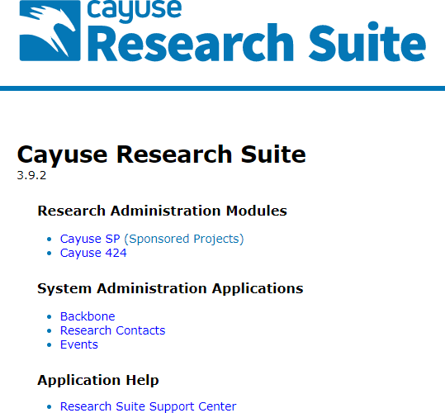

## Extramural Proposal Submission

<https://ucdavis.cayuse424.com/>

* **Cayuse SP** - Internal routing and approval
* **Cayuse 424** - Application submission to most **Federal** sponsors
* **System Administration** - Actions such as:
  + Role assignment
  + Unit contacts
  + Organizational hierarchy

## Cayuse SP Best Practices

* **Be Thorough**

Provide required information & documents

* **Confirm IPF Approvers**

All Approving Units require an IPF Approver

* **Use the Resources**

[OR Budget Templates](https://docs.or.ucdavis.edu/spo/) are helpful

* **Monitor Routing**

Check the status and ensure certified/authorized IPF is received by SPO at least 5 business days before deadline

## Roles in Cayuse SP

* **Investigator/Research Team**

Roles assigned by the individual(s) preparing the IPF in Cayuse SP under the ‘Investigator/Research Team’ tab

* **Research Contacts**

Roles assigned by department Role Managers

* + Role Managers maintain unit ‘Research Contacts’ and update them as personnel or job responsibilities change. Unit Heads assign Role Managers by requesting access from SPO via email: ORCayuseHelp@ucdavis.edu

**Research Contacts**

* **Role Manager:**

Grants access to unit information and establishes roles

* **IPF Approver:**

Authorizes IPFs, usually the unit head

* **Pre-award Spending Approver:**

Endorses advance account requests

* **Proposal Data Access:**

View access to proposals in that admin unit

* **Award Data Access:**

View access to awards in that admin unit

**Investigator/Research Team**

* **Lead Principal Investigator:**

Required; must be added first

Must certify and be authorized by IPF Approver

* **Principal Investigator:**

Co-PI if allowed by the sponsor

Must certify and be authorized by IPF Approver

* **Investigator:**

Primary contributor

Must be authorized by IPF Approver

* **Proposal Editor:**

No routing: Will have edit access to proposal and view access to associated awards

* **Other Participant:**

No Routing: Will have edit access to proposal and view access to associated awards

## Minimum Proposal Documents for SPO Assignment

* **Completely Routed and Authorized IPF**

Complete IPF with Lead PI and co-PI Certifications and IPF Authorizations

* **Budget Spreadsheet** ([OR Budget Templates](https://docs.or.ucdavis.edu/spo/) required for internal budgets)

Strongly encouraged even if NOT required by the sponsor

* **Budget Justification**

Strongly encouraged even if NOT required by the sponsor

* **Scope of Work**

May submit a draft and provide the final before submission to sponsor

## Returning an IPF for Correction and Re-Authorization

1. Incomplete Proposal
2. Incorrect or Revised Budget / Cost Sharing
3. Change in Key Personnel or Effort
4. Additional Subawards

IPFs requiring significant revisions require re-certification by the Lead PI and co-PIs and re-

authorization by the IPF Approver(s)

## Entering an IPF in Cayuse SP

<https://www.yout-ube.com/watch?v=fCUYC1-vsAI>

* *If video doesn’t start at first — “This video is unavailable” — simply refresh the video and it should work*

## PI Certification

This screenshot indicates everything that a PI certifies.

* If an IPF is routed to SPO without the required certifications, it will be returned to “Dept Approval in Process” and certification will be requested.
* **A screenshot of a computer

  Description automatically generated**No one can certify on a PIs behalf. They need to go in and do it themselves.

## Cayuse SP Statuses – Proposals

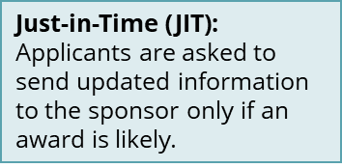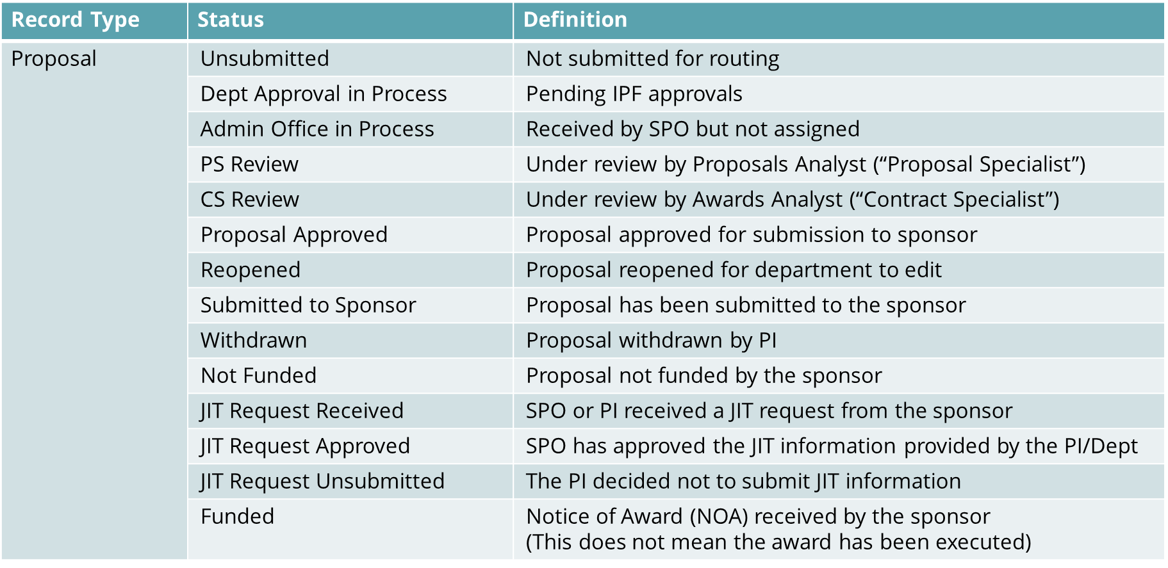Cayuse can be used to check the status of a proposal, award, or subaward.

## Cayuse SP Statuses - Awards & Subawards

Note: You will receive an email from your SPO Award Analyst notifying you when an award is made **Active** and **Obligated** and thereby forwarded to **Contracts & Grants Accounting (CGA)** for next steps.

The complete list of statuses can also be found on page 47 of the   
[Handbook for Department Contract & Grant Staff, Principal Investigators and Approvers](https://research.ucdavis.edu/wp-content/uploads/End-users-v13.pdf)

## How to Check IPF Status and SPO Assignment

Video: <https://www.yout-ube.com/watch?v=UTQDFoxmI3o> (length: 3:53)

* *If video doesn’t start at first — “This video is unavailable” — simply refresh the video and it should work*

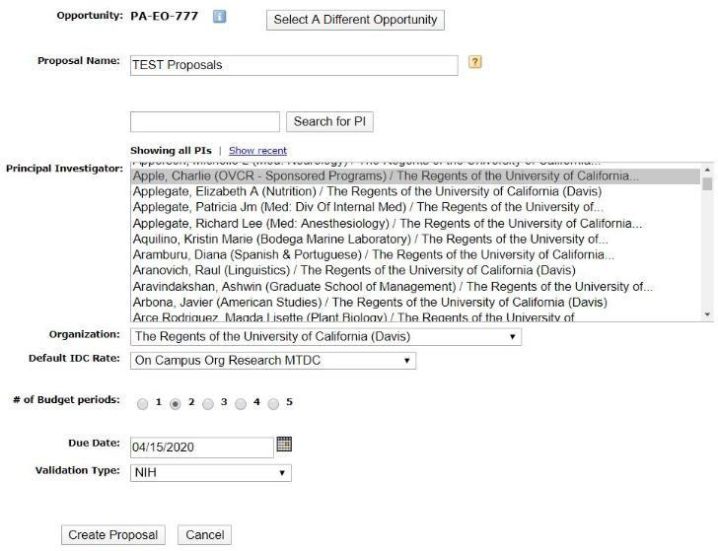

## Cayuse 424

<https://ucdavis.cayuse424.com/>

Used to submit applications to sponsors, manage profiles, and create/import subaward proposals

**Sponsor Submission**

* Use for all Grants.gov proposals.
  + Cayuse 424 is linked system-to-system to Grants.gov.
* Cannot be used for NSF or NASA Proposals

**Professional Profiles**

* Appointment, Salary and Unit Affiliation

## Cayuse 424 Best Practices

* Read ALL Sponsor Guidelines
* All involved should verify accuracy of their Professional Profiles
* Save time by completing the Cayuse 424 proposal while the Cayuse SP IPF is still being routed for approvals
* Correct Errors/Warnings
* Have Full Application Ready and Approved by PI Two (2) Days Before Business Deadline

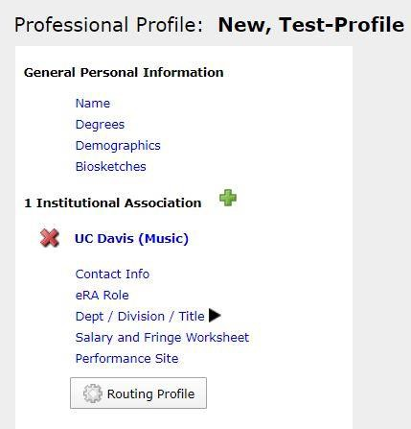

## Cayuse 424 Professional Profiles

Accuracy of Professional Profiles is critical for smooth Cayuse SP IP routing.

**Managing Professional Profiles:** <https://www.yout-ube.com/watch?v=mJqQHledB9Y> (10:26)

* *If video doesn’t start at first — “This video is unavailable” — simply refresh the video and it should work*

## Find your Professional Profile

Find Your Professional Profilein **People** tab:

1. Enter your **last name** in the search field.
2. Change the Institution to **The Regents of the University of California (Davis) – UC Davis**.
3. Select **Search**.
4. **Select your name** if it is on the list.

**If you do not have a Profile:**

1. **Email** [**ORCayuseHelp@ucdavis.edu**](mailto:ORCayuseHelp@ucdavis.edu) to request a Profile and provide the following information:
   * First Name:
   * Last Name:
   * Kerberos username (if known):
   * UC Davis Email address:
   * Dept:
   * PI status (Will you be submitting as PI at some point (Yes/No)):

## Update your Professional Profile

**Update your existing Profile / Complete your new Profile:**

1. **Review all tabs** to ensure they have correct information.
2. Notes:
   * **eRA Role**
     + **Principal Investigator:** Anyone who would be added as personnel in Cayuse 424
     + **Assistant:** Anyone assisting with proposal preparation or needing access to proposals in Cayuse 424
     + Other roles are for SPO only
   * **Dept/Division/Title:** Unit Code for the unit associated with contracts and grants
   * **Salary and Fringe Worksheet:** Employee ID, Appointment Information (Annualized Salary), Fringe Benefit Rate
   * **Performance Site:** Location where most of the PI’s work takes place
3. Select the **Save** icon on the toolbar next to your name.

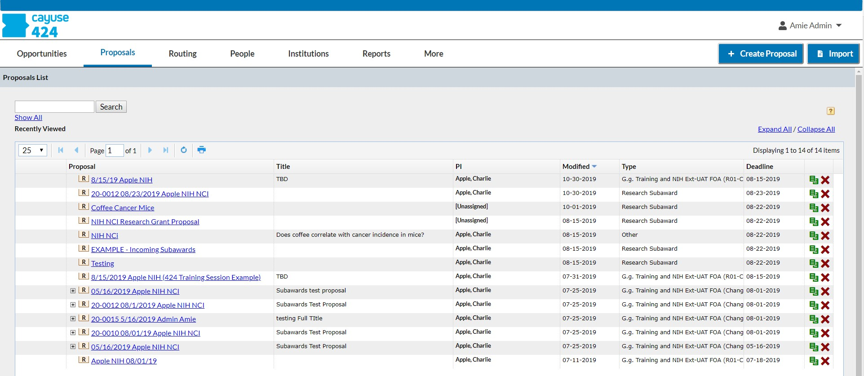

## Cayuse 424 Functions

These are the main functions you will use:

1. Navigate from the top bar
   1. Search **Opportunities** to create the proposal UNLESS you are creating a proposal as a Subrecipient.
      1. If you are preparing proposal as the Subrecipient, start from **+ Create Proposal**
   2. Find a Proposal that has already been created from **Proposals**
2. From the list, select the **Proposal** name to edit.
   1. Select **R** to view as read-only.
   2. Select the green papers to copy the proposal
   3. Select the X to delete it.
3. Select **People** on top toolbar to manage Professional Profiles

## How to Prepare a Cayuse 424 Proposal

Video: <https://www.yout-ube.com/watch?v=evL7fjN7yhE> (length: 12:33)

* *If video doesn’t start at first — “This video is unavailable” — simply refresh the video and it should work*

Tips:

* A good time to start the Cayuse 424 proposal is once the IPF is submitted for approvals in Cayuse SP.
* Helpful link: [Institutional Information](https://research.ucdavis.edu/research-support/proposals/spo-proposal/institutional-information/)
* **Proposal Name:** Include the related Cayuse SP proposal # so SPO can connect the two + PI’s name + Funding Opportunity Number.
* **Attachments** should be PDFs only.
  + Exception: Attach Excel budget if required by sponsor (some DoD and DoE applications).
* **Person to be contacted on matters involving this application:** Your SPO Proposals Analyst.

# Sponsor eRA Systems

## Sponsor eRA Systems

Though UC Davis currently engages with 200+ different sponsor eRA systems, this section of the training will only cover commonly used systems.

* SPO helps you register in these eRA systems but does not provide guidance on their further use.
* Reach out to an eRA system’s helpdesk for further guidance.

## Sponsor eRA Best Practices

We’ll cover specifics for a range of sponsor eRA systems but they all have these needs in common:

* **Register early**
* **Review sponsor guidelines**
* **Give SPO Access**
  + Unless submitting through Cayuse 424, you’ll need to add your assigned SPO analyst
* **Finalize the submission early**

**SPO always submits the proposal to the sponsor** unless the sponsor requires the PI submit.

* In such cases, SPO will forward the approved proposal package to the PI for submission.

# A group of logos on a white background Description automatically generatedStand-Alone Systems



## Research.gov

<https://www.research.gov/>

Always use Research.gov for NSF submissions.

Research.gov is used for all stages of NSF grant administration

**Roles:**

Sponsored Programs Office

* **Authorized Organizational Representative (AOR):**

Approves and submits proposals on PI’s behalf

Investigator/Research Team

* **Principal Investigator (PI):**

Responsible for scientific or technical direction;

Can perform proposal and award actions

* **Other Authorized User (OAU):**

May assist with budget preparation and revision with the Proposal PIN and ID number

## Research.gov Access Guidelines

1. **NSF ID** [**Look-Up**](https://identity.research.gov/sso/services/forgotNSFID) Ensure the user does not have an NSF ID
2. [**Register**](https://apps.research.gov/account/registration) **for an NSF ID** PIs and OAUs need an NSF ID
3. **Request Role** Select either the PI role or the OAU role to request access

SPO will be notified and process the affiliation

## A black and white logo Description automatically generatedNASA Solicitation and Proposal Integrated Review and Evaluation System **(NSPIRES)**

<https://nspires.nasaprs.com/external/>

NSPIRES is the **NASA** full life-cycle grants management system.

* View solicitations, submit proposals and conduct proposal review

**NASA grant applications must be submitted through this system** – No Cayuse 424 access.

* Individual [Registration](https://nspires.nasaprs.com/external/registration/createuser!init.do) Required
* **SPO submits** to sponsor

## ProposalCentral

<https://proposalcentral.com/>

ProposalCentral lists grant opportunities and accepts grant applications for a number of **non- profit, state, and private grantmakers**, such as the **American Cancer Society** and the **American Lung Association**.

ProposalCentral grants cannot be applied for

through Cayuse 424.

Applicants need to **register only once** to use the system. [How to register](https://docs.proposalcentral.com/RegUser.pdf) (PDF)



## Financial Assistance and Applications Submittal Tool (FAAST)

<http://faast.waterboards.ca.gov/>

Used for various **California state** agency funding opportunities, such as the:

* California Department of Housing and Community Development
* California Department of Food and Agriculture
* California Department of Education
* State Water Resources Control Board

PI self-registers

**PI submits** to sponsor

* **SPO does not have access** – Upload all documents in **Cayuse SP**

## SmartSimple

<https://rgpogrants.ucop.edu/s_Login.jsp>

Use for UCOP proposals

* Other sponsors using the system will have a unique link

**Register early** for an account

* Select **Register Here**

Key roles:

* **PI Assistant:** Dept Admin (can be multiple)
* **PI:** Principal Investigator
* **Contracts and Grants Contact:** Denise Ehlen, [proposals@ucdavis.edu](mailto:proposals@ucdavis.edu)
* **Signing Official:** Denise Ehlen, [proposals@ucdavis.edu](mailto:proposals@ucdavis.edu)
* **Fiscal Contact:** Mario Reina-Guerra, [mreinaguerra@ucdavis.edu](mailto:mreinaguerra@ucdavis.edu)

**SPO submits** to sponsor.

# eRA Systems Linked to Cayuse 424

## A blue and white logo Description automatically generatedASSIST (Application Submission System & Interface for Submission Tracking)

<https://public.era.nih.gov/assist/>

SPO recommends that all NIH proposals be submitted via **Cayuse 424**.

* This includes **multi-component proposals** (e.g., includes admin core, project, career development, and/or training components).
* Cayuse 424 allows easier access to the proposal, which speeds the review process.

Register through **eRA Commons** to access ASSIST

ASSIST is used for **proposal submissions**.

* **Post-award management** is handled through **eRA Commons**

**SPO will submit** the proposal to the sponsor, except:

* PIs submit Streamlined Noncompeting Award Process (SNAP) awards

## NIH eRA Commons

<https://public.era.nih.gov/commonsplus/>

**Note:** Prior to submitting a proposal via Cayuse 424, all investigators named in the proposal are advised to ensure that they have established their **NIH user access in eRA Commons** and it is also recommended that they have established their **Open Researcher and Contributor ID (ORCID)**.

## NIH eRA Commons Roles

**Roles:**

Sponsored Programs Office

* **Administrative Official (AO):** Reviews proposals
* **Signing Official (SO):** Approves and submits proposals

Investigator/Research Team

* **Principal Investigator (PI)/Project Director:** Responsible for scientific or technical direction; can perform proposal and award actions.
  + Must have an eRA Commons account when the application is started in ASSIST.
* **Assistant (ASST):** May edit application.

Note: The **National Oceanic and Atmospheric Administration (NOAA)** previously had its own grant management system (NOAA Grants Online) but has transitioned to using **eRA Commons**.

## NIH x-Train

<https://era.nih.gov/help-tutorials/xtrain>

Roles:

* **TRAINEE** – Enters data and manages
* **PI** – Enters data and manages
* **SO** – View access
* **BO** – Submits Terminations
* **SPONSOR** – Terminates Fellows
* **ASST** (when delegated by SPONSOR or PI)

Manage Trainee Appointments

* Institutional Research Training Grants
* Institutional Career Development Awards
* Research Education Awards

## **ezFedGrants (eFG) and Agreement System**

<https://nfc.usda.gov/FSS/clientservices/ezFedGrants/index.php>

Though eFG allows grant applications, when possible, USDA grants should be applied for through **Cayuse 424**.

* If you submit through eFG, **SPO will submit** the proposal to the sponsor

eFG is used for post-award management of USDA grants and agreements

* **Register early** – Give yourself at least one week

# Post-Award Management Systems

## A logo with text on it Description automatically generatedeBRAP (Department of Defense)

<https://eBRAP.org/>

Though applications must be submitted through **Cayuse 424**, all **DoD Congressionally Directed Medical Research Programs (CDMRP)** applications require a pre-application through the eBRAP system

You must register to use the eBRAP system.

* [User Guide](https://ebrap.org/eBRAP/public/UserGuide.pdf)

## JustGrants Resource Website | U.S. Department of JusticeJustGrants (Department of Justice)

<https://justicegrants.usdoj.gov/>

Grant applications are made through **Cayuse 424**.

* Applicants need to be registered with [SAM.gov](https://sam.gov/content/home).
* Applications need to identify an **Authorized Organizational Representative (AOR)** (assigned from the Sponsored Programs Office)

Used for **post-award management** (award modifications, performance/financial reports, closeouts).

Once you are awarded, your AOR will add you to JustGrants and **you will receive an email from “DIAMD-NoReply@usdoj.gov”** with instructions on how to create your account.

## G6/US Department of Education

<https://g6.ed.gov/>

The Department of Education accepts grant applications via **Cayuse 424.**

G6 is used for post-awards management:

* Perform administrative changes on grants
* Request no-cost extensions
* Submit progress reports

Individual [registration](https://www.g5.gov/g5/home/externaluserregistration) is required

* Note that some administrative actions require approval by the University’s **authorized signature representative** and are **typically initiated by SPO**.

## Bringing Blockchain Into GovernmentGrantSolutions

<https://home.grantsolutions.gov/>

GrantSolutions **supports various Federal agencies** such as the **Department of the Interior** and the **Department of Transportation.**

It provides **post-award services** for grants applied for through **Cayuse 424.**

* **Register early** – Give yourself at least one week
* **Non-competing continuations** and **directed supplements** may be applied for through GrantSolutions. In such cases, the PI submits the grant.

**SPO does not have access to GrantSolutions**, so all documents must be uploaded in **Cayuse SP**.

## PAMS (Department of Energy)



<https://pamspublic.science.energy.gov/>

PAMS allows PIs to manage grants awarded by the **DoE Office of Science.**

* Grant applications must be submitted through **Cayuse 424.**

While you may be invited to register in PAMS, you can also self register at <https://pamspublic.science.energy.gov/WebPAMSExternal/Interface/Registration/CreateAccount.aspx>

* There is **no approval required by SPO** once an account has been registered.
* **SPO analysts will receive an email** notifying them of the account creation.

# Resources

## Contact Us

How did we do? Please complete the course evaluation at

<https://ucdavis.co1.qualtrics.com/jfe/form/SV_5pe1W9dTaFY38YS>

Perry King

SPO Training Officer

Email: [pking@ucdavis.edu](mailto:pking@ucdavis.edu)

Terry Duperron

eRA Analyst

Email: [SPOeRAHelp@ucdavis.edu](mailto:SPOeRAHelp@ucdavis.edu)

## Electronic Research Administration Systems

[List of internal and external eRA systems UC Davis systems](https://research.ucdavis.edu/research-support/proposals/spo-proposal/proposal-submission/era/)

**UC Davis systems**

* Cayuse 424 and SP: <https://ucdavis.cayuse424.com/> (copy & paste address in browser)
* [Learn: Cayuse SP](https://research.ucdavis.edu/research-support/proposals/spo-proposal/proposal-submission/cayuse-sp/) and [Learn: Cayuse 424 and NIH ASSIST](https://research.ucdavis.edu/research-support/proposals/spo-proposal/proposal-submission/spo-training-grant-subs/)
* [Biological Use Authorization (BUA) Application](http://safetyservices.ucdavis.edu/article/biological-use-authorization-bua)
* [Electronic Conflict of Interest (eCOI) System](https://or-forms.ucdavis.edu/)
* [Anatomical Materials Review Committee (AMRC) Resources](https://research.ucdavis.edu/policiescompliance/human-anatomical-specimen-tissue-oversight/)
* [Institutional Animal Care and Use Committee (IACUC) Application](https://iacuc.ucdavis.edu/protocol/)
* [IRBNet (Human Subjects Protocols)](https://www.irbnet.org/release/index.html)

## Common Acronyms

* **AMRC:** Anatomic Materials Review Committee
* **BAA:** Broad Agency Announcement
* **BUA:** Biological Use Approval
* **CGA:** Contracts and Grants Accounting
* **COI:** Conflict of Interest
* **eRA:** Electronic Research Administration
* **F&A:** Facilities & Administrative rates, aka indirect cost rates
* **FOA:** Funding Opportunity Announcement
* **IACUC:** Institutional Animal Care and Use Committee
* **ICR:** Indirect Cost Rate
* **IDC:** Indirect Costs
* **IPF:** Internal Processing Form (Cayuse SP “proposal”)
* **IP:** Intellectual Property
* **IRB:** Institutional Review Board (Human Subjects)
* **PHS:** Public Health Service
* **PI:** Principal Investigator
* **RCR:** Responsible Conduct of Research
* **RECO:** Research Ethics and Compliance Office
* **RFA:** Request for Applications
* **RFP:** Request for Proposals
* **RPPR:** Research Performance Progress Reports
* **SBIR:** Small Business Innovation Research
* **SPO:** Sponsored Programs Office
* **STTR:** Small Business Technology Transfer

## Sponsored Programs Contacts & Links

* Proposals: [proposals@ucdavis.edu](mailto:proposals@ucdavis.edu)
* Awards: [awards@ucdavis.edu](mailto:awards@ucdavis.edu)
* Subawards: [subawards@ucdavis.edu](mailto:subawards@ucdavis.edu)
* Closeouts: [closeouts@ucdavis.edu](mailto:closeouts@ucdavis.edu)
* eRA Help: [SPOeRAhelp@ucdavis.edu](mailto:SPOeRAhelp@ucdavis.edu)
* Cayuse Help Desk: [ORCayuseHelp@ucdavis.edu](mailto:ORCayuseHelp@ucdavis.edu)
* Training: [SPOTraining@ucdavis.edu](mailto:SPOTraining@ucdavis.edu)
* Negotiations: [OR-SPO-Negotiation-Team@ad3.ucdavis.edu](mailto:OR-SPO-Negotiation-Team@ad3.ucdavis.edu)
* [SPO Contact Us webpage](https://research.ucdavis.edu/about/offices/spo-office/#ci)
* [Sponsored Programs Office (SPO)](https://research.ucdavis.edu/about/offices/spo-office/)
* [SPO Proposal and Award Learning Resources](https://research.ucdavis.edu/research-support/proposals/spo-proposal/spo-training/training-opps/)

## SPO Office Hours & Training Opportunities

**SPO Office Hours:** Bring your questions and join our knowledgeable staff for guidance and training on preparing and submitting proposals for extramural funding.

* Drop in via Zoom the 1st Thursday of each month between 10 and 11am <https://ucdavis.zoom.us/j/96045587567?pwd=MnVMTXN5SDRuM0RITzlKUjNmdjl5Zz09>

**All SPO training opportunities** at <https://research.ucdavis.edu/research-support/proposals/spo-proposal/spo-training/training-opps/>

## Research Administration Forum

Forum for department research administrators to:

**Hear updates Ask questions Provide feedback**

Sponsored Programs Office (SPO)

IRB Administration

IACUC

Technology Transfer

Contracts and Grants Accounting (CGA)

Research Ethics and Compliance Office (RECO)

**Join via** [**Zoom**](https://ucdavis.zoom.us/j/99842677540)

**4th Wednesday of each month ( Jan – Oct)**

**8:30 am**

Access videos of previous forums and related materials on the [Forum](https://research.ucdavis.edu/research-support/proposals/spo-proposal/spo-training/research-administration-forums/) webpage

## Office of Research Listservs

**Contracts & Grants (OVCR-cg) listserv**

* The primary mechanism for informing the campus community of the latest research administration news.
* Click this [link](https://lists.ucdavis.edu/sympa/subscribe/ovcr-cg) to subscribe (UC Davis emails)

**SPO Cayuse info listserv**

* Cayuse SP and 424 info and announcements, as well as training opportunities from the Sponsored Programs office.
* Click this [link](https://lists.ucdavis.edu/sympa/subscribe/spo_cayuse_info) to subscribe (UC Davis emails)

[Other Office of Research Listservs](https://research.ucdavis.edu/about/connect-with-us/listserv-subscriptions/)

## UC Learning Center classes

SPO offers classes individually or as a series:

* [Research Administration Certificate Series (RACS)](https://hr.ucdavis.edu/departments/learning-dev/certificate/research-admin)
* [eRA Train the Trainer Certificate Series](https://hr.ucdavis.edu/departments/learning-dev/certificate/eRA)
* [Individual classes](https://hr.ucdavis.edu/departments/learning-dev/course-catalog/research) (under “Grants and Sponsored Programs”)

## Thank you!

Follow SPO on [X](https://x.com/UCDavisSPO) and [YouTube](https://www.youtube.com/channel/UC5tWJ6oF2G5nYarcdAK9SwQ)!